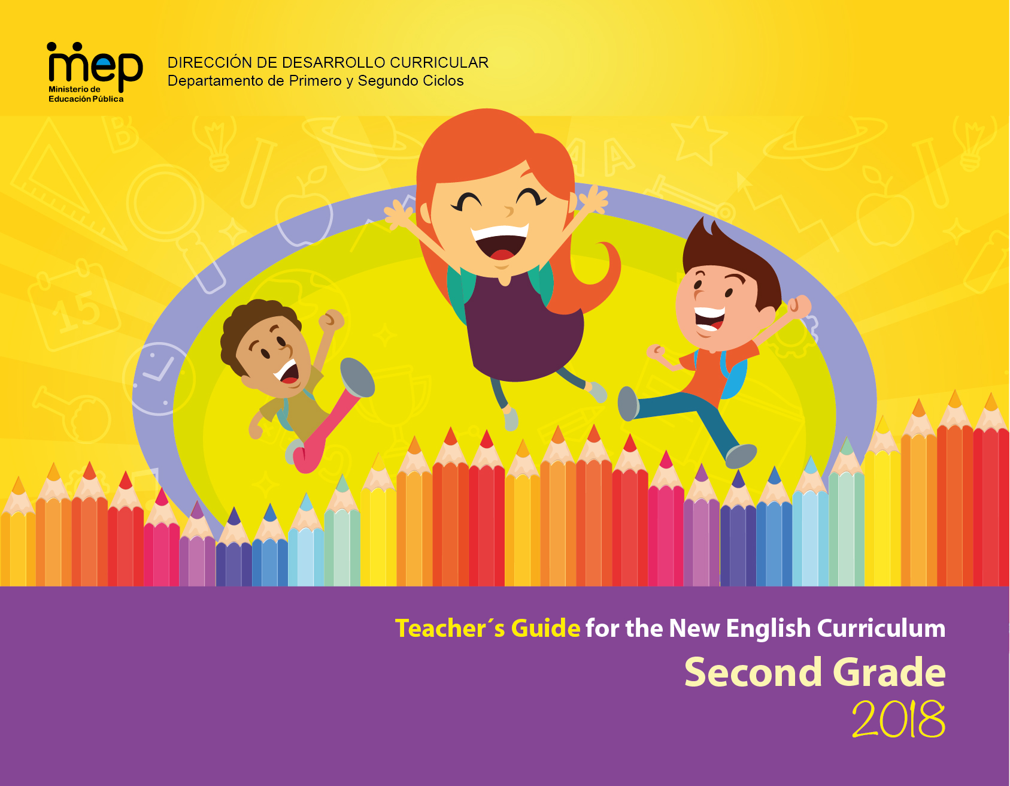

Table of Contents

Presentation 4

The Common European Framework of Reference (CEFR) 5

Costa Rican general descriptors according to CEFR English proficiency bands 6

The Action-Oriented Approach 8

Learner Exit Profiles for First Cycle 10

Integral Development and Communicative Competence 11

Scope and Sequence First Cycle 13

The Teaching of Phonemic Awareness in the first Cycle: General Guidelines 14

Unit 1 Scope and Sequence 17

Unit 1 Learning is Fun 22

Unit 2 Scope and Sequence 62

Unit 2 Healthy Habits 66

Unit 3 Scope and Sequence 107

Unit 3 Home Sweet Home 111

Unit 4 Scope and Sequence 155

Unit 4 Loving and Caring Animals 159

Unit 5 Scope and Sequence 189

Unit 5 Fabulous Flora and Fauna 194

Unit 6 Scope and Sequence 234

Unit 6 A change of scenery 239

Mini-project planner 285

ANNEXES 287

ANNEXES 287

# Presentation

This Teacher´s Guide for Second Grade has been designed to provide English teachers, who are implementing the new English curriculum in second grade, with pedagogical strategies and various resources to serve students ‘learning resulting in the development of the knowledge, skills and abilities set in the new English syllabus for this level. The main goal of every action performed in the classroom by the teacher is that learners can achieve an expected level of performance in the target language according to the CEFR as well as abilities and competences to learn to be and live in society. We believe that this resource can be useful to facilitate the implementation process of the new curriculum. The teacher can freely adapt this lesson planning teacher´s guide so that it responds to the needs and context of learners.

The guide consists of six units. Each unit lesson plan comes along with the learner´s exit profile for the level, the scenarios and themes for the cycle and the scope and sequence of each unit within a timeline of six weeks. In week 6, students are expected to carry out a mini-project, which is a formative-evaluative- complex task, to assess in an skills- integrative way the achievement of unit goals.

The special features of this Teacher’s Guide are:

A. **Assessment Strategies and Evidences of Learning:** Each goal has a specific assessment indicator for each linguistic competence which requires the elaboration of assessment instruments.

B. **Goals:** Each lesson has specific and clear learning goals connected to a domain, scenario, theme and language function.

C. **Pedagogical Mediation/ Didactic Sequence:** subdivided in the following stages;

✓**Pre-Teaching:** (Warm-up, Activation of Prior Knowledge, Modeling, Clarifying)

✓**Pre-task:** Introductory activity for activation of students’ prior knowledge to carry out a specific task connected to a goal. It places emphasis on the linguistic, cognitive resources needed by the leaner.

✓**Task rehearsal:** Class work where students practice the language in a meaningful way for successful task completion.

✓**Task completion:**  A task that learners perform to demonstrate that the goal has been successfully achieved.

✓**Task assessment:** An activity for self and/or peer assessment and teacher feedback and/ or repair in relation to the achievement of a goal. Evaluation tools to evaluate performance tasks, of what students know and can do.

D. **Time:** Each phase of the didactic sequence includes a suggestion for the time that may be needed.

E. **Integrated Mini Project:** The project is a creative opportunity for students to integrate knowledge, abilities and skills**.**

F. **Reflective Teaching:** Suggestions for you to assess your own progress in teaching the material.

## 

# The Common European Framework of Reference (CEFR)

|  |  |
| --- | --- |
| **CEFR** describes proficiency levels based on accumulated evidence gathered over time from learner activities, tasks, or projects. | **Implications:**   * Standard Terminology * Track student progress * Descriptors – teaching, learning and assessment * Students monitor and take responsibility * Transferability across settings * Parent communication |
| D:\Users\yramirez\Documents\CEFR level of proficiency.jpg | |

# Costa Rican general descriptors according to CEFR English proficiency bands

|  |  |  |
| --- | --- | --- |
| **Basic User**  **Basic User** | A1 | * Can understand and use familiar everyday expressions and very basic phrases aimed at the satisfaction of needs of a concrete type. * Can introduce him/herself and others and can ask and answer questions about personal details such as where he/she lives, people he/she knows and things he/she has. * Can interact in a simple way provided the other person talks slowly and clearly and is prepared to help. * Can show limited ability to use simple grammatical structures and conventions such as punctuation, and capitalization.   **EXTENSION OF THE CEFR STANDARDS - INTEGRATION OF LANGUAGE ABILITIES**   * Can use A1 level, grade level and age appropriate linguistic (e.g. present verb forms), socio-cognitive (e.g., associating strategies) and socio-affective (e.g., cooperating or coping strategies) resources to integrate topical content from oral and written text to perform a goal-oriented product (mini-project) based on an integrated sequence of activities within a domain, scenario and theme. Linguistic resources include grammatical forms and meanings; socio-cognitive resources include a range of meta-cognitive strategies (planning) and cognitive strategies (revising); and socio-affective resources consist of strategies such as cooperating and coping. * Can use A1 level, grade level and age appropriate digital and telecommunication resources to research, plan, and implement the mini-project. * Can give, receive, and respond to feedback at critical stages of the creative process. * Can use level and age appropriate linguistic resources to integrate information from a reading or a listening or other inputs to perform from one skill modality to another (e.g., listening to speak, read to write) to achieve the goal of the scenario. * Can display awareness and development of non-cognitive dispositions (such as effort, perseverance, engagement, empathy, and focus). |
|
| A2  A2 | * Can understand sentences and frequently used expressions related to areas of most immediate relevance (e.g., very basic personal and family information, shopping, local geography, employment). * Can communicate in simple and routine tasks requiring a simple and direct exchange of information on familiar and routine matters. * Can describe in simple terms aspects of his/her background, immediate environment, and matters in areas of immediate need. * Can use some simple structures accurately but continues to systematically exhibit basic errors (such as verbs tenses, use of prepositions, articles).   **EXTENSION OF THE CEFR STANDARDS- INTEGRATION OF LANGUAGE ABILITIES**   * Can use A2 level, grade level and age appropriate linguistic (e.g. past verb forms), socio-cognitive (e.g., grouping strategies) and socio-affective (e.g., cooperating or questioning for clarification strategies) resources to integrate topical content from oral and written text to perform a goal-oriented product (mini-project) based on an integrated sequence of activities within a domain, scenario and theme. Linguistic resources include grammatical forms and meanings; socio-cognitive resources include a range of meta-cognitive strategies (monitoring) and cognitive strategies (resourcing); and socio-affective resources consist of strategies such as cooperating and coping. * Can use A2 level, grade level and age appropriate digital and telecommunication resources to research, plan, and implement the mini-project. * Can give, receive, and respond to feedback at critical stages of the creative process. * Can use level and age appropriate linguistic resources to integrate information from a reading or a listening input or other inputs to perform from one skill modality to another (e.g., listening to speak, read to write) to achieve the goal of the scenario. * Can display awareness and development of non-cognitive dispositions (such as effort, perseverance, engagement, empathy, and focus). |

# The Action-Oriented Approach

|  |  |
| --- | --- |
| **Learner**  [Resultado de imagen de learner images](https://www.google.com/imgres?imgurl=https://learnerview.ofsted.gov.uk/sites/default/files/learner-view-homepage-banner.jpg&imgrefurl=https://learnerview.ofsted.gov.uk/&docid=5PJQQILrnbOq6M&tbnid=ztgfT50v_lCz6M:&w=665&h=300&bih=691&biw=1455&ved=0ahUKEwi7x6L9xpnOAhWJ1R4KHQxmDAQQMwg8KBQwFA&iact=mrc&uact=8) | * An agent/performer with intercultural awareness skills. * Autonomous, works cooperatively, interacts with others, investigates and solves problems using the tools at his/her disposal (general and specific competences). * Develops metacognitive, reflective and critical thinking strategies for successful completion of the task. |
| **Teacher**  Resultado de imagen de teacher images working with learners | * Facilitator, coach, resource person, guide, advisor, and observer. * Helps the learner become autonomous and be successful in the completion of the task. * Provides effective feedback in the process of learning. * Shows expert role, but shares this responsibility with the learner. |
| **Learning Resources**  [Resultado de imagen de images of innovative classrooms](https://www.google.com/imgres?imgurl=http://cdn.patch.com/users/33150/2010/10/T600x450/123f96ec19a783aa3d14f7ec1a7c23fb.jpg&imgrefurl=http://patch.com/illinois/oaklawn/spartan-education-foundation-allows-teachers-to-creat6a888cc1c2&docid=p6ec_p7CxNZgTM&tbnid=mkpmu_Q8DdoEFM:&w=600&h=450&bih=691&biw=1455&ved=0ahUKEwjAtJfEy5nOAhWK1h4KHWS_A1o4ZBAzCFsoWDBY&iact=mrc&uact=8) | * Oral or written authentic texts: business cards, bus tickets, newspaper articles, book excerpts, wikis, bus schedules, city maps, bulletin boards, voice messages, and announcements. * Appropriate to the learner´s needs and competence level. * Intercultural perspective |
| **Aims of communicative activities/tasks**  D:\Users\acamposce\Pictures\roleplay.png | * Communicative activities become actions that the learner/social agent performs in order to build up general competences and communicative language competences. * The goal is successful action and accomplishment of tasks in a particular scenario and domain aligned to the learner’s life experience and personality. |
| **Learning Environment**  [Resultado de imagen de images of students having fun](https://www.google.com/imgres?imgurl=http://www.unr.edu/Images/student-services/cultural-diversity/API%204.jpg&imgrefurl=http://www.unr.edu/cultural-diversity/programs-and-services/programming&docid=Flvpi_I3n3uTnM&tbnid=7J00HYKKtlXtXM:&w=350&h=250&bih=691&biw=1455&ved=0ahUKEwif17PuzpnOAhXGox4KHbJxB0QQMwheKDowOg&iact=mrc&uact=8) | * Real-world contexts (personal, public, educational and vocational domain) collaborative, stimulating, mediated by ICTs. |
| **Assessment**  [Resultado de imagen de images of innovative teaching materials](https://www.google.com/imgres?imgurl=http://www.weareteachers.com/images/default-source/blog-images/close-reading.png?sfvrsn=0&imgrefurl=http://www.weareteachers.com/blogs/post/2015/05/27/10-super-innovative-teacher-ideas-for-close-reading&docid=xFbAhMl4I4vvIM&tbnid=SeRAeBryAMcSqM:&w=630&h=354&bih=691&biw=1455&ved=0ahUKEwiS57CcypnOAhVKWh4KHb_LBdoQMwhJKCUwJQ&iact=mrc&uact=8) | * Assessment is based on what the social agent is able to do in real-life situations or scenarios and the process he/she requires to develop the competences. Authentic assessment is favored. * The acquisition and refinement of general and communicative competences is a continuous process, both at school and in the world beyond the school. |

# Learner Exit Profiles for First Cycle

|  |  |  |  |
| --- | --- | --- | --- |
| Types of knowledge  Orientations to | **Learn to know**  What the learner needs to know  **Learner …** | **Learn to do**  What the learner needs to do  **Learner…** | **Learn to be and live in community**  How the learner needs to be  **Learner…** |
| A Global Citizenship with Local Belonging | * extracts explicit information from visual and simple texts. * uses oral and written codes for communicating simple and familiar ideas. * identifies time and space data in sequential order by using visuals. * Understands the purpose of given instructions. * recognizes meaningful information gradually. | * recognizes gradually different styles when working in groups according to skills and motivations. * practices assertive communications skills. * Recognizes gradually own abilities for team work gradually. | * recognizes his/her own rights and responsibilities and the ones of others gradually. * values positively diversity in his/her family, school, society and context. * judges positively daily actions that contribute for wellbeing. * participates in peaceful conflict solving. |
| Education for Sustainable Development | * recognizes gradually different social and environmental risks affecting life. | * initiates valuing the implication of efforts over the achievement of goals. | * initiates differentiating beliefs, attitudes, actions over sustainable development. |

|  |  |  |  |
| --- | --- | --- | --- |
| Integral Development and Communicative Competence | | | |
| **Level**  **A1.2 Grades 2-3** | | | |
| At this stage, the learner can... | | | |
| **Learn to know** | have a level appropriate language (words, phrases, formulaic expressions) related to family and school life. Knows a small set of simple grammatical structures and heavily structured sentence patterns related to social and school activities. | | |
| **Learn to do** | use level-appropriate linguistic and topical resources in order to listen, read, speak and write in response to level and age-appropriate tasks, integrating language and topical knowledge, skills and abilities (KSA) within domains, scenarios and themes. S/he may use linking words such as *and/but and because* to connect groups of words*.* | | |
| **Learn to be and live in community** | use personal and social dispositions (e.g., coping, engagement, attitudes, cooperation, turn taking, empathy, and other universal values) when interacting and producing in the target language and taking time to search for words using oral and body language for transferable learning (enduring understanding).  use various resources in order to connect personally with the information, beyond the curriculum.  S/he holds basic contact using the simple polite forms for requests, expressing gratitude, or apologizing. | | |
| **Listening** | **Reading** | **Speaking**  **(spoken interaction & production)** | **Writing** |
| **CEFR STANDARDS**   * Can understand familiar words and very basic phrases related to social and educational contexts.   **INTEGRATION OF LANGUAGE SKILLS**   * Can recognize sounds in spoken words. (Listen to speak/ read) * Can identify details in an oral text by completing a graphic organizer.(Listen to write) | **CEFR STANDARDS**   * Has a very limited ability to comprehend text by reading independently in English but can participate more over time during shared reading activities. * Can recognize familiar words and understand short illustrated texts about familiar subjects using familiar words. * Can recognize some high-frequency words such as *a*, *the*, *and*, *of*.   **INTEGRATION OF LANGUAGE SKILLS**   * Can identify main points in a story by matching pictures with sentences. (Read to write.) * Can identify high frequency words in a text from spoken familiar language.(Listen to read) | **CEFR STANDARDS**   * Can use simple learned expressions to get immediate needs met, answer questions about personal details (name, age, location, day of the week, family members) or personal items. * Can interact in a simple way provided the other person talks slowly and clearly and is prepared to help.   **INTEGRATION OF LANGUAGE SKILLS**   * Can respond to questions with a single word or short phrase to show comprehension from oral or written inputs. (Listen to speak, read to speak) * Can participate in short interactions if the other person speaks slowly. (Listen to speak) | **CEFR STANDARDS**   * Can compose short messages copying learned expressions, labeling drawings, using inventive spelling, or dictating key words to an adult. * Can fill in phrases and sentences using a list of familiar words.   **INTEGRATION OF LANGUAGE SKILLS**   * Can describe objects, places and people using simple spoken and written language.(Speak to write, write to speak) * Can complete words and sentences after aural stimuli. (Listen to write) |

# Scope and Sequence First Cycle

|  |  |  |  |  |  |  |
| --- | --- | --- | --- | --- | --- | --- |
| **Scope and Sequence First Cycle** | | | | | | |
| **Level** | **Unit 1** | **Unit 2** | **Unit 3** | **Unit 4** | **Unit 5** | **Unit 6** |
| **First Grade** | **Scenario: All About Me!**  **Themes:**   * Saying hello! Saying Good Bye! * Introducing Myself * The Way I Look and Feel * Making New Friends | **Scenario: This is our Classroom!**  **Themes:**   * Stand up! Sit down! * Things in My Classroom * My School Supplies * Where is my Pencil? | **Scenario: We Are All Different!**  **Themes:**   * Meet my Family * What my Family Looks Like * Different Things my Family Likes to Do * I Like… | **Scenario: Going to School, so Cool!**  **Themes:**   * This Is my School. * Helpers at my School. * Going around School. * A Week at my School | **Scenario: My Neighborhood.**  **Themes:**   * This Is my Neighborhood * Where is the School? * How can I Get to the Supermarket? * Community Helpers | **Scenario: Playtime**  **Themes:**   * Fun Games and Activities * I need a Rope to Play * My Favorite Game and Activities * Show me How to Play |
| **Second Grade** | **Scenario: Learning Is Fun**  **Themes:**   * Hi! How are you today? * My Learning Environment * What Do I do at School? * What I Like about School? | **Scenario: Healthy Habits**  **Themes:**   * I Love my Body! * Healthy Habits make me Feel Great! * Yummy and Good for my Tummy * I Can Be Healthy and Happy | **Scenario: Home Sweet Home**  **Themes:**   * A Visit from my Cousins * A Home Tour * What We Do around the House * Cleaning the House | **Scenario: Loving and Caring Animals**  **Themes:**   * Barn or House? * Moo, Meow, and Cock-a-Doodle-Do * Living with Animals and Pets around me * Walk the Dog...and Other Ways to Care for Animals | **Scenario: Fabulous Flora and Fauna**  **Themes:**   * A Nature Walk * Animals A to Z * Green Kingdom * Protecting Nature | **Scenario: A change of Scenery**  **Themes:**   * Rain, Rain Go Away * Try This on * May I Have a Bite? * Please Tell me What´s Fun |
| **Third Grade** | **Scenario: Our Family “to Do” List**  **Themes:**   * Family Chores * Things I Like to Do to Help my Family * Can you help me? * Where is the Broom? | **Scenario: Families Celebrate Together!**  **Themes:**   * What is there to Celebrate? * My Family`s Special Dates * When is your Birthday? * Sharing Family Celebrations! | **Scenario: May I Help You?**  **Themes:**   * Is This the Cashier or the Clerk? * Going to a Store! * Where do I Get some Fresh Vegetables? * How Much does it Cost? | **Scenario: Getting around Town!**  **Themes:**   * A Day in my Community * Help! I Need a Pair of Shoes. * Walk this Way * Step by step Directions | **Scenario: Fun Places and Spaces**  **Themes:**   * Let´s Go Outside * Indoor fun on a rainy day * Come on! Make-up your Mind. * Are you ready to Have Fun? | **Scenario: Welcome to Costa Rica**  **Themes:**   * Costa Rica: a Diverse Country * Where Can I Go? * How will I Get There? * Exploring Costa Rica: no Better Place to Be |

## The Teaching of Phonemic Awareness in the first Cycle: General Guidelines

Basic pedagogical recommendations for the teaching of phonemic awareness in first grade.

* The main goal is to make the students **hear, notice and distinguish initial sounds** of the words when they are heard.
* Teacher shares goal with learner.
* Teacher follows the pedagogical sequence: pre-task, task rehearsal, task completion and task assessment.
* Teacher clarifies understanding by showing pictures/flashcards of words with the two sounds to see if they recognize the difference between them.
* Teacher uses strategies such as **phoneme isolation, phoneme identity and phoneme categorization**.
* Children do not have to write the words or the letter of the sound at this point. Videos are an optional resource with exaggerated gestures and pictures associated with the sounds heard.”

**Basic pedagogical recommendations for the teaching of phonemic awareness in second grade**

* Introduce the alphabet. It is very helpful to have it pasted in the classroom if you have one.
* Teach the phonics alphabet using letters attached to pictures that represent the sound and the letter.
* (<https://www.youtube.com/watch?v=BELlZKpi1Zs>)
* Students begin to make sound – letter associations.
* Focus on one or two letter names and sounds in each lesson, emphasizing tracing with upper case and lower case letters as students listen to the sound.
* Provide examples of words that begin with that letter. Always use pictures that facilitate the acquisition of the new meanings.
* Provide opportunities for children completing initial letters of words and printing words.
* Create short sentences or stories with those words.
* Connect the goal of phonemic awareness with the reading and writing goals.

**Note:** The goals for phonemic awareness development have been adjusted in this guide so that instead of teaching all the sounds and letters of the alphabet at once, children focus only in two sounds and letters per week. This adjustment is made to serve students ‘learning.

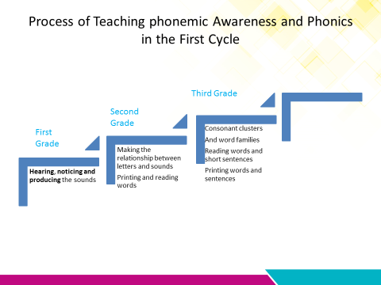

|  |  |  |  |  |
| --- | --- | --- | --- | --- |
| Unit 1 Scope and Sequence | | | | |
| **Scenario : Learning is Fun** | | | | |
| **Enduring Understanding** | Learning is fun when we like the people, the places and what we are doing. | | | |
| **Essential  Question** | What makes learning fun? | | | |
| |  | | --- | | **Dimensions** | | **1.** **Ways of thinking ( x )** | | **2. Ways of living in the world ( x )** | | **3. Ways of relating with others ( x )** | | **4. Tools for integrating with the world ( x )** | | | | | |
| **Assessment and Goals** | | | | |
| **Week 1** | **Week 2** | **Week 3** | **Week 4** | **Week 5** |
| **Theme**   1. Hi! How are you today? | **Theme**   1. 2. My Learning Environment | **Theme**   1. What do I do at school? | **Theme**   1. What I like about school? |  |
| **Assessment:**  **L.1.** Recognizes basic greetings, farewells, and common expressions of politeness.  **L.3.** Recognizes simple questions which directly concern them such as their name, where they are from, likes and dislikes.  **R.PA.3.** Recognizes each sound of letters of the alphabet that form a word.  **SI.1.** Uses one or two learned expressions of greeting, farewell, and politeness.  **Goals:**  **L.1.** understand basic greetings, farewells, and common expressions of politeness (e.g., hi, see you tomorrow, sorry).  **L.3.** understand simple questions which directly concern them such as their name and where they are from.  **R.PA.3.** imitate each sound of letters of the alphabet that form a word, with a concrete item or picture representing the sound, with a special focus on sounds and letter A,B .  **SI.1.** use one or two learned expressions of greeting, farewell, and politeness. | **Assessment:**  **L.2.** Recognizes simple classroom instructions when expressed slowly and clearly.  **R.PA.3.** Recognizes each sound of letters of the alphabet that form a word.  **SI.2.** Asks for something when pointing or gesturing.  **SP.1.**Names some common objects and people in familiar environments.  **Goals:**  **L.2.** understand simple classroom instructions, such as «Please sit down », «take out your English notebook», or «turn on the light, please» when expressed slowly and clearly, possibly with accompanying gestures and pictures.  **R.PA.3.** imitate each sound of letters of the alphabet that form a word, with a concrete item or picture representing the sound, with a special focus on sounds and letters C,D.  **SI.2.** ask for something when pointing or gesturing to support the request.  **SP.1.** name some common objects and people in familiar environments. | **Assessment:**  **R.1.** Answers yes/no questions about text heard.  **R.PA.3.** Recognizes each sound of letters of the alphabet that form a word.  **SI.3.** understand and respond in a predictable pattern to simple questions about familiar things if the other person speaks slowly and clearly.  **Goals:**  **R.1.** answer yes/no questions about text heard that is supported by pictures.  **R.PA.3.** imitate each sound of letters of the alphabet that form a word, with a concrete item or picture representing the sound, with a special focus sound and letter E.  **SI.3.** Responds in a predictable pattern to simple questions about familiar things if the other person speaks slowly and clearly. | **Assessment:**  **R.2.** Recognizes some high frequency words and straightforward phrases in simple texts.  **R.PA.4.** Identifies the short vowel **/Ɛ/** in spoken words.  **W.1.**Prints/transcribes simple high-frequency words.  **W.2.** Organizes drawings or pictures within a graphic organizer.  **Goals:**  **R.2.** recognize some high frequency words and straightforward phrases in simple texts, if these words have been previously encountered and they are attached to a picture (e.g., book, school, soccer).  **R.PA.3.** imitate each sound of letters of the alphabet that form a word, with a concrete item or picture representing the sound, with a special focus on short vowel /Ɛ/.  **W.1.** print/write simple high-frequency words  **W.2.** organize drawings or pictures within a graphic organizer (sequence or Venn diagram). | **Assessment**  **Instruments for Process/Product**  **Week 6**  **Suggested Integrated Mini project**   * **Mini book** |
| **Function**   * Greeting people and responding to greetings, introductions, leave takings. | **Function**   * Using classroom language. | **Function**   * Asking and answering questions related to favorite school activities. | **Function**   * Recognizing school personnel and parts of the school. |
| **Discourse Markers**  and, but   * I feel happy and excited. | **Discourse Markers**  and, but   * This is my eraser and pencil. | **Discourse Markers**  and, but   * I love reading but I don´t like math. | **Discourse Markers**  and, but   * My teacher is nice but the principal not. |
| **Grammar & Sentence Frames**  Personal pronouns:   * I, you, it   (S-V-C) sentences   * I feel _____. (happy, excited, and good) at school.   Information questions with do   * How do you feel at school? | **Grammar &Sentence Frames**  Possessive adjectives:  my, your   * May I _________ borrow your …? * This is my eraser.   (S-V-C) sentences with To Be  My notebook is _____ (red, blue…)  Information questions with To Be   * What is this? This is a/an ____. | **Grammar & Sentence Frames**  (S-V-C) sentences   * I love _____.(soccer, math, reading)   Yes/No questions with do:   * Do you like to do homework? Yes, I do * Do you like to study English? Yes, I do   Information questions with To Be   * When is Independence Day? It´s in September. * What are the teachers doing? * What do you like to do at school? | **Grammar & Sentence Frames**  (S-V-C) sentences   * I like to go to the playground at school.   (S-V-C) sentences with To Be   * My notebook is (big, small) * Mrs. Rojas is the _____. (janitor, principal, teacher, cook) * My teacher is _____ (nice, good)   Negative sentences with don´t:   * I don´t like to run at school. |
| **Phonemic Awareness**   * Letters of the alphabet (a-b) | **Phonemic Awareness**   * Letters of the alphabet (c-d) | **Phonemic Awareness**   * Letters of the alphabet (e) | **Phonemic Awareness**  - **/e/…p*e*n, p*e*ncil, r*e*d, r*e*st** |
| **Vocabulary**   1. Hi! How are you today?   Greetings:   * Hello, hi, good morning, good afternoon, good evening,   Leave-takings:   * Good bye, bye, good night, see you later | **Vocabulary**   1. My learning environment   Nouns:   * School items: eraser, sharpener, colored pencils, ruler, notebook, book   Colors:   * red, blue, yellow, green, brown, orange, pink, purple   Action Verbs:   * erase, write, color, play, study, sharpen, glue, rest | **Vocabulary**   1. What do I do at school?   School activities:   * Study, draw, color * play soccer/ hide and seek * race, jump rope   Months of the year | **Vocabulary**   1. What I like about school?   School personnel:   * teacher, principal, janitor, cook, assistant, security guard, secretary   Adjectives:   * nice, friendly, kind, polite   Parts of the school:   * classroom, cafeteria, library, principal´s office, soccer field   Size:   * big, small   Numbers:   * 1-10   Likes, dislikes  I like …  I don´t like …  Shape:   * rectangular |
| **Psycho-social**   * Respecting the school personnel and classmates   **Sociocultural**  **Idioms/phrases**   * Greetings and leave-takings in formal and informal ways (Hello, hi, how are you?, good bye, see you later, see you) * It´s awesome! | **Psycho-social**   * Respecting the school personnel and classmates   **Sociocultural**  **Idioms/phrases**   * Greetings and leave-takings in formal and informal ways (Hello, hi, how are you?, good bye, see you later, see you) * It´s great! | **Psycho-social**   * Being responsible with school obligations   **Sociocultural**  **Idioms/phrases**   * Participating in holidays and school activities. * It´s great! | **Psycho-social**   * Helping your partner   **Sociocultural**  **Idioms/phrases**   * Participating in holidays and school activities * It´s amazing! |  |

# Unit 1 Learning is Fun

|  |  |  |  |  |  |  |  |  |  |
| --- | --- | --- | --- | --- | --- | --- | --- | --- | --- |
| **Term: I** | | **Level: Second Grade** | | | **Unit:1** | | | **Week:1** | |
| **Domain: Socio-interpersonal** | | | | **Scenario:** Learning is Fun | | **Theme: 1** Hi! How are you today? | | | |
| **Enduring Understanding**: Learning is fun when we like the people, the places and what we are doing. | | | | | | | | | |
| **Essential Question:** What makes learning fun? | | | | | | | | | |
| |  | | --- | | **Dimensions** | | **1.** **Ways of thinking ( )** | | **2. Ways of living in the world ( )** | | **3. Ways of relating with others ( x )** | | **4. Tools for integrating with the world ( )** | | | | | | | | | | |
| **Learn to Know** | | | | **Learn to Do** | | **Learn to Be and Live in Community** | | | |
| **Grammar & Sentence Frames**  Personal pronouns:   * I, you, it   (S-V-C) sentences   * I feel _____. (happy, excited, and good) at school.   Information questions with do   * How do you feel at school? * What do you like to do at school?   **Phonemic Awareness**  Letters of the alphabet (a-b)  **Vocabulary**  Hi! How are you today?  Greetings:   * Hello, hi, good morning, good afternoon, good evening,   Leave-takings:   * Good bye, bye, good night, see you later | | | | **Function**  Greeting people and responding to greetings, introductions, leave takings.  **Discourse Markers**  and, but  I feel happy and excited. | | **Psycho-social**   * Respecting the school personnel and classmates   **Socio-cultural**  **idioms/ phrases**   * Greetings and leave-takings in formal and informal ways (Hello, hi, how are you?, good bye, see you later, see you)   It´s awesome! | | | |
| **Assessment Strategies & Evidences of learning**  (Diagnostic, formative, summative) | **Goals** | | | **Pedagogical Mediation/ Didactic Sequence** | | | | | **Time** |
| Learner…  **L.1.** Recognizes basic greetings, farewells, and common expressions of politeness.  **R.PA.3.** Recognizes each sound of letters of the alphabet that form a word.  **L.3.** Recognizes simple questions which directly concern them such as their name, where they are from, likes and dislikes.  **SI.1.** Uses one or two learned expressions of greeting, farewell, and politeness. | Learner can  **L.1.** understand basic greetings, farewells, and common expressions of politeness (e.g., hi, see you tomorrow, sorry).  **R.PA.3.** imitate each sound of letters of the alphabet that form a word, with a concrete item or picture representing the sound, with a special focus on sounds and letter A,B .  **L.3.** understand simple questions which directly concern them such as their name and where they are from.  **SI.1.** use one or two learned expressions of greeting, farewell, and politeness. | | | (Teacher pastes/writes the scenario, goal and the essential question on the board)  **Pre-teaching**  **Warm-up**  Teacher plays the “**Hello” Song** for learners. Learners first listen to the song. (<https://www.youtube.com/watch?v=tVlcKp3bWH8>). Teacher can create a song for greetings and leave takings and sing the song to the students.  **Activation of Prior Knowledge**  Teacher asks the learner what words they heard in the video or from the teacher´s song: Example, hello, how are you? I`m great, I`m good, to activate their prior knowledge.  Teacher reviews the phrases given by the learners using pictures and body language. Teacher reads the phrases aloud and the learners repeat.  **Modeling**  Teacher plays the song for a second time and the learners sing along with the teacher using body language. Teacher introduces or reviews sentence frames related to greetings and farewells using TPR, puppets or pictures.  **Clarifying**  Teacher clarifies meanings of sentence frames using body language and yes/no questions. Teacher emphasizes the pronunciation.  **Oral Comprehension ( listening)**  **Pre-task**  Teacher introduces the goal of the lesson.  Teacher reviews the greetings and farewells using the phrases on the board using body language (Hi, Good morning, Good evening, Good bye, Good afternoon, Bye, Good night, see you later, how do you feel at school? I`m happy) TPR or pictures to make meaning clear. Teacher teaches the above phrases and learners repeat the phrases. Teacher also writes the following phrase on the board ``it`s awesome! `` Teacher makes meaning clear.  **Task-rehearsal**  Teacher gives the learners pictures that have either a greeting or a farewell. The learners will listen to the song and will show the picture that represents the meanings in the song as they hear it.  The teachers following the procedure above changes the lyrics of the song in order to practice other greetings and farewells, for example:  Good morning, how are you? I am great. I am wonderful.  Good afternoon, how are you? I am happy, I am good.  Good evening, how do you feel? I am tired, I am fine. Good bye- see you.  The students show the right pictures as they hear the lyrics of the song.  **Task completion**  Teacher divides the class in three groups with greetings and farewells in the morning, afternoon and evening accompanied with pictures. As they listen to the song, they will identify if it responds to the picture that have, then they sing it and act it out in the form of a role-play.  **Task assessment**   * Self and peer assessment. Whole class assesses their achievement of the goal.   **Goal: Approaching Met Excelled**   * Teacher provides feedback by chanting the short conversations as a whole group. * Teacher works on repair if necessary.   **Post- task to connect to spoken production**  Teacher forms a circle with all the students. Teacher passes a stuffed animal or ball to a learner and asks the learner ``Hello, how are you? `` and the learner responds, “fine, thank you”. Teacher continues passing the stuffed animal and asking the question until all learners respond. Then, Teacher asks the learners ``how do you feel at school? ` and each learner responds, “I feel awesome”  **Phonemic Awareness**  **Pre-task**  Teacher introduces the goal for the class. Teacher introduces the alphabet with a short alphabet song: <https://www.youtube.com/watch?v=4_hgFcLM9Rg>.  Teacher complements the song with the letters printed on the board. Students repeat the song as they look at the letters. Then teacher shows the phonics alphabet for students to listen first and then repeat. Use the video: <https://www.youtube.com/watch?v=BELlZKpi1Zs>. Teacher highlights the letter A and B. Teacher shows to the children the lower case and upper case letters A and B with a word and a picture attached to it, for example:   |  |  | | --- | --- | | a | b    BeeResultado de imagen para examples of the letter A and B with pictures |     Teacher introduces the sound of A and B and the learners must repeat. Teacher also introduces the name of letter A and B and the symbol that represents each letter.  **Task-rehearsal**  Teacher provides a worksheet with pictures and words representing the sound A. Learners repeat the words that begin with letter A emphasizing the sound of letter A. Then learners trace the upper case and lower case letter A as it is shown below.  Resultado de imagen para worksheets of letter a with pictures of words that begin with letter a  Teacher provides a worksheet with pictures and words representing the sound B. Learners repeat the words that begin with letter B emphasizing the sound of letter B.  Then learners trace the upper case and lower case letter B as it is shown below.  Resultado de imagen para examples of the letter A and B with pictures  **Task completion**  Students sing the alphabet song together. Then, they listen to the teacher say the word “ant” and “bee”. Learners write the letter that completes the word attached to a picture. When they finish, students chorally say aloud the sound and name of the letter of the words completed.  Resultado de imagen para worksheet with a word for completing with letter B  ______nt. ___________ ee.  **Task assessment**  Students listen to the words that begin with the sound A or B and they match the picture with the word and the letter they hear. Example.  Resultado de imagen para worksheets of letter a with pictures of words that begin with letter aResultado de imagen para examples of the letter A and B with pictures  A apple    B ball  **Post task**  Students listen to a short story that contains the words studied and read it on their own.  Story:  The ants are awesome.  A brown bee bathes the bear.  **Oral comprehension ( listen to speak)**  **Pre-task**   * Teacher introduces goal for the lesson. Teacher tells learners that they will hear a * song about greetings and introductions. Learners listen to the What´s Your Name * Song <https://www.youtube.com/watch?v=BAFSTrSNJMg> * Teacher pauses video after Teacher asks, “what´s your name” and emphasizes this phrase and models it to the class. Teacher then continues playing the video. * Teacher plays the video for a second time and the learner’s sing along to the video. * Teacher does the same with the song, where are you from?<https://www.youtube.com/watch?v=l6A2EFkjXq4>.   **Task-rehearsal**   * Teacher forms a circle with all the students. Teacher passes a stuffed animal or ball to a learner and asks the learner ``Hello, what´s your name? `` and the learners respond: * My name is..,. Teacher continues passing the stuffed animal and asking the second question, where are you from? until all learners respond, I am from…. * Teacher divides the class into small groups of 3-4 learners. Teacher will play the songs again and each group will dramatize the questions they hear with their partners in the form of a real conversation.   **Task completion**   * Teacher tells the learners they will listen to an audio with two people talking and learners must identify what question the speaker is asking by pointing to the question on the board accompanied with pictures or gestures and saying the question aloud. * Then teacher writes the following three questions on the board: How are you? Where are you from? and What is your name? * Then, the teacher asks the three questions to the learners: How are you? What´s your name? and where are you from? and they answer aloud using their own personal information.   **Task assessment**   * As an exit ticket, the learners line up in front of the door to get ready to leave. In order to leave the class, each learner must have a conversation with the Teacher. * Then Teacher, one by one, has a basic conversation with each student using the questions covered in class. Teacher must include the following three questions, ``How are you? ``, ``Where are you from? ``, and ``What is your name? ``, along with basic greetings and farewells. * All learners must respond to the Teacher`s questions, greetings, and farewells in order to leave the class.  |  |  |  |  | | --- | --- | --- | --- | | **Indicator** | **Yes** | **In progress** | **No** | | I can say understand by responding to the question, how are you? |  |  |  | | I can understand by responding to the question what´s your name? |  |  |  | | I can understand by responding to the question, where are you from? |  |  |  |   **Oral Production**  **Pre-task**   * Teacher introduces the goal for the lesson. * **Give me a (face)!**  Teacher asks each learner to act out a certain kind of face. * For example, ``give me a happy face to say Hi! `` and the learners must smile big and say Hi! or ``give me a sad face to say good-bye, learners make a say face and say “Good- bye to a partner`` Teacher continues this activity until the learners can correctly act out some of the greetings showing feelings. * Teacher reviews three greetings and two leave-takings using body language and gestures. Learners guess the greeting or farewell teacher is performing.   **Task-rehearsal**   * Using puppets or toys students role-play and practice the greetings and farewells with their partners.   **Task completion**   * Teacher creates the situation of classroom party and gives masks to the learners. They are going to greet their partners, say their name, where they come from and then say good-bye.   **Task assessment**   * Students role-play short conversations in pairs by using mini flashcards with greetings, leave-takings. * The teacher provides feedback or repair. Whole group assesses their performance. * Self-assessment and group assessment grid  |  |  |  |  | | --- | --- | --- | --- | | **Indicator** | **Yes** | **In progress** | **No** | | I can say two greetings |  |  |  | | I can respond to two types of greetings |  |  |  | | I can say good-bye |  |  |  | | I can respond to a farewell |  |  |  | | | | | | 40 minutes |
| **Integrated Mini-Project** | | | | | | | | | **Time** |
| Phase: _______ | | | | | | | | |  |
| **Reflective Teaching** | | | | | | | | | |
| What worked well | | | What didn’t work well | | | | How to improve | | |
| **Enduring Understanding Reflection** | | | | | | | | | |
|  | | | | | | | | | |

|  |  |  |  |  |  |  |  |  |  |
| --- | --- | --- | --- | --- | --- | --- | --- | --- | --- |
| **Term: I** | | **Level: Second Grade** | | | **Unit:1** | | | **Week:2** | |
| **Domain: Socio-interpersonal** | | | | **Scenario: Learning is Fun** | | **Theme: 2** My learning Environment | | | |
| **Enduring Understanding**: Learning is fun when we like the people, the places and what we are doing. | | | | | | | | | |
| **Essential Question:** What makes learning fun? | | | | | | | | | |
| |  | | --- | | **Dimensions** | | **1.** **Ways of thinking ( )** | | **2. Ways of living in the world ( x )** | | **3. Ways of relating with others ( )** | | **4. Tools for integrating with the world ( x )** | | | | | | | | | | |
| **Learn to Know** | | | | **Learn to Do** | | **Learn to Be and Live in Community** | | | |
| **Grammar & Sentence Frames**  Possessive Adjectives  my, your   * May I _________ borrow your …? * This is my eraser.   (S-V-C) sentences with To Be  My notebook is _____ (red, blue…)   * May I _________ borrow your …? * This is my eraser.   (S-V-C) sentences with To Be  My notebook is _____ (red, blue…)  **Phonemic Awareness**  letters of the alphabet (c-d)  **Vocabulary**  My Learning Environment  Nouns:   * School items: eraser, sharpener, colored pencils, ruler, notebook, book   Colors:   * red, blue, yellow, green, brown, orange, pink, purple   Action Verbs:   * erase, write, color, play, study, sharpen, glue, rest | | | | **Function**   * Using classroom language.   **Discourse Markers**  And, but   * This is my eraser and pencil. | | **Psycho-social**   * Respecting the school personnel and classmates   **Socio-cultural**  **idioms/ phrases**   * Greetings and leave-takings in formal and informal ways (Hello, hi, how are you?, good bye, see you later, see you) * It´s great! | | | |
| **Assessment Strategies & Evidences of learning**  (Diagnostic, formative, summative) | **Goals** | | | **Pedagogical Mediation/ Didactic Sequence** | | | | | **Time** |
| Learner…  **L.2.** Recognizes simple classroom instructions when expressed slowly and clearly.  **SP.1.** name some common objects and people in familiar environments.  **R.PA.3.** Recognizes each sound of letters of the alphabet that form a word.  **SI.2.** ask for something when pointing or gesturing to support the request. | Learner can  **L.2.** understand simple classroom instructions, such as «Please sit down », «take out your English notebook», or «turn on the light, please» when expressed slowly and clearly, possibly with accompanying gestures and pictures.  **SP.1.** name some common objects and people in familiar environments.  **R.PA.3.** imitate each sound of letters of the alphabet that form a word, with a concrete item or picture representing the sound, with a special focus on sounds and letters C,D.  **SI.2.** ask for something when pointing or gesturing to support the request. | | | (Teacher pastes/writes the scenario, goal and the essential question on the board)  **Pre-teaching**  **Warm-up**  Teacher tells the learners they will listen to a song about classroom language. Teacher plays the classroom language song for the first time and learners listen. https://www.youtube.com/watch?v=fuZktwZKYNE  **Activation of prior knowledge**   * Teacher plays the song a second time and stops the song after each command and models the command. * After each command, the learners must repeat after the Teacher and model the same action.   **Modeling**   * Teacher plays the song a third time and models the behavior of each classroom command and the learners follow along with the Teacher.   **Clarifying**   * Teacher plays the song one last time and the learners must model the action stated in the video. Teacher clarifies any misunderstandings.   **Pre-task**   * Teacher introduces the goal of the lesson. * Teacher introduces the following classroom commands by acting out the command, ``please sit down, turn on the light, please, take out your pencil, take out your notebook, stand up, turn off the light``. * Teacher also includes the `and` discourse marker, for example, ``please sit down and take out your notebook``.   **Task-rehearsal**   * Teacher gives commands to students and they must act out the action.   **Task completion**   * Students imaging that they are participating in a contest where they receive commands that they have to follow, if they do not understand them or do not do them well, they are out of the game. * Students listen to several commands given by the teacher and follow them using classroom objects and school supplies.   **Task assessment**   * Teacher separates the class into three groups. * Teacher gives each group of students a group of pictures exhibiting different classroom commands. * Teacher says a classroom command and each group selects the classroom command heard and raises it. * The first team to raise the correct phrase earns a point. Teacher should use the phrase `It`s great` to praise the students for a job well done. * Self-assessment and group assessment grid  |  |  |  |  | | --- | --- | --- | --- | | **Indicator** | **Yes** | **In progress** | **No** | | I follow instructions like sit down, stand up |  |  |  | | I can follow instructions take out your English notebook |  |  |  | | I can follow instructions like sharpen your pen. |  |  |  |   **Post task- listen to speak**   * Teacher picks a learner to say the commands and the other classmates and teacher must follow the commands.   **Pre-task**   * Teacher introduces the goal of the lesson. Teacher activates prior knowledge by showing real classroom objects and let students name them. * Teacher pastes on one side of the board the question “What´s this?” on the other side, “It´s a ______” along with pictures of classroom objects. * Teacher reads the sentences for the students, they listen and repeat. Then, teacher tells the students they will watch a video based on the names of classroom objects. (<https://www.youtube.com/watch?v=TARreOtrWUg>.) * Teacher plays the classroom objects video for the first time and the learners must listen. Teacher then shows the video for a second time and pauses after each statement. Teacher repeats the statement, explains it, and then learners repeat with the teacher.   **Task-rehearsal**   * Students form a circle; they select one classroom object and pass it asking their partner, what is this? And the partner is going to respond with the name of the object, It´s a …. * They can continue the chain adding as many classroom objects as they can.   **Task completion**   * Teacher organizes the class into three groups. * Each group selects different classroom objects and put them on one desk or on the floor. * Each group will ask the members of one of the other groups, “what is this?” The other group has to answer … It´s a …. . If they answer is incorrect, group number three has the opportunity to answer as well. * The group that gets more correct responses wins.   **Task assessment**   * Using realia, the Teacher asks the following question. `What is this?` The learners respond with the correct answer. * The teacher provides feedback or repair. Whole group assesses their performance.   **Goal: Approaching Good Excellent**  **Phonemic Awareness**  **Pre-task**   * Teacher introduces the goal for the class. Teacher reviews the alphabet with a short alphabet song: <https://www.youtube.com/watch?v=4_hgFcLM9Rg>. * Students . * Teacher complements the song with the letters printed on the board. Students repeat the song as they look at the letters. Then teacher shows the phonics alphabet for students to listen to first and then repeat. Use the video: <https://www.youtube.com/watch?v=BELlZKpi1Zs>. Teacher highlights the letter C and D. Teachers shows then to the children lower case and upper case letters C and D letter with a word and a picture attached to it, for example:   .      **Task-rehearsal**   * Teacher introduces the sound of C and D and the learners must repeat. Teacher also introduces the name of letter C and D and the symbol that represents each letter.   **Task-rehearsal**   * Teacher provides letter with a worksheet with pictures and words representing the sound C. * Learners repeat the words that begin with letter C emphasizing the sound of letter C. * Then learners trace the upper case and lower case letter C as it is shown in the example below.   Resultado de imagen para worksheet with pictures for letter c   * Teacher provides letter with a worksheet with pictures and words representing the sound D. * Learners repeat the words that begin with letter D emphasizing the sound of letter D. Then learners trace the upper case and lower case letter D as it is shown in the example below.   Resultado de imagen para worksheet with pictures for letter d  **Task completion**   * Students sing the alphabet song together. * Then, they listen to the teacher say the word “cat” and “dog” and write the letter that completes the word attached to a picture. * When they finish, students chorally say aloud the sound and name of the letter of the words completed. * Teacher can include more words as the example below based on students ‘performances.   Resultado de imagen para drawings of dogs for kids Resultado de imagen para drawings of cats for kids ______at. ___________og.  **Task assessment**   * Students listen to the words that begin with the sound C o D and they match the picture with the word and the letter they hear. Example.   Resultado de imagen para drawings of cats for kids  Resultado de imagen para drawings of dogs for kids  **D dog**  **Post task**  Students listen to a short story that contains the words studied and read it on their own.  Story:  The cat on the car is cold.  The dog and the doll dance happily.  **Pre-task**   * Teacher introduces the goal of the lesson. * Teacher plays the colors song as a warm-up. * <https://www.youtube.com/watch?v=BGa3AqeqRy0>, * Learners listen to the song for the first time. The Teacher stops after each color and states the name of the color and the learners should repeat. * Teacher asks learners about the color of some classroom objects, like what color is the pen? To activate their background knowledge. Teacher waits for students ‘responses. * Teacher introduces the sentence frame, May I borrow your pen? with the video, https://www.youtube.com/watch?v=NVGMLMRuGs8. * Students listen and repeat the song in the form of a conversation, they first ask the request and then they answer chorally.   **Task-rehearsal**   * Role-play. One student requests, “excuse me, May I borrow your pen?” The partner responds: “Sure, here you are.” The other says: “thank you”, and the partner responds, “you are welcome.” * They continue practicing the same conversation pattern with other classroom objects including colors, example: excuse me; may I borrow your red pen?   **Task completion**   * Game: Students are divided in five groups. * Each group is given a paper with a drawing that they need to color using five different colored pencils. * The drawing indicates the colors that are requested. * Each group is given only two colored pencils. * In order to complete the task, they have to request the other groups to borrow some of the colored pencils they have, using, excuse me, may I borrow a blue pencil? The other group answers, Sure, here you are… they continue until they have what they need to color their drawings.   **Task assessment**   * Students role-play short conversations in pairs requesting a school item. * The teacher provides feedback or repair. Whole group assesses their performance.   Self-assessment grid  .   |  |  |  |  | | --- | --- | --- | --- | | **Indicator** | **Yes** | **In progress** | **No** | | I can say four colors in a complete sentence. For example, the pencil is red. |  |  |  | | I can borrow a school item politely. |  |  |  | | I can respond politely. |  |  |  | | | | | |  |
| **Integrated Mini-Project** | | | | | | | | | **Time** |
| Phase: _______ | | | | | | | | |  |
| **Reflective Teaching** | | | | | | | | | |
| What worked well | | | What didn’t work well | | | | How to improve | | |
| **Enduring Understanding Reflection** | | | | | | | | | |
|  | | | | | | | | | |

|  |  |  |  |  |  |  |  |  |  |
| --- | --- | --- | --- | --- | --- | --- | --- | --- | --- |
| **Term: I** | | **Level: Second Grade** | | | **Unit:1** | | | **Week:3** | |
| **Domain: Socio-interpersonal** | | | | **Scenario: Learning is Fun** | | **Theme: 3 What do I do at school** | | | |
| **Enduring Understanding**: Learning is fun when we like the people, the places and what we are doing. | | | | | | | | | |
| **Essential Question:** What makes learning fun? | | | | | | | | | |
| |  | | --- | | **Dimensions** | | **1.** **Ways of thinking ( )** | | **2. Ways of living in the world ( )** | | **3. Ways of relating with others ( x )** | | **4. Tools for integrating with the world ( )** | | | | | | | | | | |
| **Learn to Know** | | | | **Learn to Do** | | **Learn to Be and Live in Community** | | | |
| **Grammar & Sentence Frames**  (S-V-C) sentences   * I love ______ (soccer, math, reading)   Yes/No Questions with do:   * Do you like to do homework? Yes, I do * Do you like to study English? Yes, I do.   Information Questions with Verb to Be   * When is Independence Day? It is in September. * What are the Teachers doing?   **Phonemic Awareness**  letters of the alphabet (e)  **Vocabulary**  What do I do at school?  School activities:   * Study, draw, color, play hide and seek * Race, jump rope   Months of the Year | | | | **Function**   * Asking and answering questions related to school activities.   **Discourse Markers**   * And, but * I love reading, but I don´t like math. | | **Psycho-social**   * Being responsible with the school obligations.   **Socio-cultural**  **idioms/ phrases**   * Participating in holidays and school activities * It`s great! | | | |
| **Assessment Strategies & Evidences of learning**  (Diagnostic, formative, summative) | **Goals** | | | **Pedagogical Mediation/ Didactic Sequence** | | | | | **Time** |
| Learner…  **R.1.** Answers yes/no questions about text heard.  **R.PA.3.** Recognizes each sound of letters of the alphabet that form a word.  **SI.3.** understand and respond in a predictable pattern to simple questions about familiar things if the other person speaks slowly and clearly. | Learner can  **R.1.** answer yes/no questions about text heard that is supported by pictures.  .  **R.PA.3.** imitate each sound of letters of the alphabet that form a word, with a concrete item or picture representing the sound, with a special focus sound and letter E.  **SI.3.** Responds in a predictable pattern to simple questions about familiar things if the other person speaks slowly and clearly. | | | (Teacher pastes/writes the scenario, goal and the essential question on the board)  **Pre-teaching**  **Warm-up:**   * Teacher gives each learner a sheet of paper that states ``I like`` and ``I don´t like``. Learners draw the things they like at school on the left side of the paper and the things they don´t like at school on the right side of the paper.   **Activation of prior knowledge:**   * Using puppets. Teacher begins by having a basic conversation, such as ``Hello, how are you? I am good. And you? I am great! How do you feel at school today? I feel happy. ``   **Modeling:**   * Using the puppets, the Teacher introduces the learners to the new topic of what they like to do at school. * Teacher continues the previous conversation by adding the following phrases, ``What do you like to do at school? I love ____. I like ____. `` * Teacher introduces the following vocabulary words, science, math, reading, soccer, study, draw, play hide and seek, race, and jump rope using flash cards. * Learners watch the video about likes at school, https://www.youtube.com/watch?v=SEPIsd6wnGo   **Clarifying:**   * The Teacher clarifies doubts or vocabulary related to the conversation with the topics.   **Pre-task**   * Teacher introduces the goal of the lesson. * Teacher reinforces the sentence frames, I like: with the following vocabulary words, science, math, reading, soccer, study, draw, play hide and seek, race, and jump rope using flash cards.   **Task-rehearsal**   * Divide the class into three groups. * Each group receives a set of memory flashcards related with school activities. All cards must be turned upside down. * Then, one at a time, learners flip the card and then flip it back so it remains with the picture faced down. * Learners match the picture with the word based on their memory. * Once the learner matches the word with the picture, the cards can stay with the picture facing up. The learner says, I like or I don´t like … soccer… I like English. The teacher asks learners, do you like English? They answer, Yes, I do or No I don´t.   **Task completion**   * Teacher gives each learner a reading exercise to complete with their likes and dislikes. The Teacher reads aloud the following and story and the learner determines which picture goes where. In each empty space, the learner pastes the corresponding picture in the box.   Story:   * I like to draw, but I don´t like to race. I love math. I like to study English. I like to play jump rope and race with my friends. Then, teacher asks, do you like to draw? Learners answer based on the story.   **Task assessment**   * Teacher reads the reading exercise aloud as the learners follow along with the Teacher. * Then, the Teacher asks the following questions out loud to the learners. ``Does she like to play soccer? Does she like math? Does she like reading? Does she like to go to school? Does she like to draw? Learners answer based on the story.   **Phonemic Awareness**  **Pre-task**   * Teacher shows the phonics alphabet for students to listen to first and then repeat. Use the video: <https://www.youtube.com/watch?v=BELlZKpi1Zs>. * Teacher introduces the goal of the lesson. * Teacher plays the letter E video for the first time. * The second time the Teacher plays the video the Teacher pauses the video after the sound and has the students repeat the sound. * Teacher also introduces the name of letter E and the symbol that represents each letter. * Teacher highlights the letter E. Teachers shows then to the children lower case and upper case letter E.     **Task-rehearsal**   * Teacher provides letter E with a worksheet with pictures and words representing the sound E. * Learners repeat the words that begin with letter E emphasizing the sound of letter E. Then learners trace the upper case and lower case letter E as it is shown in the example below.   Resultado de imagen para worksheet with pictures for letter e  .  **Task completion**   * Students listen to the teacher say the word “elephant” and write the letter that completes the word attached to a picture. * When they finish, students chorally say aloud the sound and name of the letter of the words completed. * Teacher can include more words as the example below based on students ‘performances.   Resultado de imagen para drawings of elephants for children ____ lephant  **Task assessment**   * Students listen to three words that begin with the sound E and they match the picture with the word and the letter they hear. Example.   Resultado de imagen para drawings of elephants for children  Egg  Elephant  Resultado de imagen para drawings of egg for children  **Post task**   * Students listen to a short story that contains the words studied and read it on their own.   Story:  The egg and the elephant are excellent friends.  **Task assessment**   * Teacher writes the following words on the board that contain the letter E. * Teacher claps along three times to each word and creates a chant. * Learners chime in and clap and repeat after the Teacher.   Wet  Eat  Teen  Hen  Pet  Den  **Pre-task**   * Teacher introduces the goal of the lesson. * Teacher introduces the months of the year through a video, <https://www.youtube.com/watch?v=Fe9bnYRzFvk>. * Teacher plays the video for the first time and learners listen. The second time the students must sing-a-long to the song. * Teacher uses the month and month picture flashcards to teach the holidays and celebrations throughout the year.   **Task-rehearsal**   * Teacher gives 12 students a piece of paper corresponding to a month of the year and 12 other students a picture of a holiday that corresponds to the month. * Each month must find its pair picture. * Then, the learners must stand in the correct order using the picture and month of the year. * If there are more than 24 students, the students can pair up. If there are less than 24 students, a student can represent two months back to back or the month that corresponds with the picture.   **Task completion**   * Teacher introduces the following sentence structure ``When is _______ celebration? `` It`s in ________. `` Teacher passes out months of the year and pictures again. learners form pairs each having a month and a picture that corresponds to that month. One learner asks the question ``When is _____ celebration? `` and the other learner responds ``It is in _____.``   **Task assessment**   * T posts all of the pictures and months of the year on the board in a random order. T asks an L to come to the board. The L must choose a month that corresponds with the celebration. The T then asks ``When is ______ celebration. `` and the student responds ``It is in ________.``   Grid for self-assessment and group assessment   |  |  |  |  | | --- | --- | --- | --- | | **Indicator** | **Yes** | **In progress** | **No** | | I can say the months of the year |  |  |  | | I can identify some celebrations. |  |  |  | | I can understand and respond to questions related to celebrations. |  |  |  | | | | | |  |
| **Integrated Mini-Project** | | | | | | | | | **Time** |
| Phase: _______ | | | | | | | | |  |
| **Reflective Teaching** | | | | | | | | | |
| What worked well | | | What didn’t work well | | | | How to improve | | |
| **Enduring Understanding Reflection** | | | | | | | | | |
|  | | | | | | | | | |

|  |  |  |  |  |  |  |  |  |  |
| --- | --- | --- | --- | --- | --- | --- | --- | --- | --- |
| **Term: I** | | **Level: Second Grade** | | | **Unit:1** | | | **Week:4** | |
| **Domain: Socio-interpersonal** | | | | **Scenario: Learning is Fun** | | **Theme: 4 What I like about school?** | | | |
| **Enduring Understanding**: Learning is fun when we like the people, the places and what we are doing. | | | | | | | | | |
| **Essential Question:** What makes learning fun? | | | | | | | | | |
| |  | | --- | | **Dimensions** | | **1.** **Ways of thinking ( X )** | | **2. Ways of living in the world ( )** | | **3. Ways of relating with others ( )** | | **4. Tools for integrating with the world ( )** | | | | | | | | | | |
| **Learn to Know** | | | | **Learn to Do** | | **Learn to Be and Live in Community** | | | |
| **Grammar & Sentence Frames**  (S-V-C) Sentences  -I like to go to the playground at school.  (S-V-C) sentences with Verb to Be   * My notebook is (big, small). * Mr. Rojas is the _____ (janitor, principal, Teacher, cook). * My Teacher is _____ (nice, good).   Negative sentences with don´t   * I don´t like to run at school.   **Phonemic Awareness**   * **/e/…pen, pencil, red, rest**   **Vocabulary**  What I like about school?  School personnel   * Teacher, principal, janitor, cook, assistant, security guard, secretary   Adjectives   * Nice, friendly, kind, polite   Parts of the school   * Classroom, cafeteria, library, principal´s office, soccer field   Size   * Big, small   Numbers   * 1-10   likes and dislikes  I like…  I don´t like…  Shape   * Rectangular | | | | **Function**  Recognizing school personnel and parts of the school.  **Discourse Markers**  And, but   * My Teacher is nice, but the principal is not. | | **Psycho-social**   * Helping your partner   **Socio-cultural**  **idioms/ phrases**   * Participating in holidays and school activities * It`s amazing! | | | |
| **Assessment Strategies & Evidences of learning**  (Diagnostic, formative, summative) | **Goals** | | | **Pedagogical Mediation/ Didactic Sequence** | | | | | **Time** |
| Learner…  **R.2.** Recognizes some high frequency words and straightforward phrases in simple texts.  **R.PA.3.** imitate each sound of letters of the alphabet that form a word, with a concrete item or picture representing the sound, with a special focus on short vowel /Ɛ/.  **W.2.** Organizes drawings or pictures within a graphic organizer.  **W.1.** print/write simple high-frequency words | Learner can  **R.2.** recognize some high frequency words and straightforward phrases in simple texts, if these words have been previously encountered and they are attached to a picture (e.g., book, school, soccer).  **R.PA.4.** Identifies the short vowel **/Ɛ/** in spoken words.  **W.2.** organize drawings or pictures within a graphic organizer (sequence or Venn diagram).  **W.1.**Prints/transcribes simple high-frequency words. | | | (Teacher pastes/writes the scenario, goal and the essential question on the board)  **Pre-teaching**  **Warm-up:**   * Teacher tells the learners to create groups of different amounts of learners. For example, Teacher says ``create groups of 3 learners`` and learners must create groups of 3 learners each. * Then, the Teacher can continue with a different amount of learners in the group.   **Activation of Prior Knowledge:**   * Teacher tells the learners to pick as many mini M&Ms as they like from 1-10. * After the learners have chosen their amount of M&Ms, the learners must make a sentence using the structure ``I like ____. `` for each M&M, they have.   **Modeling:**   * Teacher shows the 1-10 Video Song for the first time, https://www.youtube.com/watch?v=DR-cfDsHCGA. Teacher tells the learners to sing-a-long.   **Clarifying:**   * Teacher clarifies the subjects by using realia school objects and asking `How many ____ do you have``.   **Pre-task**   * Teacher introduces the goal of the lesson. * Teacher creates a short conversation using puppets presenting the school personnel. Each puppet is created by using a popsicle stick and the picture of the school personnel. * The following vocabulary must be used in the conversation: Teacher, principal, janitor, cook, assistant, security guard, secretary, nice, friendly, kind, and polite. * Below is an example of the puppet conversation. * Hello, I am a Teacher. I am nice. * Hello, I am principal. I am friendly.   **Task-rehearsal**   * Teacher gives the learners a reading exercise with pictures that describe the school personnel. * The learners must identify what school personnel are shown in the text. * Teacher reads the story along with the learners.   Example:  This is my school. This is the principal. She is nice. This is the secretary. She is tall. This is my teacher. She is beautiful. This is the janitor. She is strong. This is the cook. This is the library. This is the cafeteria. This is the restroom. This is the playground. This is the soccer field. I like my school  **Task completion**   * Learners read chorally short statements and key words related to the school personnel and adjectives written on the board.   **Task assessment**   * Teacher asks the students by using pictures Who is this? * Where does she work? Learner will answer according to the picture.   Grid for self-assessment and group assessment.   |  |  |  |  | | --- | --- | --- | --- | |  | **Yes** | **In process** | **No** | | I can identify three people in my school |  |  |  | | I can identify three places in my school |  |  |  | | I can understand some characteristics about people. |  |  |  |   **Phonemic Awareness**  **Pre-task**   * Teacher introduces the goal of the lesson. * Teacher plays the video for the first time on the short vowel /e/ sound and learners listen to the video, <https://www.youtube.com/watch?v=y1VTHOfIO4E>. * The second-time Teacher pauses video and the learners repeat the sound.   **Task-rehearsal**   * Learners play a game of Bingo to practice the short /e/ vowel sound. * The Teacher gives the words and the first learner to get three in a row wins. The learner must then read aloud the three words, example, (ten, pen, egg, pet)   **Task completion**   * Teacher distributes the cards randomly to the learners. * Some learners may get more than one card. * Select a learner to begin by reading their card aloud (example: I have egg. Who has pet?) The student who has the card with the correct answer to the previous learners ``Who has…`` question reads their card aloud. (Example: I have pet. Who has ten?) And so on. * Learners must listen for their turn and try not to break the chain. When the chain circles around to the first learner, the game is over.   **Task assessment**   * Teacher writes the following poem on the board.   **Beg for an egg**  I beg for an egg  from my red hen.  She clucks! What luck!  This is the end  of begging for an egg  from my red hen.   * Teacher first reads the poem aloud and learners listen to the poem. * Then, Teacher reads the poem and the learners repeat after the Teacher. * Learners then practice the poem and recite the poem on their own.   **Pre-task**   * Teacher introduces the goal of a lesson. * On the board, Teacher pastes a large map of the school. * Teacher gives the learners pictures of different areas in the school. * Learners paste the picture of the areas in the school on the map. * Teacher then pastes the name of each place in the school below the picture. * Teacher reviews the name of each location in the school with the learners. The following areas must be included: classroom, cafeteria, library, principal`s office, and soccer field.   **Task-rehearsal**   * The Teacher takes off all of the pictures from the map. * The learners must paste the picture in the correct location of the map based on their school. * Then, they paste the corresponding name to each place on the map.   **Task completion**   * Teacher divides the class into pairs. * In pairs, the learners must imagine and create their own imaginary school. * The school must include the following places: classroom, cafeteria, library, principal`s office, and soccer field. * The learners must label each of the areas in their school and name the school. * The learners must also include the school personnel in their drawing and label them. They can also name each of the school personnel. They must include a teacher, principal, janitor, cook, assistant, security guard, and secretary.   **Task assessment**   * Each pair must present their imaginary school. * Learners should use complete sentences to describe their school. For example, ``This is the classroom. This is the principal. She is nice.``   **Pre-task**   * Teacher gives each learner a piece of paper with one word from the sentence. * The learners must unscramble the sentence to correctly formulate the sentence. * The learners who have a piece of paper should not talk. * The learners who do not have a piece of paper must correctly arrange the learners to form a sentence. * Teacher uses the following sentences to create the separate pieces of paper that will later form a complete sentence.   This is the classroom.  This is my Teacher.  My Teacher is friendly.  This is the school.  This is the principal`s office.  **Task-rehearsal**   * Two learners go up to the board. * The Teacher says the name of the school object, personnel, or adjective. * The learners must correctly print the name of a school object or place that the Teacher said and write it. The first learner that correctly prints it wins.   **Task completion**  Teacher places pictures of the school areas and personnel on the floor. In groups, the learners will walk around to each station and explain the picture with a phrase, such as ``This is the teacher. The teacher is nice. `` Teacher gives learners a worksheet with pictures describing school people and places. They have to complete sentences with one word missing. For example, This is the _________ (picture of school). Learners have to print the word school.  **Task assessment**  Teacher gives the learners pictures of the school areas and personnel. The learners must complete the sentences with the name of the person or place in the picture.   |  |  |  |  | | --- | --- | --- | --- | |  | **Yes** | **In progress** | **No** | | I can transcribe/print 3 high frequency words to complete a sentence. |  |  |  | | | | | |  |
| **Integrated Mini-Project**   * **Planning**, **creating** a (e.g., a mini book) in small collaborative groups to describe favorite school activities and parts of the school.   **Rehearsing and briefly describing** in oral or/and written formthe integrated mini-project to the class.  **Participating** in individual and peer assessment. | | | | | | | | | **Time** |
| Phase: _______ | | | | | | | | |  |
| **Reflective Teaching** | | | | | | | | | |
| What worked well | | | What didn’t work well | | | | How to improve | | |
| **Enduring Understanding Reflection** | | | | | | | | | |

|  |  |  |  |  |
| --- | --- | --- | --- | --- |
| Unit 2 Scope and Sequence | | | | |
| **Scenario: Healthy Habits** | | | | |
| **Enduring Understanding** | Healthy people take care of themselves, eat well and exercise. | | | |
| **Essential  Question** | How can people be healthy? | | | |
| |  | | --- | | **Dimensions** | | **1.** **Ways of thinking ( x )** | | **2. Ways of living in the world ( x )** | | **3. Ways of relating with others ( x )** | | **4. Tools for integrating with the world ( )** | | | | | |
| **Assessment and Goals** | | | | |
| **Week 1** | **Week 2** | **Week 3** | **Week 4** | **Week 5** |
| **Theme**   1. I Love my Body! | **Theme**  2. Healthy Habits Make me Feel Great! | **Theme**  3. Yummy and Good for my Tummy. | **Theme**   1. I can be healthy and happy. |  |
| **Assessment:**  **R.2.** Participates in choral reading  **R.PA.3.** Identifies each sound of letters of the alphabet that form a word.  **W.1.** Represents an event or character from a picture story or one main idea.  **Goals:**  **R.2.** participate in choral reading (clapping and chanting) in response to the rhyme and rhythm of a predictable patterned song or picture story that is read aloud.  **R.PA.3.** imitate each sound of letters of the alphabet that form a word, with a concrete item or picture representing the sound, with a special focus on sounds and letters F and G  **W.1.** draw pictures of an event or character from a picture story or one main idea. | **Assessment:**  **L.2.** Recognizes simple instructions to be healthy when expressed slowly and clearly.  **R.PA.3.** Identifies each sound of letters of the alphabet that form a word.  **SP.1.** Uses one or two learned expressions about healthy habits.  **Goals:**  **L.2.** understand simple instructions, such as “Wash your face”, “sleep well”, or “brush your teeth” when expressed slowly and clearly, with accompanying gestures and pictures.  **R.PA.3.** imitate each sound of letters of the alphabet that form a word, with a concrete item or picture representing the sound, with a special focus on sounds and letters H and I.  **SP.1.** use one or two learned expressions about healthy habits. | **Assessment:**  **L.1.** Recognizes simple information about healthy habits and food if the person speaks slowly and clearly.  **R.PA.3.** Identifies each sound of letters of the alphabet that form a word.  **SP.1.** Uses one or two learned expressions about healthy habits.  **W.2.** Organizes drawings or pictures within a graphic organizer (sequence or Venn diagram).  **W.2.** Organizes drawings or pictures within a graphic organizer.  **Goals**  **L.1.** understand simple information about healthy habits (for example, "I need to exercise".) if the person speaks slowly and clearly, possibly with accompanying gestures.  **R.PA.3.** imitate each sound of letters of the alphabet that form a word, with a concrete item or picture representing the sound, with a special focus on sounds and letter J.  **SP.1.** use one or two learned expressions about healthy habits.  **W.2.** organize drawings or pictures within a graphic organizer (sequence or Venn diagram). | **Assessment:**  **R.1.** Recognizes some high frequency words and straightforward phrases in simple texts.  **R.PA.4.** Identifies the short vowel **/a/** in spoken word.  **SI.1.** Responds in a predictable pattern to simple questions about familiar things.  **W.3.** Prints/writes simple high-frequency words.  **Goals:**  **R.1.** recognize some high frequency words and straightforward phrases in simple texts, if these words have been previously encountered and they are attached to a picture.  **R.PA.3.** imitate each sound of letters of the alphabet that form a word, with a concrete item or picture representing the sound, with a special focus on short vowel / **a** /.  **SI.1.** understand and respond in a predictable pattern to simple questions about familiar things if the other person speaks slowly and clearly.  **W.3.** print/write simple high-frequency words | **Assessment**  **Instruments for Process/Product**   * checklists, * rubrics   **Week 6**  **Suggested Integrated Mini project**   * Health Fair |
| **Function**   * Identifying parts of the body | **Function**   * Describing habits and routines | **Function**   * Identifying healthy and unhealthy food | **Function**   * Asking and responding to questions about healthy habits |
| **Discourse Markers**   * And, but * I play soccer and run. | **Discourse Markers**   * And, but * I eat fruits and vegetables. | **Discourse Markers**   * And, but * You always wash your hands, but you don´t eat healthy. | **Discourse Markers**   * And, but * I eat healthy food, but I never exercise |
| **Grammar & Sentence Frames**  Personal pronouns:   * I, you   Possessive adjectives:   * my, your   Imperative forms   * Show me your…   Touch your …  Demonstrative Pronouns   * This/These | **Grammar &Sentence Frames**  Simple present tense sentence:   * To be healthy, I need to____ (exercise, wash my hands, eat healthy food).   Conjunction "and":   * I play soccer and run.   Information questions:   * What healthy food do you eat? | **Grammar & Sentence Frames**  Personal pronouns:   * I, you   Simple present tense sentence:   * I don´t eat junk food. * I like bananas.   Conjunction "and":   * You and I eat healthy food. | **Grammar & Sentence Frames**  Personal pronouns:   * I, you   Information questions:   * What do you need/ have to do to be healthy? * How often do you exercise? I sometimes exercise. |
| **Phonemic Awareness**   * Letters of the alphabet (F,G) | **Phonemic Awareness**   * Letters of the alphabet (H,I) | **Phonemic Awareness**   * Letters of the alphabet (K) | **Phonemic Awareness**   * Vowel **/a/**   /a/ h*a*nd, b*a*d, f*a*t, h*a*ve, *dance* |
| **Vocabulary**  1.I love my body  Parts of the body:   * hands, fingers, ears, face, hair, teeth, legs, head, arms   Numbers from 1-20 | **Vocabulary**  2.Healthy habits make me feel great  Action Verbs:   * wash your hands, eat fruits, take a shower, brush your teeth, exercise, drink water, sleep well, eat vegetables | **Vocabulary**  3.Yummy and good for my tummy  Healthy food:   * cereal, grains   Junk Food:   * pizza, hamburger, coke   Fruits:   * apple, orange, pineapple   Vegetables:  carrots, tomatoes | **Vocabulary**  4. I can be healthy and happy  Healthy habits   * Take a shower * Wash my hands   Toiletries:   * soap, toothbrush, toothpaste   Adjectives:   * healthy, happy clean, energetic   Adverbs of frequency:   * always, sometimes, never |
| **Psycho-social**   * Encouraging good hygiene to help the body.   **Socio-cultural**  **idioms/ phrases**   * Participating in indoor and outdoor school activities. | **Psycho-social**   * Encouraging good hygiene to help the body.   **Sociocultural**  **Idioms/phrases**   * Participating in indoor and outdoor school activities. | **Psycho-social**   * Promoting healthy eating habits.   **Sociocultural**  **Idioms/phrases**   * Asking about other people´s likes and dislikes. * An apple a day keeps the doctor away. | **Psycho-social**   * Increasing physical activity to keep the body healthy.   **Sociocultural**  **Idioms/phrases**   * Asking about other people´s likes and dislikes. * Eat your vegetables, take your vitamins |  |

# Unit 2 Healthy Habits

|  |  |  |  |  |  |  |  |  |  |
| --- | --- | --- | --- | --- | --- | --- | --- | --- | --- |
| **Term: I** | | **Level: Second Grade** | | | **Unit:2** | | | **Week:1** | |
| **Domain: Socio-interpersonal** | | | | **Scenario: Healthy Habits** | | **Theme: I love my body** | | | |
| **Enduring Understanding**: Healthy people take care of themselves, eat well and exercise. | | | | | | | | | |
| **Essential Question:** How can people be healthy? | | | | | | | | | |
| |  | | --- | | **Dimensions** | | **1.** **Ways of thinking ( )** | | **2. Ways of living in the world ( x )** | | **3. Ways of relating with others ( )** | | **4. Tools for integrating with the world ( )** | | | | | | | | | | |
| **Learn to Know** | | | | **Learn to Do** | | **Learn to Be and Live in Community** | | | |
| **Grammar & Sentence Frames**  Personal pronouns:   * I, you   Possessive adjectives:   * my, your   Imperative forms   * Show me your…   Touch your …  Demonstrative Pronouns  This/These  **Phonemic Awareness**  Letters of the alphabet (F,G)  **Vocabulary**  1.I love my body  Parts of the body:   * hands, fingers, ears, face, hair, teeth, legs, head, arms   Numbers from 1-20 | | | | **Function**   * Identifying parts of the body   **Discourse Markers**   * And, but * I play soccer and run. | | **Psycho-social**   * Encouraging good hygiene to help the body.   **Socio-cultural**  **idioms/ phrases**   * Participating in indoor and outdoor school activities. | | | |
| **Assessment Strategies & Evidences of learning**  (Diagnostic, formative, summative) | **Goals** | | | **Pedagogical Mediation/ Didactic Sequence** | | | | | **Time** |
| Learner…  **R.2.** Participates in choral reading  **W.1.** Represents an event or character from a picture story or one main idea.  **R.PA.3.** Identifies each sound of letters of the alphabet that form a word. | Learner can  **R.2.** participate in choral reading (clapping and chanting) in response to the rhyme and rhythm of a predictable patterned song or picture story that is read aloud.  **W.1.** draw pictures of an event or character from a picture story or one main idea.  **R.PA.3.** imitate each sound of letters of the alphabet that form a word, with a concrete item or picture representing the sound, with a special focus on sounds and letters F and G | | | * Teacher greets students and pastes Essential Question and goals for the day.   **Pre-teaching**  **Warm-up**   * Listening and singing the song, “This is me”. https://www.youtube.com/watch?v=QkHQ0CYwjaI   **Activation of prior knowledge**   * Teacher introduces sentence frames and vocabulary about the body with the video, “This is…These are…” Teacher uses real pictures or videos and TPR to motivate the students to touch and identify their parts of the body. (See annexes for videos)   **Modeling**   * Teacher uses real body pictures and/or her/his own body to identify and pronounce the new sentence frames and words for the students. Students repeat after the teacher.   **Clarifying**   * Teacher asks questions to students like… are these my eyes? Is this my nose? to verify students’ understanding of new meanings. Teacher using TPR plays a game with the students like Simon says… touch your ears or show me your ears.   **Pre-task**   * Teacher shares the goal of the lesson with students. Teacher reviews sentences frames and vocabulary using a video, a chant or pictures.   **Task-rehearsal**   * Learners listen to the chant, This is… these are… identifying body parts and repeat it chorally with the help of the teacher. * This is my head. This is my hair. These are my eyes. These are my ears. * Learners chorally supported with the video or pictures read a series of sentences identifying parts of the body. * Learners in groups or pairs listen to one of the sentences supported with pictures and touch the part of the body that corresponds as they repeat the sentence chorally. Learners take turns to take one of pictures that represent one part of the body and read chorally the sentence. This is my hair.   **Task completion**   * Learners are giving one picture with a sentence. When they hear their sentences read by the teacher, they rise their picture and read chorally their sentence.   **Task assessment**   * The teacher provides feedback to learners by asking them to listen to her reading the text or sentences and asking some volunteers to read the text chorally as well. * Teacher uses this rubric for self-assessment or pair-assessment.   **Self-assessment/ peer rubric for choral Reading**  Name: _________________________________   |  |  |  |  | | --- | --- | --- | --- | | **Exceeds** | **Meets** | **Approaches** | **Not met yet** | | Student always participates in choral reading in groups or individually. | Student often participates in choral reading in groups or individually. | Student sometimes participates in reading in groups or individually. | Student rarely participates in choral reading in groups or individually. | | Student always reads the text smoothly with accurate pronunciation and punctuation. | Student often reads the text smoothly with accurate pronunciation and punctuation. | Student sometimes reads the text smoothly with accurate pronunciation and punctuation. | Student rarely reads the text smoothly with accurate pronunciation and punctuation. |   **Pre-task**   * Teacher introduces the goal of the lesson, sentence frames, and vocabulary needed for the main task using flashcards, own body, or a video.   **Task-rehearsal**   * Students listen to the story “The Boy with No Head” using a video, two times (https://www.youtube.com/watch?v=-C_Av07C2u0.) They touch their part of the body as they listen to the story. * Students listen to the story for a third time, they receive a drawing of Bred´s body and draw the parts of the body that are missing. Students answer orally the questions in the story.     **Task completion**   * Students listen to the story one more time and they make one drawing representing one character or main idea from the story. Students with the help of the teacher write a sentence to identify one part of the body of the characters. Ex: This is Bret. This is Bret`s head. This is an elephant. This is its mouth.   **Task assessment**   * In small groups or a circle, students share their drawing and describe it orally.   **Self-assessment/ peer rubric for choral Reading**  Name: _________________________________   |  |  |  |  | | --- | --- | --- | --- | | **Exceeds** | **Meets** | **Approaches** | **Not met yet** | | Student identifies two events, characters or main ideas from the story represented in the drawing. | Student identifies one event, character or main idea from the story represented in the drawing. | Student identifies one part of the body in the drawing. | Student cannot identify one event, character or main idea from the story represented in the drawing. |   **Phonemic Awareness**  **Pre-task**   * Teacher introduces the goal of the lesson. * Students listen to and sing the phonics song (https://www.youtube.com/watch?v=ffeZXPtTGC4). Then, students listen to the song about letter F (https://www.youtube.com/watch?v=ffeZXPtTGC4) and Letter G (https://www.youtube.com/watch?v=0KXtxIiQ7gk) supported with gestures and pictures that represent the words heard. (See annexes for the videos)   **Task-rehearsal**   * Learners listen to the sounds of the letters F and G and point to the letter and the picture that represents the sound heard. * Students match the letters with the correct pictures drawing a line. Example:  |  |  | | --- | --- | | **Ff**  fish | Resultado de imagen para drawing of goat for kids | | **Gg**  Goat | Resultado de imagen para picture of fish |  * Students trace the letters and make the sound of the letter.   Example:  https://cdn.education.com/worksheet-image/237180/tracing-sight-words-fish-handwriting.gifResultado de imagen para tracing of the word fish   * Students listen to the beginning sound and circle the correct picture.   Example:     |  |  |  | | --- | --- | --- | | Ff | Resultado de imagen para drawing of goat for kids | Resultado de imagen para picture of fish |   **Task completion**   * Students listen to the beginning sound of the word and write the beginning letter of the word attached to a picture.   Example  Resultado de imagen para picture of fish  ____ ISH  **Task assessment**   * Students listen to a short story that contains the words studied and read it on their own.   Story:  The fish, the girl, and five goats are in the park. | | | | |  |
| **Integrated Mini-Project** | | | | | | | | | **Time** |
| Phase: _______ | | | | | | | | |  |
| **Reflective Teaching** | | | | | | | | | |
| What worked well | | | What didn’t work well | | | | How to improve | | |
| **Enduring Understanding Reflection** | | | | | | | | | |
|  | | | | | | | | | |

|  |  |  |  |  |  |  |  |  |  |
| --- | --- | --- | --- | --- | --- | --- | --- | --- | --- |
| **Term: I** | | **Level: Second Grade** | | | **Unit:2** | | | **Week:2** | |
| **Domain: Socio-interpersonal** | | | | **Scenario: Healthy Habits** | | **Theme: Healthy Habits make me feel great** | | | |
| **Enduring Understanding**: Healthy people take care of themselves, eat well and exercise. | | | | | | | | | |
| **Essential Question:** How can people be healthy? | | | | | | | | | |
| |  | | --- | | **Dimensions** | | **1.** **Ways of thinking ( x )** | | **2. Ways of living in the world ( x )** | | **3. Ways of relating with others ( x )** | | **4. Tools for integrating with the world ( )** | | | | | | | | | | |
| **Learn to Know** | | | | **Learn to Do** | | **Learn to Be and Live in Community** | | | |
| **Grammar & Sentence Frames**  Simple present tense sentence:   * To be healthy, I need to____ (exercise, wash my hands, eat healthy food).   Conjunction "and":   * I play soccer and run.   Information questions:  What healthy food do you eat?  **Phonemic Awareness**  Letters of the alphabet (H,I)  **Vocabulary**  **2.**Healthy Habits make me feel great  Action Verbs:   * wash your hands, eat fruits, take a shower, brush your teeth, exercise, drink water, sleep well, eat vegetables | | | | **Function**  Describing habits and routines  **Discourse Markers**   * And, but   I eat fruits and vegetables. | | **Psycho-social**   * Encouraging good hygiene to help the body.   **Sociocultural**  **Idioms/phrases**   * Participating in indoor and outdoor school activities. | | | |
| **Assessment Strategies & Evidences of learning**  (Diagnostic, formative, summative) | **Goals** | | | **Pedagogical Mediation/ Didactic Sequence** | | | | | **Time** |
| Learner…  **L.2.** Recognizes simple instructions to be healthy when expressed slowly and clearly.  **SP.1.** Uses one or two learned expressions about healthy habits.  **R.PA.3.** Identifies each sound of letters of the alphabet that form a word. | Learner can  **L.2.** understand simple instructions, such as “Wash your face”, “sleep well”, or “brush your teeth” when expressed slowly and clearly, with accompanying gestures and pictures.  **SP.1.** use one or two learned expressions about healthy habits.  **R.PA.3.** imitate each sound of letters of the alphabet that form a word, with a concrete item or picture representing the sound, with a special focus on sounds and letters H and I. | | | * Teacher greets students and pastes Essential Question and goals for the day.   **Pre-teaching**  **Warm-up**   * Listening to and singing the morning routine song for children * (https://www.youtube.com/watch?v=eyPfpSt-SXc) * Teacher introduces essential question and provokes students’ personal reflection for construction of an enduring understanding.   **How can people be healthy?**    **Activation of prior knowledge**   * Teacher introduces sentence frames and vocabulary about healthy habits and routines using real pictures or the video, “The Morning Routines Song”   **Modeling**   * Teacher uses gestures, real pictures and the video “The Morning Routines Song” to identify and pronounce the new sentence frames and words for the students. Students repeat after the teacher.   **Clarifying**   * Teacher makes an action of a daily routine and says I brush my teeth or wash my hands, to clarify meanings and make sure students understand the new sentence frames. The teacher says an action and students perform it.   **Pre-task**   * Teacher introduces the goal of the lesson, sentence frames, and vocabulary needed for the main task, using pictures, own body, or a video.   **Task-rehearsal**   * Students listen to the song, “Morning Routine Song” (https://www.youtube.com/watch?v=eyPfpSt-SXc) and perform the actions or point to the pictures or flashcards representing the daily routine or action heard with the help of the teacher. * Students using real objects like a toothbrush or a comb perform the actions they hear. * Students listen to “the Morning Routine Song” and identify the daily routines of the character by sequencing them using numbers from 1 to 5.   **Task completion**   * Students listen to instructions from the teacher about daily routines and perform the actions as theyare heard.   **Task assessment**   * For feedback, the teacher places pictures of daily routines on the floor or gives small pictures of daily routines to the children. Teachers pastes the picture of a child on the board and says, I am going to give instructions to Tim/Laura about his/her daily routines in the form of a story, show your picture as you hear the instruction that corresponds to your picture. Students participate in self-assessment using a rubric.   **Goal: Approaching Good Excellent**  **Post task**   * Students give instructions about daily routines to one another using gestures or pictures.   **Pre-task**   * Teacher introduces the goal of the lesson, sentence frames, and vocabulary needed for the main task, using pictures, own body, or a video. * Good Habits for children, <https://www.youtube.com/watch?v=McVQ-ssbib8> or https://www.youtube.com/watch?v=Ktw8lZIT-EA. Teachers asks students, What do you need to be healthy, To be healthy, I need to ---      * Rise early * Wash my hands * Exercise * Brush my teeth * Eat vegetables and fruits. * Teacher models pronunciation and students listen and repeat.   **Task-rehearsal**   * Students in pairs select the three healthy habits that they considered the most necessary to be healthy using a set of pictures about healthy habits. Students share their healthy habits with their partner. * In a rotating circle students share the healthy habits they considered more important with the class using a picture.   **Task completion**   * Students in pairs or small groups pretend that they are doing a school campaign about healthy habits and make a banner to say to the rest of the school about what to do to be healthy. This is an example, but depending on the context, it can be a drawing. Children share orally in a rotating circle their banner saying the healthy habit(s) they are promoting.   Resultado de imagen de images of banners for healthy habits  **Task assessment**  **Self-assessment/ peer rubric for choral Reading**  Name: _________________________________   |  |  |  |  | | --- | --- | --- | --- | | **Exceeds** | **Meets** | **Approaches** | **Not met yet** | | Student can use three or more healthy habits in a short exchange. | Student can use one or two healthy habits in a short exchange. | Student can use one healthy habit with some difficulty in a short exchange. | Student cannot say a complete expression about healthy habits in a short exchange. |   **Phonemic Awareness**  **Pre-task**   * Teacher introduces the goal of the lesson. * Students listen to and sing the phonics alphabet. After, students listen to the songs of letter **H (https://www.youtube.com/watch?v=NtUSMBzacQ0&t=21s)** and Letter **I (https://www.youtube.com/watch?v=P56hZEhqFCw)** to focus deeply on those sounds and letters using as examples three words for each letter sound. The song can be supported with gestures and pictures that represent the words heard. The teacher explains the difference between the sound of the letter and the name of the letter, which is usually different.   **Task-rehearsal**   * Learners listen to the sounds of the letters H and I and point to the letter and the picture that represents the sound heard, for example:   F:\caballo.png  **H**    **I** F:\picture of iguana.jpg  Students match the letters with the correct pictures drawing a line. Example:   |  |  | | --- | --- | | F:\caballo.png | I | | F:\picture of iguana.jpg | H |  * Students listen to the beginning sound of the word and circle the correct picture.  |  |  |  |  | | --- | --- | --- | --- | | **I** | C:\Users\Ana Isabel\Desktop\Letters of ther alphabet\Letter-I.jpg | C:\Users\Ana Isabel\Desktop\Letters of ther alphabet\Letter-I.jpg | C:\Users\Ana Isabel\Desktop\Letters of ther alphabet\Letter-I.jpg | | **H** | C:\Users\Ana Isabel\Desktop\Letters of ther alphabet\Letter H.jpg | C:\Users\Ana Isabel\Desktop\Letters of ther alphabet\Letter H.jpg | C:\Users\Ana Isabel\Desktop\Letters of ther alphabet\Letter H.jpg |  * Students trace and write the letters to complete words. Example:   F:\H for horse.jpg  C:\Users\Ana Isabel\Desktop\Letters of ther alphabet\Letter H.jpg  F:\I letter for Iguana.png  **Task completion**   * Students listen to the sound of the letter and write the beginning letter of the word attached to a picture.  |  |  | | --- | --- | | F:\picture of iguana.jpg | ___ guana | | F:\caballo.png | ___ orse |   **Task assessment**   * Listen and write the beginning letters of words that contain the target sounds and letters. * Students do self-assessment.   **Self-assessment/ peer rubric for choral Reading**  Name: _________________________________   |  |  |  | | --- | --- | --- | | **Exceeds** | **Meets** | **Approaches** | | I can identify the sound of letter H and I and write the letter H and I in different words in initial position | I can identify the sound of letter H or I and write only the letter H or I in different words in initial position | I can identify the sounds but not write the letter H and I in different words in initial position | | | | | |  |
| **Integrated Mini-Project** | | | | | | | | | **Time** |
| Phase: _______ | | | | | | | | |  |
| **Reflective Teaching** | | | | | | | | | |
| What worked well | | | What didn’t work well | | | | How to improve | | |
| **Enduring Understanding Reflection** | | | | | | | | | |

|  |  |  |  |  |  |  |  |  |  |
| --- | --- | --- | --- | --- | --- | --- | --- | --- | --- |
| **Term: I** | | **Level: Second Grade** | | | **Unit:2** | | | **Week:3** | |
| **Domain: Socio-interpersonal** | | | | **Scenario: Healthy Habits** | | **Theme: Yummy and good for my tummy** | | | |
| **Enduring Understanding**: Healthy people take care of themselves, eat well and exercise. | | | | | | | | | |
| **Essential Question:** How can people be healthy? | | | | | | | | | |
| |  | | --- | | **Dimensions** | | **1.** **Ways of thinking (x )** | | **2. Ways of living in the world ( x )** | | **3. Ways of relating with others ( x )** | | **4. Tools for integrating with the world ( )** | | | | | | | | | | |
| **Learn to Know** | | | | **Learn to Do** | | **Learn to Be and Live in Community** | | | |
| **Grammar & Sentence Frames**  Personal pronouns:   * I, you   Simple present tense sentence:   * I don´t eat junk food. * I like bananas.   Conjunction "and":  You and I eat healthy food.  **Phonemic Awareness**  Letters of the alphabet (K)  **Vocabulary**  **-**Yummy and good for my tummy  Healthy food:   * cereal, grains   Junk Food:   * pizza, hamburger, coke   Fruits:   * apple, orange, pineapple   Vegetables:  -carrots, tomatoes | | | | **Function**  Identifying healthy and unhealthy food  **Discourse Markers**   * And, but   You always wash your hands but you don´t eat healthy. | | **Psycho-social**   * Promoting healthy eating habits.   **Sociocultural**  **Idioms/phrases**   * Asking about other people´s likes and dislikes.   An apple a day keeps the doctor away. | | | |
| **Assessment Strategies & Evidences of learning**  (Diagnostic, formative, summative) | **Goals** | | | **Pedagogical Mediation/ Didactic Sequence** | | | | | **Time** |
| Learner…  **L.1.** Recognizes simple information about healthy habits and food if the person speaks slowly and clearly.  **SP.1.** Uses one or two learned expressions about healthy habits.  **W.2.** organize drawings or pictures within a graphic organizer (sequence or Venn diagram).  **R.PA.3.** Identifies each sound of letters of the alphabet that form a word. | Learner can  **L.1.** understand simple information about healthy habits (for example, "I need to exercise".) if the person speaks slowly and clearly, possibly with accompanying gestures.  **SP.1.** use one or two learned expressions about healthy habits.  **W.2.** organize drawings or pictures within a graphic organizer (sequence or Venn diagram).  **R.PA.3.** imitate each sound of letters of the alphabet that form a word, with a concrete item or picture representing the sound, with a special focus on sounds and letter J. | | | * Teacher greets students and pastes Essential Question and goals for the day.   **Pre-teaching**  **Warm-up**   * Listening to and singing the “I like food” for children. * <https://www.youtube.com/watch?v=7lKclr67ajY> * Teacher reviews essential question and provokes student`s personal reflection for construction of an enduring understanding. Emphasize the expression “Yummy!!!”   **Activation of prior knowledge**   * Teacher introduces sentence frames and vocabulary related to healthy and unhealthy food using a video (https://www.youtube.com/watch?v=GnfTHsdTodA). Teachers puts a table in the center of the classroom and places some junk food like candy, chips and fries, and some healthy food like apples, bananas and cereal. Teachers asks students, do you like? ….and shows the food. Then teacher asks, is candy healthy or unhealthy? Teacher waits for students’ answers. Teacher shows the sentence frame *I like bananas and apples… I don`t like candy*. Emphasize the expression: An apple a day keeps the doctor away.   C:\Users\APLICACION-LAB103\AppData\Local\Microsoft\Windows\INetCache\Content.Word\descarga (2).jpg  C:\Users\APLICACION-LAB103\AppData\Local\Microsoft\Windows\INetCache\Content.Word\descarga (3).jpg  **Modeling**   * Teacher uses gestures, and real healthy and unhealthy food to identify the food he/she prefers. Teacher pronounces the new sentence frames and words for the students. Students repeat after the teacher.   **Clarifying**   * Teacher asks students questions like: do you like apples? Yes I do, No I don`t. Are apples healthy or unhealthy food? To clarify the forms and meanings for children. * They sing “I like food” again.   **Pre-task**   * Teacher introduces the goal of the lesson, sentence frames, and vocabulary needed for the main task, using pictures, real food, or a video. Learners listen to the healthy and unhealthy food quiz (https://www.youtube.com/watch?v=GnfTHsdTodA) and identify the healthy and unhealthy food with teacher´s support.   **Task-rehearsal**   * Students listen to the song “I am healthy”. * (<https://www.youtube.com/watch?v=q3XWjexSHH8>) * Students in groups listen to the song and identify from a chart the type of healthy food the person likes to eat by circling the type of food.   **Task completion**   * Learners individually listen to a short video about some healthy habits (https://www.youtube.com/watch?v=u_EvZzdxJhI). They identify two types of healthy foods recommended in the video and two healthy habits by selecting options on a worksheet.   **Task assessment**   * For feedback, the teacher pastes pictures related to healthy and unhealthy food on the board or projects the video so that students can check their answers. Students assess their achievement of the goal.   **Goal: Approaching Good Excellent**   * **Pre-task** * Teacher introduces the goal of the lesson, sentence frames, and vocabulary needed for the main task, using pictures or real food shared with the students - the food s/he likes and does not like. * **Task-rehearsal** * Students bring different types of food to the classroom or draw or select from pictures the food they like and don´t like. * Students using real food items tell their partners the food they like and they don`t like, for example… I like carrots, carrots are healthy, but I don´t like candy, candy is unhealthy.   **Task completion**   * Students are going to participate in a contest about the healthiest and the unhealthiest types of food in the school. They have to select one type of food from a set of pictures, they have to say the name of the food, say if they like it or not and if it is healthy or unhealthy. Example: * I like apples, apples are healthy. I don´t like chips. Chips are unhealthy.   **Task assessment**   * Students self-asses their progress using the following rubric. Teacher provides feedback on their performance.   **Self-assessment/ peer rubric for choral Reading**  Name: _________________________________   |  |  |  | | --- | --- | --- | | **Exceeds** | **Meets** | **Approaches** | | Student can use three or more expressions to identify healthy and unhealthy food in a short exchange. | Student can use one or two expressions to identify healthy and unhealthy food in a short exchange. | Student can use one expression to identify healthy and unhealthy food in a short exchange with difficulties. |   **Pre-task**   * Teacher introduces the goal of the lesson, sentence frames, and vocabulary needed for the main task, using pictures, real food, and the video “healthy and unhealthy food”   **Task-rehearsal**   * Students match the picture with the word that represents the type of food. **Example:**  |  |  | | --- | --- | | F:\healthy and unhealthy food pictures.jpeg | **Healthy food** | | F:\healthy and unhealthy food pictures.jpeg | | F:\healthy and unhealthy food pictures.jpeg | **Unhealthy food** | | F:\healthy and unhealthy food pictures.jpeg |   **Task completion**   * Learners have to classify a set of pictures that mix healthy and unhealthy food within a two-column graphic organizer.  |  |  | | --- | --- | | **Healthy food** | **Unhealthy food** | |  |  |  |  | | --- | | F:\healthy and unhealthy food pictures.jpegF:\healthy and unhealthy food pictures.jpegF:\healthy and unhealthy food pictures.jpegF:\healthy and unhealthy food pictures.jpegF:\healthy and unhealthy food pictures.jpegF:\More healthy and unhealthy food.jpgF:\More healthy and unhealthy food.jpgF:\More healthy and unhealthy food.jpgF:\More healthy and unhealthy food.jpgF:\healthy and unhealthy food pictures.jpeg |  * Students trace the words of healthy and unhealthy food. Example:   F:\Tracing food.jpgF:\candy tracing.jpg  F:\Tracing more words food.jpg  F:\banana TRACING.png  **Task assessment**   * Teacher creates the chart on the board of healthy and unhealthy food and learners go and paste the picture or dictate the word for the teacher to write. Teacher provides feedback.   **Phonemic Awareness**  **Pre-task**   * Teacher introduces the goal of the lesson. * Students listen to and sing the phonics alphabet (https://www.youtube.com/watch?v=zWss7p8DjVU) . After, students listen to the songs of letter **J (https://www.youtube.com/watch?v=6KXX6fCKWes)** to focus deeply on this sound and letter using as examples three words for letter sound. The song can be supported with gestures and pictures that represent the words heard. The teacher explains the difference between the sound of the letter and the name of the letter, which is usually different.   **Task-rehearsal**   * Learners listen to the sound of the letter J and point to the letter and the picture that represents the sound heard, for example:   **J** C:\Users\Ana Isabel\Desktop\Letters of ther alphabet\Letter J.jpgC:\Users\Ana Isabel\Desktop\Letters of ther alphabet\Letter J.jpg   * Students match the letter sound with the correct pictures drawing a line. Example:  |  |  | | --- | --- | | F:\caballo.png | Ii | | C:\Users\Ana Isabel\Desktop\Letters of ther alphabet\Letter J.jpg | Hh | | F:\picture of iguana.jpg | Jh |  * Students listen to the beginning sound of several words and circle the words of pictures that correspond to the sound of letter J.  |  |  |  |  |  | | --- | --- | --- | --- | --- | | **J** | **F:\caballo.pnghorse** | C:\Users\Ana Isabel\Desktop\Letters of ther alphabet\Letter J.jpg | C:\Users\Ana Isabel\Desktop\Letters of ther alphabet\Letter-I.jpg | C:\Users\Ana Isabel\Desktop\Letters of ther alphabet\Letter J.jpg |  * Students trace and write the letters to complete words. Example:   F:\Letter J for jellyfish.png  C:\Users\Ana Isabel\Desktop\Letters of ther alphabet\Letter J.jpg  **Task completion**   * Students listen to the sound of the letter and write the beginning letter of the word attached to a picture.  |  |  | | --- | --- | | C:\Users\Ana Isabel\Desktop\Letters of ther alphabet\Letter J.jpg | ___ ar | | C:\Users\Ana Isabel\Desktop\Letters of ther alphabet\Letter J.jpg | __ et |   **Task assessment**   * Listen and write the beginning letters of words that contain the target sounds and letters. * Students do self-assessment.   **Self-assessment/ peer rubric for choral Reading**  Name: _________________________________   |  |  |  | | --- | --- | --- | | **Exceeds** | **Meets** | **Approaches** | | I can identify the sound of letter J and write the letter J in different words in initial position | I can identify the sound of letter J in words, but only write the letter J in two words in initial position | I can identify the sound J in words but cannot write the letter J in different words in initial position |   **Task assessment**   * Students listen to a short story that contains the words studied and read it on their own.   The jar of jelly is on the table. Mary eats bread with jelly.  F:\frasco de mermelada.jpgF:\woman eating bread with jelly.jpg | | | | |  |
| **Integrated Mini-Project** | | | | | | | | | **Time** |
| Phase: _______ | | | | | | | | |  |
| **Reflective Teaching** | | | | | | | | | |
| What worked well | | | What didn’t work well | | | | How to improve | | |
| **Enduring Understanding Reflection** | | | | | | | | | |
|  | | | | | | | | | |

|  |  |  |  |  |  |  |  |  |  |
| --- | --- | --- | --- | --- | --- | --- | --- | --- | --- |
| **Term: I** | | **Level: Second Grade** | | | **Unit:2** | | | **Week:4** | |
| **Domain: Socio-interpersonal** | | | | **Scenario: Healthy Habits** | | **Theme: I can be healthy and happy** | | | |
| **Enduring Understanding**: Healthy people take care of themselves, eat well and exercise. | | | | | | | | | |
| **Essential Question:** How can people be healthy? | | | | | | | | | |
| |  | | --- | | **Dimensions** | | **1.** **Ways of thinking ( x )** | | **2. Ways of living in the world ( )** | | **3. Ways of relating with others ( x )** | | **4. Tools for integrating with the world ( )** | | | | | | | | | | |
| **Learn to Know** | | | | **Learn to Do** | | **Learn to Be and Live in Community** | | | |
| **Grammar & Sentence Frames**  Personal pronouns:   * I, you   Information questions:   * What do you need/ have to do to be healthy?   How often do you exercise? I sometimes exercise.  **Phonemic Awareness**   * Vowel **/a/**   **/a/ h*a*nd, b*a*d, f*a*t, h*a*ve, *dance***  **Vocabulary**  4. I can be healthy and happy  Healthy habits   * Take a shower * Wash my hands   Toiletries:   * soap, toothbrush, toothpaste   Adjectives:   * healthy, happy clean, energetic   Adverbs of frequency:  always, sometimes, never | | | | **Function**  Asking and responding to questions about healthy habits  **Discourse Markers**   * And, but   -I eat healthy food but I never exercise | | **Psycho-social**   * Increasing physical activity to keep the body healthy.   **Sociocultural**  **Idioms/phrases**   * Asking about other people´s likes and dislikes. * Eat your vegetables, take your vitamins | | | |
| **Assessment Strategies & Evidences of learning**  (Diagnostic, formative, summative) | **Goals** | | | **Pedagogical Mediation/ Didactic Sequence** | | | | | **Time** |
| Learner…  **R.1.** Recognizes some high frequency words and straightforward phrases in simple texts.  .  **W.3.** Prints/writes simple high-frequency words  **R.PA.4.** Identifies the short vowel **/a/** in spoken word.  **SI.1.** Responds in a predictable pattern to simple questions about familiar things. | Learner can  **R.1.** recognize some high frequency words and straightforward phrases in simple texts, if these words have been previously encountered and they are attached to a picture.  **W.3.** print/write simple high-frequency words  **R.PA.3.** imitate each sound of letters of the alphabet that form a word, with a concrete item or picture representing the sound, with a special focus on short vowel / **a** /.  **SI.1.** understand and respond in a predictable pattern to simple questions about familiar things if the other person speaks slowly and clearly. | | | **Pre-teaching**   * Teacher greets students and pastes Essential Question and goals for the day.   **Warm-up**   * Looking at and singing the song “I am healthy, Yes I am.” https://www.youtube.com/watch?v=q3XWjexSHH8. * Teacher reviews essential question and provokes student`s personal reflection for construction of an enduring understanding. * **How can people be healthy?**     **Activation of prior knowledge**   * Teacher reviews sentence frames and vocabulary about how to be healthy asking children what are some good habits to be healthy? Students brainstorm some ideas. Teacher shows some flashcards to help students remember some healthy habits. * Teacher brainstorms with children some good habits they have to be healthy and happy asking the question: What do you do to be healthy and happy? What do you eat? Waits for students to answer.   **Modeling**   * Teacher shows the video “ This is what I do when I get up in the morning” for children to read the chant and identify high frequency words such as **I** brush, **my** teeth **I** wash, **my** face (https://www.youtube.com/watch?v=eUXkj6j6Ezw). Teacher extracts the flashcards from the video and prints them for the students to read.   **This is what I do when I get up in the morning**    **I** wake up  I wash **my** face  **This** is what I do when I wake up in the morning  I brush **my teeth**  I comb **my hair**  This is what I do when I wake up in the morning  **I** eat breakfast  **I** go to school  This is what I do when I wake up in the morning   * Using the video or the flashcards the teacher read/chants the song with the children. Teacher writes the chant on the board or on a wall poster.   **Clarifying**   * Teacher uses gestures for students to guess some healthy habits to clarify meanings and make sure students understand the sentence frames and the high frequency words ( I, my, this). The teacher says an action and students perform it. I wake up; I brush my teeth to verify comprehension.   **Pre-task**   * Teacher introduces the goal of the lesson. Teacher reviews healthy habits using the texts and they do choral reading of the text using gestures, flashcards and videos. Teacher reinforces, the word, I followed by an action “wake up” or “brush” and the word my followed by teeth, or hair.   High frequency words   |  | | --- | | I, my, the |   the the morning  my my face  my teeth  I wake up  brush  **Task-rehearsal**   * Teacher gives the learners the reading passage and they have to circle in the text the high frequency words ( I, my, the)   I wake up  I wash my face  This is what I do when I wake up in the morning  I brush my teeth  I comb my hair  This is what I do when I wake up in the morning  I eat breakfast  I go to school  This is what I do when I wake up in the morning  **Task completion**   * Learners trace the high frequency words in the text by completing the text with those words as the text is read by the teacher supported with the flashcards or the video.   F:\Sight-Word-Cards-.jpg wake up  F:\Sight-Word-Cards-.jpgwash F:\my for printing.jpg face. This is what F:\Sight-Word-Cards-.jpg do when F:\Sight-Word-Cards-.jpgwake up in F:\sight words.png morning.  F:\Sight-Word-Cards-.jpg brush F:\my for printing.jpg teeth.  F:\Sight-Word-Cards-.jpg comb F:\my for printing.jpg hair. This is what F:\Sight-Word-Cards-.jpg do when F:\Sight-Word-Cards-.jpg wake up in F:\sight words.png morning  F:\Sight-Word-Cards-.jpgeat breakfast  F:\Sight-Word-Cards-.jpggo to school  This is what F:\Sight-Word-Cards-.jpg do when F:\Sight-Word-Cards-.jpg wake up in F:\sight words.png morning.   * Learners complete some sentences with high frequency words attached to pictures. ( I, my, the)   I wake up in _______ morning. F:\daily routines.jpg  I brush ______ teeth. F:\daily routines.jpg  _____ go to school. F:\going to school.jpg  **Task assessment**   * Teacher asks the students by using pictures “What do you do to be healthy and happy?” Learners will answer according to the pictures on the poster. * Grid for self-assessment and group assessment.  |  |  |  |  | | --- | --- | --- | --- | |  | **Yes** | **In process** | **No** | | I can identify three high frequency words. |  |  |  | | I can trace high frequency words in a text |  |  |  | | I can print thee high frequency words to complete sentences. |  |  |  |   **Phonemic Awareness**  **Pre-task**   * Teacher introduces the goal of the lesson. Teacher plays the video for the first time on the short vowel /a/ sound and learners listen to the video, (https://www.youtube.com/watch?v=vE2T8P8kURo). The second time, teacher pauses video and the learners repeat the sound. * **Task-rehearsal** * Learners play a game of Bingo to practice the short /a / vowel sound with some of the words presented in the video. The teacher gives the words and the first learner to get three in a row wins. The learner must then read aloud the three words, example:  |  |  | | --- | --- | | Cat | bat | | fan | bag | | hat | jam |   **Task completion**   * Teacher distributes the cards randomly to the learners. Some learners may get more than one card. Select a learner to begin by reading their card aloud (example: I have a cat. Who has a hat?) The student who has the card with the correct answer to the previous learners ``Who has…`` question reads their card aloud. (Example: I have bat. Who has jam?) And so on. Learners must listen for their turn and try not to break the chain. When the chain circles around to the first learner, the game is over.   **Task assessment**   * Teacher writes the following poem on the board. * **I have a cat in a bag** * **and a bat in a van** * **I have a fan in my hand** * **and jam with ham.** * Teacher first reads the poem aloud and learners listen to the poem. Then, teacher reads the poem and the learners repeat after the teacher. Learners then practice the poem and recite the poem on their own.   **Pre-task**   * Teacher introduces the goal of the lesson. Teacher introduces the sentence frames for the question: How often do eat breakfast? How often do you exercise? How often do you brush your teeth? * The teacher says I sometimes exercise. I always eat breakfast. I always eat lunch. Teacher introduces the adverbs of frequency using pictures or numbers like :  |  |  |  | | --- | --- | --- | | **Always= 0** | **Sometimes: 5** | **Never: 10** |   **Task-rehearsal**   * Teacher gives students a set of pictures with healthy and unhealthy food and healthy habits. Each student selects a card and asks a partner, how often do you brush your teeth? or How often do you eat apples? * The partner answers: always, sometimes or never.   **Task completion**   * Teacher pastes many pictures on the walls of the classmates. Students are divided in teams. Each student has to take a card from the wall and ask one classmate from the other teams a question about their habits: * How often do you go to school? How often do you eat bananas? Based on the pictures. * The person from the other team answers using the frequency adverbs. * The team who makes more questions is the winner.   **Task assessment**   * In a rotating circle, students ask one question to the partner using the sentence frame: How often do you exercise? How often do you eat…?   Grid for self-assessment and group assessment   |  |  |  |  | | --- | --- | --- | --- | | **Indicator** | **Yes** | **In progress** | **No** | | I can understand and respond to two questions about food and healthy habits. |  |  |  | | I can use frequency adverbs to describe my habits, |  |  |  | | | | | |  |
| **Integrated Mini-Project** | | | | | | | | | **Time** |
| * Phase: **Planning** State the goal of task, language and strategies involved. * **Collaborative creating** a (Health Fair) in the classroom/school. Learners prepare stands/stations to show to small groups or whole class how they can have a healthy lifestyle. * **Rehearsing and briefly describing** the project to the class. * **Participating** in individual and group assessment. | | | | | | | | |  |
| **Reflective Teaching** | | | | | | | | | |
| What worked well | | | What didn’t work well | | | | How to improve | | |
| **Enduring Understanding Reflection** | | | | | | | | | |
|  | | | | | | | | | |

|  |  |  |  |  |
| --- | --- | --- | --- | --- |
| Unit 3 Scope and Sequence | | | | |
| **Scenario: Home Sweet Home** | | | | |
| **Enduring Understanding** | We can make our homes into special places where we care for people and things. | | | |
| **Essential  Question** | How can we make our homes into special places? | | | |
| |  | | --- | | **Dimensions** | | **1.** **Ways of thinking ( )** | | **2. Ways of living in the world ( x )** | | **3. Ways of relating with others ( x )** | | **4. Tools for integrating with the world ( x )** | | | | | |
| **Assessment and Goals** | | | | |
| **Week 1** | **Week 2** | **Week 3** | **Week 4** | **Week 5** |
| **Theme**   1. A Visit from my Cousins | **Theme**   1. A Home Tour | **Theme**   1. What We do around the House | **Theme**   1. Cleaning the House |  |
| **Assessment:**  **L.2.** Recognizes spoken words similar to the languages with which they are familiar.  **R.PA.3.** Imitates and identifies each sound of letters of the alphabet that form a word.  **SP.1.** Names some common objects and people in familiar environments.  **Goals:**  **L.2.** recognize often spoken words similar to the languages with which they are familiar (e.g., sofa, table, picture)  **R.PA.3.** imitate each sound of letters of the alphabet that form a word, with a concrete item or picture representing the sound, particularly focusing on sounds and letters K and L.  **SP.1.** name some common objects and people in familiar environments. | **Assessment:**  **R.1.** Recognizes some high frequency words and straightforward phrases in simple texts.  **R.PA.4.** Identifies the /m,n **/** in spoken word.  **SP.1.** Names some common objects and people in familiar environments.  **W.2.** print/write simple high-frequency words.  **Goals:**  **R.1.** recognize some high frequency words and straightforward phrases in simple texts, if these words have been previously encountered and they are attached to a picture. (e.g., bed, bedroom).  **R.PA.3.** imitate each sound of letters of the alphabet that form a word, with a concrete item or picture representing the sound, particularly focusing on sounds and letters M,N.  **SP.1.** name some common objects and people in familiar environments.  **W.2.** print/write simple high-frequency words. | **Assessment:**  **R.2.** Answers yes/no questions about text heard.  **R.PA.4.** Identifies the short vowel /**I/**in spoken word.  **W.1.** Represents an event or character from a picture story or one main idea.  **W.2.** Prints/writes simple high-frequency words.  **Goals**  **R.2.** answer yes/no questions about text heard that is supported by pictures  **R.PA.3.** imitate each sound of letters of the alphabet that form a word, with a concrete item or picture representing the sound, particularly focusing on the short vowel /I/  **W.1.** draw pictures of an event or character from a picture story or one main idea.  **W.2.** print/write simple high-frequency words. | **Assessment:**  **L.1.** Recognizes simple information about a household item if the person speaks slowly and clearly.  **SI.1**. Responds in a predictable pattern to simple questions about familiar things.  **SP.2.** Uses one or two learned expressions to locate people and things.  **R.PA.4.** Identifies the short vowel /**I/**in spoken word.  **Goals:**  **L.1.** understand simple information about an object (e.g. the size and color of a stereo, who it belongs to, and where it is) if the person speaks slowly and clearly, possibly with accompanying gestures.  **SI.1.**understand and respond in a predictable pattern to simple questions about familiar things if the other person speaks slowly and clearly.  **SP.2.** use one or two learned expressions to locate people and things  **R.PA.3.** imitate each sound of letters of the alphabet that form a word, with a concrete item or picture representing the sound, particularly focusing on the short vowel /I/ | **Assessment**  **Instruments for Process/Product**   * Checklist * Rubrics   **Week 6**  **Suggested Integrated Mini project**   * stories, * mini-books, * pictionaries, * family albums |
| **Function**   * Identifying extended family members | **Function**   * Recognizing parts of the house | **Function**   * Identifying family activities and chores | **Function**   * Locating household items, parts of the house and family members. |
| **Discourse Markers**  and, but   * This is my sister but this is not my mother. | **Discourse Markers**  and, but   * My house has three bedrooms and a yard. | **Discourse Markers**  and, but | **Discourse Markers**  and, but   * There is a bed in the bedroom but there is not a table in the kitchen. |
| **Grammar & Sentence Frames**  Sentences using  There is, this is   * This is my _____ (brother, sister, father, mother...)   Personal pronouns:   * he, she   Possessive adjective:   * your | **Grammar &Sentence Frames**  Sentences using  There is, this is   * This is the _____ (kitchen, living room...)   Simple present sentences:   * My house has three bedrooms and a yard. | **Grammar & Sentence Frames**  Sentences using  There is, this is  Yes-No questions in simple present   * Does your sister ____ (play, read, study) in the ______? (bedroom, living room, kitchen) Yes, s /he does.   Information questions in simple present   * Where does your father ____? (read, rest, eat)In the _____.(living room, kitchen) | **Grammar & Sentence Frames**  Sentences using  There is, this is   * There is a bed in the bedroom   Yes-no questions with *is there*  Is there a ____ (chair, bed, table) in the ____? (kitchen, bedroom, living room)  Information questions with To Be   * Where is the TV? It´s in the _____ (living room, bedroom) |
| **Phonemic Awareness**   * Letters of the alphabet (k-l-) | **Phonemic Awareness**  Letters of the alphabet (- m-n) | **Phonemic Awareness**  **/I/ *i*nside, *i*n, k*i*tchen, b*i*g, sit** | **Phonemic Awareness**  **/I/ *i*nside, *i*n, k*i*tchen, b*i*g, sit** |
| **Vocabulary**   1. A visit from my cousins   Family members:   * father, mother, brother, sister, grandfather, grandmother, uncle, aunt, cousin | **Vocabulary**   1. A home tour   Parts of the house:   * Kitchen, bedroom, bathroom, living room, dining room, laundry, garage. | **Vocabulary**   1. What we do around the house   Verbs:   * sleep, cook, sit, eat, take a shower, study, watch TV, rest, play   Numbers:   * 11-20 | **Vocabulary**   1. Cleaning the house   Furniture and appliances:  sofa, lamp, table, chair, bed, toilet, mirror, dresser, bookcase, stove, refrigerator, window, television |
| **Psycho-social**   * Respecting family members   **Socio-cultural**  **idioms/ phrases**   * Participating in family gatherings and comparing similarities and differences among individuals and communities. * Help yourself! | **Psycho-social**   * Helping in the house   **Sociocultural**  **Idioms/phrases**   * Participating in family gatherings and comparing similarities and differences among individuals and communities. * Help out in the kitchen! | **Psycho-social**   * Enjoying time with extended family   **Sociocultural**  **Idioms/phrases**   * Participating in family activities and celebrations * Elbow room | **Psycho-social**   * Helping in the house   **Sociocultural**  **Idioms/phrases**   * Participating in family activities and celebrations * Please help me out! |  |

# Unit 3 Home Sweet Home

|  |  |  |  |  |  |  |  |  |
| --- | --- | --- | --- | --- | --- | --- | --- | --- |
| **Term: II** | | **Level: Second Grade** | | | **Unit:3** | | **Week:1** | |
| **Domain: Socio-interpersonal** | | | | **Scenario: Home Sweet Home** | | **Theme:** A Visit from my Cousins | | |
| **Enduring Understanding**: We can make our homes into special places where we care for people and things. | | | | | | | | |
| **Essential Question:** How can we make our homes into special places? | | | | | | | | |
| |  | | --- | | **Dimensions** | | **1.** **Ways of thinking ( )** | | **2. Ways of living in the world ( )** | | **3. Ways of relating with others ( x )** | | **4. Tools for integrating with the world ( )** | | | | | | | | | |
| **Learn to Know** | | | | **Learn to Do** | | **Learn to Be and Live in Community** | | |
| **Grammar & Sentence Frames**  Sentences using  There is, this is   * This is my _____ (brother, sister, father, mother…)   **Phonemic Awareness**   * Letters of the alphabet (K and L)   **Vocabulary**  Family members:   * father, mother, brother, sister, grandfather, grandmother, uncle, aunt, cousin   Personal pronouns:   * he, she | | | | **Function**   * Identifying extended family members   **Discourse Markers**  and, but | | **Psycho-social**   * Respecting family members   **Socio-cultural**  **idioms/ phrases**   * Participating in family gatherings and comparing similarities and differences among individuals and communities. * Help yourself! | | |
| **Assessment Strategies & Evidences of learning**  (Diagnostic, formative, summative) | **Goals** | | | **Pedagogical Mediation/ Didactic Sequence** | | | | **Time** |
| Learner…  **L.2.** Recognizes spoken words similar to the languages with which they are familiar nuclear and extended family members: mother, father grandfather, grandmother, uncle, aunt, cousin)  SP.1. name some common objects and people in familiar environments.  **R.PA.3.** Imitates and identifies each sound of letters of the alphabet that form a word. | Learner can  **L.2.** Recognizes spoken words similar to the languages with which they are familiar.  SP.1. name some common objects (**family members**) and people in familiar environments.  **R.PA.3.** Imitate each sound of letters of the alphabet that form a word, with a concrete item or picture representing the sounds, particularly focusing on sounds and letters K and L. | | | * Teacher greets students and pastes Essential Question and goals for the day.   **Pre-teaching**  **Warm-up**  Listening and singing the song, “https://www.youtube.com/watch?v=d_WQEw13TCo  **Activation of prior knowledge**   * Using the video again, students listen to the song and identify the name of family members they already know. * They call out and identify on a piece of paper nuclear family members as they are heard in the video. * The teacher asks them to pay attention to names of new family members. * Teacher explains that these are extended family members.   **Modeling**   * Teacher introduces his/her own nuclear and extended family members using real pictures, sentence frames and vocabulary. “This is my uncle/ aunt. This is my grandfather”. * Teacher can use this video instead. * (<https://www.youtube.com/watch?v=FHaObkHEkHQ>). * Teacher introduces the sentence frames and the vocabulary in the form of complete sentences of a short description of family members. * This is my family. This is my mother. He is my father. She is my grandmother… * Teacher models the pronunciation of the sentence frames and have students repeat them multiple times.   **Clarifying**   * Teacher asks questions to students like… is this my grandmother or my grandfather? to verify students’ understanding of new meanings.   **Pre-task**   * Teacher introduces the goal of the lesson and the essential questions. * Using the same visuals (flashcards, pictures or the video, picture on one side and name on the other) that you introduced in the pre-teaching activity, have your students name the different members of a family using sentence frames, but only provide the visual representation that was introduced in the video. * This will allow students to strengthen their knowledge of the unit’s vocabulary by having them make a mental connection with the pictures and the vocabulary words. * Run through the vocabulary multiple times to confirm that your students have a clear understanding of the meanings of visual aids and the sentences frames.   **Task-rehearsal**   * Family member BINGO: Using the same visuals from the video, pairs of students put together a small BINGO, identifying the family members as they are introduced in the video.      * In this activity, students will have to listen to the names of the specific family members as they are called and place their chips on the BINGO board. Play the game multiple times to reinforce their listening ability and retention of the vocabulary and the sentence frames.   **Task completion**   * Have students put together a family tree or complete a photo album using pictures of family members as students individually listen to the teacher introducing family members or a video of someone introducing their family members (https://www.youtube.com/watch?v=2UEfpsIPMvQ)  |  |  |  | | --- | --- | --- | | D:\Users\acamposce\Documents\extended family members.jpg | D:\Users\acamposce\Documents\extended family members.jpg | D:\Users\acamposce\Documents\extended family members.jpg | | D:\Users\acamposce\Documents\extended family members.jpg | D:\Users\acamposce\Documents\extended family members.jpg | D:\Users\acamposce\Documents\extended family members.jpg | |  | D:\Users\acamposce\Documents\extended family members.jpg |  |   D:\Users\acamposce\Documents\400-photos-on-family-tree.jpg  **Task assessment**   * As an exit ticket activity have the flashcards ready with the picture side facing the students and quiz them as they leave.   **assessment/ peer rubric for choral Reading**  Name: _________________________________   |  |  |  |  | | --- | --- | --- | --- | | **Exceeds** | **Meets** | **Approaches** | **Not met yet** | | Student identifies 4 nuclear family members and all new extended family members from an aural stimulus. | Student identifies 4 nuclear family members and four extended family members. | Student identifies nuclear family members. | Student identifies one of two family members. |   **Pre-task**   * Review family members to introduce the lesson’s objective (sentences using the/this is and there is). * Using individual pictures of your family present them using the sentence structure (This is my brother, This is my mother…This is my father). Using pictures with multiple individuals point out your family members using the sentence structure (He is my father, She is my mother, He is my brother, and She is my sister.) * Using the family members vocabulary, explain the sentence structure and discourse marker to your students using simple example sentences such as (This is my father AND this is my mother).   **Task-rehearsal**   * Have your students either draw a family or have them bring a photo of their family to help with the development of the activity. * Have them use the example sentences to describe one family member to a partner. For example: * Student A: Hi! Show me your family. * Student B: Sure! This is my mother AND this is my father. * Once they have practiced the initial sentence structure, have them practice the possessive form YOUR. A simple form of using the initial sentence structure and the possessive is a simple question format. * With a partner, have your students ask one another who the members of their families are from the picture they either drew or brought with them. * This will again reinforce your students’ vocabulary and allow them to practice in a real-life context.   ***“Is that your mother?”***  ***“Yes that is my mother.”***  ***“Is that your brother?”***  ***“No that is my cousin.”***  **Task Completion**   * Students, using a photo album/ or drawings of family members, introduce some of their extended family members to a group of partners using the new vocabulary and sentence frames.   **Task assessment**   * Students display their photo albums on the floor in a rotating circle, then using a puppet or toy, each of them who has the puppet introduces two or three family members, at least one has to be an extended family member.   **Self-assessment/ peer rubric for choral Reading**  Name: _________________________________   |  |  |  | | --- | --- | --- | | **Exceeds** | **Meets** | **Approaches** | | Student uses five or more sentence frames to introduce nuclear and extended family members. | Student uses four or more sentence frames to introduce nuclear and extended family members. | Student uses one or two sentence frames to introduce nuclear and extended family members. |   **Phonemic Awareness**  **Pre-task**   * Teacher introduces the goal of the lesson. * Students listen to and sing the phonics alphabet to activate their prior knowledge. (<https://www.youtube.com/watch?v=ffeZXPtTGC4&t=65s>) After, students listen to the songs of letter **K (https://www.youtube.com/watch?v=OGVbUgqp7LQ)** and Letter **L (https://www.youtube.com/watch?v=qEXMoeYe47c)** to focus deeply on those sounds and letters using as examples three words for each letter sound. * The song can be supported with gestures and pictures that represent the words heard. * The teacher explains the difference between the sound of the letter and the name of the letter, which is usually different. * Show students various examples of K and L word initial sounds and have them stress the sound while repeating. Some examples are…   **K (kick) *k k k* kick**  **K (kazoo) *k k k* kazoo**  **K (kayak) *k k k* kayak**  **K (key) *k k k* key**  **L (log) *l l l* log**  **L (lake) *l l l* lake**  **L (lunch) *l l l* lunch**  **L (lock) *l l l* lock**  **Task-rehearsal**   * Learners listen to the sounds of the letters K and L and point to the letter and the picture that represents the sound heard, for example:   **K** D:\Users\acamposce\Documents\pictures letter k.gif  **L** D:\Users\acamposce\Documents\Words-Starting-With-Letter-L.jpg   * Students match the letters with the correct pictures drawing a line. Example:  |  |  | | --- | --- | | D:\Users\acamposce\Documents\Words-Starting-With-Letter-L.jpg | K | | D:\Users\acamposce\Documents\pictures letter k.gif | L |  * Students listen to the beginning sound of the word and circle the correct picture.  |  |  |  |  | | --- | --- | --- | --- | | **K** | D:\Users\acamposce\Documents\Words-Starting-With-Letter-L.jpg | C:\Users\Ana Isabel\Desktop\Letters of ther alphabet\Letter-I.jpg | D:\Users\acamposce\Documents\pictures letter k.gif | | **L** | C:\Users\Ana Isabel\Desktop\Letters of ther alphabet\Letter H.jpg | D:\Users\acamposce\Documents\Words-Starting-With-Letter-L.jpg | D:\Users\acamposce\Documents\pictures letter k.gif |  * Students trace and write the letters to complete words. Example:   D:\Users\acamposce\Documents\Letter Ll.png  D:\Users\acamposce\Documents\Printable-letter-K-tracing-worksheets-for-kindergarten.jpg  D:\Users\acamposce\Documents\pictures letter k.gif  D:\Users\acamposce\Documents\Words-Starting-With-Letter-L.jpg  **Task completion**   * Students listen to the sound of the letter and write the beginning letter of the word attached to a picture. For example:  |  |  | | --- | --- | | D:\Users\acamposce\Documents\pictures letter k.gif | It is a ___ angaroo. | | D:\Users\acamposce\Documents\Words-Starting-With-Letter-L.jpg | It is a ___ ion. |   **Task assessment**   * Phonetics Relay Race: For the final part of this lesson, have your students get into teams and have them form two lines. * The objective of this activity is to have your students correctly identify the sounds that were introduced at the beginning of the class. * Stand in between the two lines and show them pictures from the material demonstrated in class the students will then have to race to the board to write the letter that starts the word. * To further check comprehension, have the student who correctly wrote the initial letter say sound and name of the object that was shown and then have the class repeat it for further comprehension. * This is an engaging activity because it gets students up and out of their seats. Set a max score as an objective for your students to reach. * Repeat as many times as time will permit. | | | |  |
| Integrated Mini-Project | | | | | | | | **Time** |
| Phase: _______ | | | | | | | |  |
| **Reflective Teaching** | | | | | | | | |
| What worked well | | | What didn’t work well | | | How to improve | | |
| **Enduring Understanding Reflection** | | | | | | | | |
|  | | | | | | | | |

|  |  |  |  |  |  |  |  |  |  |  |  |  |  |  |  |  |
| --- | --- | --- | --- | --- | --- | --- | --- | --- | --- | --- | --- | --- | --- | --- | --- | --- |
| **Term: II** | | | **Level: Second Grade** | | | | | **Unit:3** | | | | | **Week:2** | | | |
| **Domain: Socio-interpersonal** | | | | | | | **Scenario: Home Sweet Home** | | | **Theme:** A Home Tour | | | | | | |
| **Enduring Understanding**: We can make our homes into special places where we care for people and things. | | | | | | | | | | | | | | | | |
| **Essential Question:** How can we make our homes into special places? | | | | | | | | | | | | | | | | |
| |  | | --- | | **Dimensions** | | **1.** **Ways of thinking ( )** | | **2. Ways of living in the world ( x )** | | **3. Ways of relating with others ( )** | | **4. Tools for integrating with the world ( x )** | | | | | | | | | | | | | | | | | |
| **Learn to Know** | | | | | | | **Learn to Do** | | | **Learn to Be and Live in Community** | | | | | | |
| **Grammar & Sentence Frames**  Sentences using  There is, this is   * This is the _____ (kitchen, living room...)   Simple present sentences:   * My house has three bedrooms and a yard.   **Phonemic Awareness**  Letters of the alphabet (- m-n)  **Vocabulary**  A home tour  Parts of the house:   * Kitchen, bedroom, bathroom, living room, dining room, laundry, garage.   Bed, night table, lamp, closet, dresser, sofa, coffee table, carpet, armchair, shower, toilet, toilet paper, sink, refrigerator, microwave oven, stove, table, chair, car, motorcycle, bike, . | | | | | | | **Function**   * Recognizing parts of the house   **Discourse Markers**  and, but  My house has three bedrooms and a yard. | | | **Psycho-social**   * Helping in the house   **Socio-cultural**  **idioms/ phrases**   * Participating in family gatherings and comparing similarities and differences among individuals and communities.   Help out in the kitchen! | | | | | | |
| **Assessment Strategies & Evidences of learning**  (Diagnostic, formative, summative) | | **Goals** | | | | | **Pedagogical Mediation/ Didactic Sequence** | | | | | | | | **Time** | |
| Learner…  **R.1.** Recognizes some high frequency words and straightforward phrases in simple texts.  **W.2.** print/write simple high-frequency words.  **SP.1.** Names some common objects and people in familiar environments.  **R.PA.4.** Identifies the sound of the letter M | | Learner can  **R.1.** recognize some high frequency words and straightforward phrases in simple texts, if these words have been previously encountered and they are attached to a picture. (e.g., bed, bedroom).  **W.2.** print/write simple high-frequency words  **SP.1.** name some common objects and people in familiar environments.  **R.PA.3.** imitate each sound of letters of the alphabet that form a word, with a concrete item or picture representing the sound, particularly focusing on sounds and letters M,N. | | | | | * Teacher greets students and pastes Essential Question and goals for the day.   **Pre-teaching**  **Warm-up**  **D:\Users\acamposce\Documents\This is my house picture.jpg**   * Looking to and singing the song “What is this room?” * (https://www.youtube.com/watch?v=qsmlxP8T720) * Teacher reviews essential question and provokes student`s personal reflection for construction of an enduring understanding.   **Activation of prior knowledge**   * Teacher reviews sentence frames and vocabulary about how to make our home a special place. * Students brainstorm some ideas. * Teacher shows some flashcards related to one´s home and the places in the house. * Teacher brainstorms with children parts of the house and different types of house. Some are big, others are small.   **Modeling**   * -Teacher introduces the goal for the lesson * -Teacher with a poster describes her/his house and all its parts and furniture using real pictures or flashcards. Another possibility is to use the following video: <https://www.youtube.com/watch?v=qO1_qYACNLE> * Teacher creates a text like this and highlights the following high-frequency words.   **This** is **my** house. **This** is **the** living room. **I** watch TV here. **This** is **the** dining room. **It** has a table **and** four chairs. **This** is **the** kitchen. **It** has a stove, a sink **and** a refrigerator. **This** is **my** bedroom **and this** is **my** bed. **This** is **the** bathroom. **I** take **my** shower here. **My** house has a big and beautiful garden **and** a big yard where **I** play with **my** friends.  **Clarifying**   * Teacher shows a picture of a part of the house to students and asks them: which part of the house is this one? Is it the kitchen or the living room? In order to clarify meanings and understandings. Teacher explains the importance of the high frequency words (I, my, this and and).   **Pre-task**   * Teacher reviews sentence frames using flashcards. * Teacher hands out a worksheet with the parts of the house and the text in each sentence so that students read the sentences “This is the living room.” “This is the dining room “. They identify the different parts of the house. * Teacher reinforces, the word, I followed by an action “watch TV” or “eat” and the word my followed by bedroom, or bathroom. * High frequency words  |  | | --- | | I, my, the, and |   the the living room  my my bed  my sofa  I sleep  eat  **Task-rehearsal**   * Teacher gives the learners the reading passage and as the teacher reads the passage and emphasizes the high frequency words ( I, my, the, and ) learners circle those high frequency words, * Example: * **This** is **my** house. **This** is **the** living room. **I** watch TV here. **This** is **the** dining room. **It** has a table **and** four chairs. **This** is **the** kitchen. **It** has a stove, a sink **and** a refrigerator. **This** is **my** bedroom **and this** is **my** bed. **This** is **the** bathroom. **I** take **my** shower here. **My** house has a big and beautiful garden **and** a big yard where **I** play with **my** friends. * Teacher pastes different parts of the house around the classroom. Name one of them and students should move to the part of the house the teacher mentioned. This activity can be performed in pairs or individually.   **Task completion**   * Learners trace the high frequency words in the text by completing the text with those words as the text read by the teacher supported with the flashcards or the video.   Example:  F:\Sight-words-this.jpg isF:\my for printing.jpg house. F:\Sight-words-this.jpgis F:\sight words.png living room. F:\Sight-Word-Cards-.jpg watch TV here. F:\Sight-words-this.jpgis F:\sight words.pngdining room. It has a table F:\and as a high frecuency word.jpgfour chairs. F:\Sight-words-this.jpg is F:\sight words.png kitchen. **It** has a stove, a sink F:\and as a high frecuency word.jpg a refrigerator. F:\Sight-words-this.jpg is F:\my for printing.jpg bedroom F:\and as a high frecuency word.jpgF:\Sight-words-this.jpg isF:\my for printing.jpg bed.  **Task assessment**   * Teacher asks the students by using pictures, which part of the house is this? Learner will answer according to the pictures on the poster. * Learners complete some sentences about parts of the house with high frequency words attached to pictures. ( I, my, the, and)   _______ is my bedroom. G:\kindergarten-home-clipart-18.jpg  ______ watch TV in the living room.. G:\kindergarten-home-clipart-18.jpg  The table _______ the chairs are in the dinning room. G:\kindergarten-home-clipart-18.jpg  This is _______ kitchen. G:\kindergarten-home-clipart-18.jpg  **Task assessment**   * Teacher asks the students by using pictures: What do you do to be healthy and happy? Learner will answer according to the pictures on the poster. * Grid for self-assessment and group assessment.  |  |  |  |  | | --- | --- | --- | --- | |  | **Yes** | **In process** | **No** | | I can identify three high frequency words. |  |  |  | | I can trace high frequency words in a text |  |  |  | | I can print thee high frequency words to complete sentences. |  |  |  |   **Phonemic Awarenes**  **Pre-task Oral Production Speaking**   * Teacher shares the speaking goal with students * Responding to simple questions: what is this? This is a bed   G:\house and furniture.jpg  G:\In my house furniture goods pictionary poster vocabulary worksheet icon.png   * By using a video teacher introduces vocabulary about furniture for the house. * Teacher can also use flashcards to reinforce the furniture of parts of the house. (<https://www.youtube.com/watch?v=rKfpeShavbo>)   **Task-rehearsal**   * By using flashcards teacher reinforces each piece of furniture of the house, using the sentence frame, “this is the refrigerator”. * Students listen to teacher´s pronunciation and repeat after her/him. ( WORKSHEET 1 )   **Task completion**   * Students will work in pairs. * They will draw their house, will describe it to his/her classmate using colors and sizes and then each pair group will describe their classmates` house to the classroom.   **Task assessment**   * Teacher pastes flashcards about parts of the house on the board for students to identify and say in which part of the house it should be.  |  |  |  |  | | --- | --- | --- | --- | |  | **Yes** | **In process** | **No** | | I name all five parts of the house using complete sentence frames. |  |  |  | | I name two items inside each room of the house using complete sentence frames. |  |  |  |   **Pre-task**   * Teacher shows students flashcards of words that initial sound is /m/ and /n/ * Teacher shows pictures and models the initial sound of three words beginning with /m/ and 3 words beginning with /n/. * Teacher exaggerates the sound and compels students to repeat it. * Teacher can use this video to reinforce the sound. * [https://www.youtube.com/watch?v=YiK7IL0kqd0](%20https://www.youtube.com/watch?v=Nvn9QvV7Aqk&t=45s) * <https://www.youtube.com/watch?v=hCxv2ZPU3vg> * Teacher prints the pictures from the video for students to repeat and identify the words and the initial sound of each word.   **Task-rehearsal**   * Students repeat the letter sound and the words right after the teacher. * Teacher shows pictures from each word mention in the video and compels students to repeat it.   **Task completion**   * Students listen to teacher`s pronunciation of a set of 3 words and raise their hands or stand up when they identify a word beginning with the letters /m, n /.   **Task assessment**  -Teacher pastes on the board pictures of letter M and N, then asks students to pick up a picture from a box, identify it orally and paste it in the correct place according to the initial sound.   * Teacher observes students ‘performance to provide feedback or repair. * Self-assessment. Whole group assesses achievement of the goal.  |  |  |  |  | | --- | --- | --- | --- | |  | **Yes** | **In process** | **No** | | I identify the sound and the letter M in several words. |  |  |  | | I identify the sound and the letter N  in several words. |  |  |  | | | | | | | | |  | |
| **Integrated Mini-Project** | | | | | | | | | | | | | | | **Time** | |
| Phase: _______ | | | | | | | | | | | | | | |  | |
| **Reflective Teaching** | | | | | | | | | | | | | | | | |
| What worked well | | | | | What didn’t work well | | | | | | How to improve | | | | | |
| **Enduring Understanding Reflection** | | | | | | | | | | | | | | | | |
|  | | | | | | | | | | | | | | | | |
| **Term: II** | | | **Level: Second Grade** | | | | | **Unit:3** | | | | | **Week:3** | | | |
| **Domain: Socio-interpersonal** | | | | | | | **Scenario: Home Sweet Home** | | | | **Theme:** What We do around the House | | | | | |
| **Enduring Understanding**: We can make our homes into special places where we care for people and things. | | | | | | | | | | | | | | | | |
| **Essential Question:** How can we make our homes into special places? | | | | | | | | | | | | | | | | |
| |  | | --- | | **Dimensions** | | **1.** **Ways of thinking ( )** | | **2. Ways of living in the world ( )** | | **3. Ways of relating with others ( x )** | | **4. Tools for integrating with the world ( )** | | | | | | | | | | | | | | | | | |
| **Learn to Know** | | | | | | | **Learn to Do** | | | | **Learn to Be and Live in Community** | | | | | |
| **Grammar & Sentence Frames**  Sentences using  There is, this is  Yes-No questions in simple present   * Does your sister ____ (play, read, study) in the ______? (bedroom, living room, kitchen) Yes, s /he does.   Information questions in simple present  Where does your father ____? (read, rest, eat)In the _____.(living  **Phonemic Awareness**  **/I/ inside**  **/I/ in**  **/I/ kitchen**  **/I/ big**  **/I/ sit**  **Vocabulary**   1. What we do around the house   Verbs:   * sleep, cook, sit, eat, take a shower, study, watch TV, rest, play   Numbers:  11-20 | | | | | | | **Function**   * Identifying family activities and chores   **Discourse Markers**  **And, but** | | | | **Psycho-social**   * Enjoying time with extended family   **Socio-cultural**  **idioms/ phrases**   * Participating in family activities and celebrations | | | | | |
| **Assessment Strategies & Evidences of learning**  (Diagnostic, formative, summative) | | **Goals** | | | | | **Pedagogical Mediation/ Didactic Sequence** | | | | | | | | **Time** | |
| Learner…  **R.2.** Answers yes/no questions about text heard.  **W.1.** Represents an event or character from a picture story or one main idea.  **W.2.** Prints/writes simple high-frequency words.  **R.PA.4.** Identifies the short vowel /**I/**in spoken word. | | Learner can  **R.2.** answer yes/no questions about text heard that is supported by pictures  **W.1.** draw pictures of an event or character from a picture story or one main idea.  **W.2.** print/write simple high-frequency words.  **R.PA.3.** imitate each sound of letters of the alphabet that form a word, with a concrete item or picture representing the sound, particularly focusing on the short vowel /I/ | | | | | * Teacher greets students and pastes Essential Question and goals for the day.   **Pre-teaching**  **Warm-up**   * Students listen to a sound and see the letter. * They guess what name of a family member begin with that sound and letter, for example: letter and sound F, for father, letter and sound M for mother, letter and sound B, for brother, letter and sound G for grandfather**.** * Teacher does the same for places of the house. He/ She can say one part of my house is the B, B, B …. For students to say bedroom. * Teacher emphasizes that students use the sentence frame. Mother… This is my mother.   **Activation of prior knowledge**   * Teacher activates prior knowledge by asking students to identify the family members mentioned in the video. * <https://www.youtube.com/watch?v=FHaObkHEkHQ> * Teacher asks personal questions to student like who has a grandmother? Who has two brothers? Who has three sisters? And waits for students to raise their hands.   **Modeling**   * Teacher introduces the goal for the lesson * Teacher introduces vocabulary and sentence frames for identifying family activities and home chores, Using pictures or flashcards, teacher identifies some activities that his/her family perform at home like: sleep, cook, sit, eat, study, take a shower, watch T.V, rest and play. Teacher can show this video: * . <https://www.youtube.com/watch?v=EyR_JTs8Yt4> * Teacher also introduces the question: Where do you take a shower? Then chorally all the students answer: in the bathroom. Where does your father cook? They answer in the kitchen. Teacher then asks: Does your father cook in the living? and emphasizes to say Yes or No for comprehension. * Teacher models pronunciation and students listen and repeat.   **Clarifying**   * Teacher shows a picture of a family chore or activity and asks the student: Where does your brother study? Where do you play soccer? Where does your mother watch T.V.? * Teacher checks comprehension and clarifies the new vocabulary and sentence frames.   **Written Comprehension (Reading)**  **Pre-task- Responding to questions**   * Teacher shares the reading goal with students. * Teacher reads the following texts to learners supported by pictures.  |  |  | | --- | --- | | Hello. I am Tony. This is my family. These are family chores and activities | D:\Users\acamposce\Documents\boy-clipart-boy-student-4.jpg | | My mother cooks in the kitchen | Resultado de imagen de cooks  clipart | | My brother eats a sandwich in the dining room. | Resultado de imagen de eat    clipart | | My father washes the dishes. |  | | My brother sleeps in the bedroom. | Resultado de imagen de sleep clipart | | …and takes a shower every day. | Imagen relacionada | | My sister studies in the living room. |  | | My grandfather watches T.V. in his room. | Imagen relacionada | | I play soccer in the backyard. | Imagen relacionada |  * Students participate in choral reading as a group and individually after modeling by the teacher who points to the pictures to make meaning clear.   **Task rehearsal**   * Using the pictures, students answer these two questions: * Does your brother eat a sandwich? Yes, he does / No, he does not. * Where does your brother take a shower? In the bathroom. * Students have a set of pictures and the possible answers pasted on the walls on pieces of paper. * In pairs, students respond appropriately when the teacher shows a picture and asks a question.   **Task completion**   * Students play a game divided in two teams. They receive all the pictures of family chores and activities, and the possible answers in pieces of cardboard, the pictures and the sentences can be either projected or printed. The teacher asks the first student in each line to respond to the question as he/she asks, for example, Does your grandfather watch T. V in the living room? Teams get a point when the student answers the question correctly.   **Task assessment**   * Teacher notes the scores as part of the assessment of the task. * Teacher asks, “Does your father take a shower?” to various students in the room and assesses if students have an understanding of the phrases and if they are able to respond to the questions. * Students assess as a group their performance in achieving the goal.   **Goal: Approaching Good Excellent**   |  |  |  |  | | --- | --- | --- | --- | |  | **Yes** | **In process** | **No** | | I answer yes/no questions from the text read by the teacher. |  |  |  |   **Pre-Task**  **Expression of ideas through pre-writing**   * Teacher shares the goal with the student. * Teachers sings the song of numbers with students * Teacher narrates a short story about family activities. * Students listen to the story as they look at the pictures.   Resultado de imagen de FAMILY ACTIVITIES CLIPARTImagen relacionadaResultado de imagen de cooks  clipartResultado de imagen de eat    clipart  A FAMILY DAY  Today is a sunny day.  My father watches T.V. in the living room.  My mother cooks in the kitchen a delicious soup.  My brother takes a shower in the bathroom.  My sister plays with a doll in the bedroom.  My grandfather reads a book in the garden.  My grandmother eats a ham and cheese sandwich and I study for the English test.  We are a happy family.    **Task-rehearsal**   * Students listen to the story an twice and in small groups, they read the story and make drawings or three main ideas from the story.   **Task completion**   * Students listen to the story a third time and individually they draw two pictures that represents one main idea from the story.   **Task assessment**   * Students look at the text heard written on a poster or on the wall, and they copy the sentence that represents their picture. * **Pre-task** * Teacher sings the number song with the students as a warm-p. * Teacher reads the text to the students and highlights the high-frequency words of the text.   A FAMILY DAY  Today is a sunny day.  **My f**ather watches T.V. in **the** living room.  **My** mother cooks in **the** kitchen a delicious soup.  **My** brother takes a shower in **the** bathroom.  **M**y sister plays with a doll in **the** bedroom.  **My** grandfather reads a book in **the** garden.  **My** grandmother eats a ham **and** cheese sandwich and **I** study for **the** English test.  **We** are a happy family.  Teacher emphasizes the meaning and the form:  My mother/father/ sister/ cousin  I / We  The kitchen/ bedroom/ living room  The bedroom **and** the kitchen are big.  **Task rehearsal**  Students in pairs complete one sentence with the correct high frequency word.  **__________** brother takes a shower in **______** bathroom. Imagen relacionada  Students check in pairs their responses and teacher provides feedback.  **Task completion**  Students individually complete one sentence with the correct high frequency word.  ______ mother cooks in **______** kitchen a delicious soup. Resultado de imagen de cooks  clipart  **Task assessment**   |  |  |  |  | | --- | --- | --- | --- | |  | **Yes** | **In process** | **No** | | I draw one main idea from a text that is read aloud. |  |  |  | | I print high frequency words from a text to complete a sentence. |  |  |  |   **Phonemic Awareness**  **Pre-task: Identification of sounds**   * Teacher shares goals with the students. * Teacher reviews past unit sounds to activate students´ background knowledge.( https://www.youtube.com/watch?v=ffeZXPtTGC4&t=65s) * Teacher shows pictures and models the initial sound of words with the /I**/** sound: **inside, in, kitchen**. See the video (https://www.youtube.com/watch?v=ZY1ZRuEcah4).Teacher exaggerates the sound. Teacher can use this video to get additional ideas. * **https://www.youtube.com/watch?v=iOu-QkmInKc**   **Task rehearsal**   * Students **repeat** each letter sound and the three words right after the teacher.      * Learners play a game of Bingo to practice the short /I / vowel sound with some of the words presented in the video. The teacher gives the words and the first learner to get three in a row wins. The learner must then read aloud the three words that have the /I/ short vowel sound, example: Lip, six, pin.  |  |  |  | | --- | --- | --- | |  |  |  | |  |  |  | |  |  |  |  * Students practice the following chant with motions with their study buddy, as shown below:   Imagen relacionada  **Task Completion**   * Teacher reads from a list of several words or repeats the chant and students stand up as they listen to the sound / I/ in words.   Ink, in, six, milk, sit, igloo.  .  **Task assessment**   * Students see a set of cards, some of them representing words that have the sound /I/, as they listen to the words they identify the ones that have the sound /I/   For other words with the /I / sound see the following worksheet  Imagen relacionada | | | | | | | |  | |
| **Integrated Mini-Project** | | | | | | | | | | | | | | | **Time** | |
| Phase: _______ | | | | | | | | | | | | | | |  | |
| **Reflective Teaching** | | | | | | | | | | | | | | | | |
| What worked well | | | | | What didn’t work well | | | | | | | How to improve | | | | |
| **Enduring Understanding Reflection** | | | | | | | | | | | | | | | | |
|  | | | | | | | | | | | | | | | | |

|  |  |  |  |  |  |  |  |  |  |
| --- | --- | --- | --- | --- | --- | --- | --- | --- | --- |
| **Term: II** | | **Level: Second Grade** | | | **Unit:3** | | | **Week:4** | |
| **Domain: Socio-interpersonal** | | | | **Scenario: Home Sweet Home** | | **Theme: 4** | | | |
| **Enduring Understanding**: We can make our homes into special places where we care for people and things. | | | | | | | | | |
| **Essential Question:** How can we make our homes into special places? | | | | | | | | | |
| |  | | --- | | **Dimensions** | | **1.** **Ways of thinking ( )** | | **2. Ways of living in the world ( x )** | | **3. Ways of relating with others ( x )** | | **4. Tools for integrating with the world ( x )** | | | | | | | | | | |
| **Learn to Know** | | | | **Learn to Do** | | **Learn to Be and Live in Community** | | | |
| **Grammar & Sentence Frames**  Sentences using  There is, this is   * There is a bed in the bedroom   Yes-no questions with *is there*  Is there a ____ (chair, bed, table) in the ____? (kitchen, bedroom, living room)  Information questions with To Be  Where is the TV? It´s in the _____ (living room, bedroom)  **Phonemic Awareness**  **/I/ *i*nside, *i*n, k*i*tchen, b*i*g, sit**  **Vocabulary**   1. Cleaning the house   Furniture and appliances:  sofa, lamp, table, chair, bed, toilet, mirror, dresser, bookcase, stove, refrigerator, window, television | | | | **Function**  Locating household items, parts of the house and family members.  **Discourse Markers**  and, but  There is a bed in the bedroom but there is not a table in the kitchen. | | **Psycho-social**   * Helping in the house   **Socio-cultural**  **idioms/ phrases**   * Participating in family activities and celebrations   Please help me out! | | | |
| **Assessment Strategies & Evidences of learning**  (Diagnostic, formative, summative) | **Goals** | | | **Pedagogical Mediation/ Didactic Sequence** | | | | | **Time** |
| Learner…  **Assessment:**  **L.1.** Recognizes simple information about a household item if the person speaks slowly and clearly.  **SI.1**. Responds in a predictable pattern to simple questions about familiar things.  **SP.2.** Uses one or two learned expressions to locate people and things.  **R.PA.4.** Identifies the short vowel /**I/**in spoken word. | Learner can  **Goals:**  **L.1.** understand simple information about an object (e.g. where it is) if the person speaks slowly and clearly, possibly with accompanying gestures.  **SI.1.**understand and respond in a predictable pattern to simple questions about familiar things if the other person speaks slowly and clearly.  **SP.2.** use one or two learned expressions to locate people and things  **R.PA.3.** imitate each sound of letters of the alphabet that form a word, with a concrete item or picture representing the sound, particularly focusing on the short vowel /I/ | | | * Teacher greets students and pastes Essential Question and goals for the day.   **Pre-teaching**  **Warm-Up**   * For pre-teaching, review the parts of the house using the flash cards, a poster like this.   **D:\Users\acamposce\Documents\Parts of the house.jpg**  **Activation of Prior Knowledge**   * Have your students tell you what parts of the house and household items they recognize in the picture.   D:\Users\acamposce\Documents\parts of the house 2.jpg  **Modeling**  D:\Users\acamposce\Documents\There is and there are picture.png   * With the images and/or flashcards, teacher describes the objects of the bedroom and its location. Teacher uses vocabulary and sentence frames such: there is a bed, a doll and a bicycle **in** the bedroom. The doll is **on** the chair. Teacher presents examples for preposition **in** and **on**. * Teacher uses video to introduce location of house items with the question: where is the…?(https://www.youtube.com/watch?v=5Tf0DLBkkzw)   **Clarifying**   * Teacher uses questions to clarify understanding of students of new vocabulary and prepositions. For example, Is the doll on the chair or on the floor? Is the bed in the bedroom or in the living room?   **Pre-task**   * Once you have reviewed, the parts of the house place the flash cards in different parts of the room. Your students must run to the part of the classroom that features the flash card with the part of the house that you called. Have your students run through this activity a couple of times.   **Task-rehearsal**   * After reviewing the parts of the house the vocabulary, the two prepositions, in and on, and the sentence frames for asking location (where is the bed? It is in the bedroom). * Using a drawing of the house, the students in pairs listen twice to the teacher, asking for the location of an object and then responding where it is located. As they listen, they draw or paste the object in the appropriate location. As they finish they check their answers and get feedback from the teacher.  |  |  | | --- | --- | | D:\Users\acamposce\Documents\parts of the house for listening.png | “**Where is** the refrigerator?”  “The refrigerator **is in** the kitchen”  “**Where is** the shower?”  “The shower **is in** the bathroom” |   **Task completion**   * Students individually listen a third time to the teacher´s questions and answers and they place the household items in the places they hear. Example:   **“Where is** the sofa**?”**  **“**The sofa **is in** the living room**”**  **Where is** my mother**?**  She is in the bathroom.  D:\Users\acamposce\Documents\parts of the house for listening.pngD:\Users\acamposce\Documents\parts of the house for listening.png  **Task assessment**   * Each student receives a flashcard or a picture of a household item. Teachers places a poster of the house with its parts. Learners will stand up and place the household item in the part of the house they hear.   **Pre-task**   * Teacher shares the goal with the learner. * To begin the lesson, have your students stand up and get into a place where they can move around a bit. For review pull out a set of colored paper and assign movements to the colors.   **RED (go to the bedroom)**  **BLUE (go to the bathroom)**  **GREEN (go to the living room)**  **YELLOW (go to the dining room)**   * You can assign whatever action you want whatever color you choose just make sure to review multiple colors. This will get your students active for the next activity. Teacher reviews the question form: where is …? And the prepositions **in** and **on** using real objects and pictures and drawings of household items and pictures.   **Task- rehearsal**   * Students in pairs, using pictures of parts of the house, ask their partners, where is the sofa? And the partner answers, “it is the living room.” Students change partners to continue practicing with location of household items in different parts of the house.   D:\Users\acamposce\Documents\pictures of parts of the house.jpgD:\Users\acamposce\Documents\Bathroom.jpg  D:\Users\acamposce\Documents\pictures of parts of the house.jpg  **Task completion**   * Students play a game in groups of three. They receive five pictures of parts of the house that are used as stations in the game. To win or complete the game each player has to pass through each of the stations and answer at least one question from their partners. They can use questions like: where is my father? The player has to answer: he is in the living room. Another question could be: Where is the sofa? The player answers: The sofa is in the living room. The one who finishes first is the winner.   **Task assessment**   * The students form two teams. Students play tic-tac-toe, using pictures with parts of the house, they have to answer the questions posed by the teacher in order to complete a square and try to win the game. * Label the four corners of the room as parts of the house using the different rooms of the house. Have your students answer questions about their houses and have them place the various items in the rooms in which they belong.   **Pre-task**   * Teacher shares the goal of the lesson**.** This lesson is about describing and distinguishing common household items. Teacher activates students’ prior knowledge by identifying parts of a house and household items, using the sentence frames: Teacher gives a tour of his/her house showing pictures and using the sentence frames: * This is my house. This is the living room. This is my bedroom. Then, teacher introduces:   **In** my bedroom, **there is** a … bed and a chair… Teacher models pronunciation and students practice and repeat  **In** my bedroom, **there is a bed and a chair**….  **Task rehearsal**   * Students draw or receive a picture of parts of the house and they practice sentence frame in a rotating circle * There is a bed and a chair **in** the bedroom. * There is a sofa and a TV chair **in** the living room.   **Task-completion**   * Students in pairs draw their own house, its parts and some household items and they give a mini-tour a partner: including parts of the house and two household items in each part of the house using sentences frames studied.   .  **D:\Users\acamposce\Documents\parts of the house in white and black.jpg**  **Task assessment**   * As an exit ticket ask your students about one of the things, they described in their rooms while giving their tour.  |  |  |  |  | | --- | --- | --- | --- | |  | **Yes** | **In process** | **No** | | I can identify .parts of the house and locate household items in the house. |  |  |  |   .  **Phonemic Awareness**  **Pre-task: Identification of sounds**   * Teacher shares goals with the students. * Teacher reviews past unit sounds to activate students´ background knowledge.( https://www.youtube.com/watch?v=ffeZXPtTGC4&t=65s) * Teacher shows pictures and models the initial sound of words with the /I**/** sound: **pig, big, six**. * See the video (https://www.youtube.com/watch?v=ZY1ZRuEcah4).Teacher exaggerates the sound. Teacher can use this video for children to identify the words with the /I/ sound. * <https://www.youtube.com/watch?v=iOu-QkmInKc>   There was a pig, and he was big. He´d like to dig and wore a wig. He did a jig and ate a fig. He was a big, big, pig.     * Make sure your students know not only the name of the letter but also the sound. Teacher need to be aware of the different spellings of sound /I/.   **/I/ with Different Spelling**  (y) gym, syrup, symbol, system, rhythm  (ui) build, quick, quilt, guilty, guitar  (i) sin, lips, with, gift, differ  **Task rehearsal**   * Students listen to the chant and stand up when they listen to the words that have the sound /I/.   **Task completion**   * **Pop Corn Game**: The following activity will call upon individual sounds to build words. Students listen to the teacher say the sounds that form the word and learners shout out the word emphasizing the short vowel /I/. For example, learners hear: /p/ /I/ /g/ and they say: pig. /I,I, I/   Big, wig, six, hit, sit, ink, lip, little  It, inn, is, insect,  **Task assessment**  **Robot Sound Out**: The following video demonstrates the activity with a one on one lesson.  <https://www.youtube.com/watch?v=9_Pp6HjTKG8>   * One person is the robot; the robot listens to a word said by the other person. The robot says the sounds in that word. For example, if the robot listens to the word: lip, the robot will say the sounds in the word /l/ I/ /p/.  |  |  |  |  | | --- | --- | --- | --- | |  | **Yes** | **In process** | **No** | | I identify the sound and the letter /I/ in several words. |  |  |  | | | | | | 15 minutes |
| **Integrated Mini-Project** | | | | | | | | | **Time** |
| * Phase **Planning, creating** collaborative(stories, mini-books, pictionaries, family albums) related to family and house, to share it within small groups or whole class. * **Rehearsing and briefly describing** the stories or mini-books, Pictionaries, family albums to class orally and in written form. * **Participating** in individual and peer assessment. | | | | | | | | |  |
| **Reflective Teaching** | | | | | | | | | |
| What worked well | | | What didn’t work well | | | | How to improve | | |
| **Enduring Understanding Reflection** | | | | | | | | | |
|  | | | | | | | | | |

|  |  |  |  |  |
| --- | --- | --- | --- | --- |
| Unit 4 Scope and Sequence | | | | |
| **Scenario: Loving and caring animals** | | | | |
| **Enduring Understanding** | Loving and taking care of animals is a part of growing up. | | | |
| **Essential  Question** | Why is it important to take care of the animals? | | | |
| |  | | --- | | **Dimensions** | | **1.** **Ways of thinking ( )** | | **2. Ways of living in the world ( x )** | | **3. Ways of relating with others ( x )** | | **4. Tools for integrating with the world ( x )** | | | | | |
| **Assessment and Goals** | | | | |
| **Week 1** | **Week 2** | **Week 3** | **Week 4** | **Week 5** |
| **Theme**  1. Barn or house? | **Theme**   1. Moo, Meow, and Cock-a-Doodle-Do | **Theme**   1. Living with Animals and Pets around me | **Theme**   1. Walk the Dog...and Other Ways to Care for Animals |  |
| **Assessment:**  **L.1.** Recognizes colors, names of animals, sizes and numbers when heard in a short, simple recording delivered at a slow pace.  **R.PA.3.** Identifies each sound of letters of the alphabet that form a word.  **SI.2.** Asks simple questions to get information about animals’ names.  **Goals:**  **L.1.** identifies colors, sizes, names of animals and numbers previously learned when heard in a short, simple recording delivered at a slow pace.  **R.PA.3.** imitate each sound of letters of the alphabet that form a word, with a concrete item or picture representing the sound, particularly focusing on sounds and letters O and P of a spoken word if attached to a picture.  **SI.2.** ask what something is using learned expressions of language and by pointing to an object. | **Assessment:**  **R.1.** Recognizes some high frequency words and straightforward phrases in simple texts  **R.PA.3.** Identifies each sound of letters of the alphabet that form a word.  **SP.1.** Names some common characteristics of animals or objects in familiar environments.  **W.2.** Prints/writes simple high-frequency words.  **Goals:**  **R.1.** recognize some high frequency words and straightforward phrases in simple texts, if these words have been previously encountered and they are attached to a picture.  **R.PA.3.** imitate each sound of letters of the alphabet that form a word, with a concrete item or picture representing the sound, particularly focusing on sounds and letters Q and R of a spoken word if attached to a picture.  **SP.1.** name some common words or objects in familiar environments.  **W.2.** print/write simple high-frequency words | **Assessment:**  **R.2.** Identifies main characters from a picture story.  **R.PA.3.** Identifies each sound of letters of the alphabet that form a word.  **SP.1.** Name some common characteristics of animals or objects in familiar environments.  **W.1.** Organizes drawings or pictures within a graphic organizer.  **Goals**  **R.2.**identify main characters by pointing, naming or labeling from a picture story that is read aloud.  **R.PA.3.** imitate each sound of letters of the alphabet that form a word, with a concrete item or picture representing the sound, particularly focusing on short vowel **/o/** in a spoken word if attached to a picture.  **SP.1.** name some common words or objects in familiar environments  **W.1.** organize drawings or pictures within a graphic organizer (sequence or Venn diagram). | **Assessment:**  **L.2.** Identifies simple information from descriptions of farm and domestic animals if the person speaks slowly and clearly.  **R.PA.3.** Identifies each sound of letters of the alphabet that form a word.  **SI.1.** Responds in a predictable pattern to simple questions about familiar things.  **SI.3.** Expresses a lack of understanding.  **Goals:**  **L.2.** understand simple information about an animal (for example, the size, color, and where it is) if the person speaks slowly and clearly, possibly with accompanying gestures.  **R.PA.3.** imitate each sound of letters of the alphabet that form a word, with a concrete item or picture representing the sound, particularly focusing on short vowel **/o/** in a spoken word if attached to a picture.  **SI.1.** understand and respond in a predictable pattern to simple questions about familiar things if the other person speaks slowly and clearly.  **SI.3.** express a lack of understanding. | **Assessment**  **Instruments for Process/Product**   * Checklist * Rubrics   **Week 6**  **Suggested Integrated Mini project**   * storybooks * mini-books |
| **Function**   * Identifying farm animals and pets | **Function**   * Identifying where animals live and their actions. | **Function**   * Describing likes and dislikes related to animals and pets. | **Function**   * Describing how to take care of animals. |
| **Discourse Markers**   * And, but | **Discourse Markers**   * And, but | **Discourse Markers**   * And, but * Birds have feathers and horses have hair. | **Discourse Markers**   * And, but * Cows have fur, but roosters have feathers. |
| **Grammar & Sentence Frames**  Information questions in simple present:   * What is this? | **Grammar &Sentence Frames**  Sentences in simple present   * Birds/Horses live _____(on the farm, in a nest, in the barn)   Information questions in simple present:   * What noise do cows make? Cows moo. | **Grammar & Sentence Frames**  Sentences in simple present   * My favorite pet/ farm animal is the ____ (dog, cat, duck, horse). | **Grammar & Sentence Frames**  Sentences in simple present   * Dogs/Ducks have ____   (feathers, tail)  Yes-No questions in simple present   * Do hens have feathers? Yes. * Do cows have fur? Yes. * Is this a lion?   Information questions in simple present:   * What do ______ (animals, pets, dogs) need? Animals need ______(shelter, water, medicine, grooming) |
| **Phonemic Awareness and Phonics**   * Letters of the alphabet O and P | **Phonemic Awareness and Phonics**  Letters of the alphabet Q and R | **Phonemic Awareness and Phonics**  **/o/ *o*n, dog, horse, long,** | **Phonemic Awareness and Phonics**  Letters of the alphabet  O, P, Q and R. |
| **Vocabulary**   1. Barn or house?   Plural of animals:   * cats, dogs, birds, ducks, horses, cows | **Vocabulary**   1. Moo, meow, and cock-a-doodle-do  * Dogs bark * Cows moo * Birds sing * Cats meow * Roosters crow * Pigs oink | **Vocabulary**   1. Living with animals and pets around me   Farm animals:   * hen, duck, pig, horse, cow, goose, rooster   Pets:   * dog, cat, rabbit, bird, turtle * a tail, fur, feathers,   Like and dislikes   * animals, pets | **Vocabulary**   1. Walk the dog... and other ways to care for animals   Animal care:   * food, shelter, water, medicine, exercise, training, grooming   Verbs:   * Feed, water, take care, clean, play, wash, live   Adjectives:   * Colors: brown, pink, gray, white, yellow   Furry, feathery |
| **Psycho-social**   * Working collaborative with partners and community.   **Socio-cultural**  **idioms/ phrases**   * Identifying the needs of animals * Early bird | **Psycho-social**   * Being sensitive to the needs of others including pets.   **Sociocultural**  **Idioms/phrases**   * Identifying the needs of animals * A dog is man´s best friend | **Psycho-social**   * Expressing interest in doing research about animals’ needs and habitats.   **Sociocultural**  **Idioms/phrases**   * Taking care of animals * A dog is man´s best friend | **Psycho-social**   * Expressing interest in doing research about animals’ needs and habitats.   **Sociocultural**  **Idioms/phrases**   * Making animals´ lives safe and comfortable * Getting your ducks in a row |  |

# Unit 4 Loving and Caring Animals

|  |  |  |  |  |  |  |  |  |  |
| --- | --- | --- | --- | --- | --- | --- | --- | --- | --- |
| **Term: II** | | **Level: Second Grade** | | | **Unit:4** | | | **Week:1** | |
| **Domain: Socio-interpersonal** | | | | **Scenario: Loving and caring animals** | | **Theme: 1.** Barn or house? | | | |
| **Enduring Understanding**: Loving and taking care of animals is a part of growing up. | | | | | | | | | |
| **Essential Question:** Why is it important to take care of the animals? | | | | | | | | | |
| |  | | --- | | **Dimensions** | | **1.** **Ways of thinking ( )** | | **2. Ways of living in the world ( x )** | | **3. Ways of relating with others ( x )** | | **4. Tools for integrating with the world ( )** | | | | | | | | | | |
| **Learn to Know** | | | | **Learn to Do** | | **Learn to Be and Live in Community** | | | |
| **Grammar & Sentence Frames**  Information questions in simple present:   * What is this?   **Phonemic Awareness**  Letters of the alphabet O, P, Q and R.  **Vocabulary**   1. Barn or house?   Plural of animals:   * cats, dogs, birds, ducks, horses, cow | | | | **Function**  Identifying farm animals and pets  **Discourse Markers**  And, but | | **Psycho-social**   * Working collaborative with partners and community.   **Socio-cultural**  **idioms/ phrases**   * Identifying the needs of animals * Early bird | | | |
| **Assessment Strategies & Evidences of learning**  (Diagnostic, formative, summative) | **Goals** | | | **Pedagogical Mediation/ Didactic Sequence** | | | | | **Time** |
| **Assessment:**  **L.1.** Recognizes colors, names of animals, sizes and numbers when heard in a short, simple recording delivered at a slow pace.  **SI.2.** Asks simple questions to get information about animals’ names.  **R.PA.3.** Identifies each sound of letters of the alphabet that form a word. | Learner can  **Goals:**  **L.1.** identifies colors, sizes, names of animals and numbers previously learned when heard in a short, simple recording delivered at a slow pace.  **SI.2.** ask what something is using learned expressions of language and by pointing to an object.  **R.PA.3.** imitate each sound of letters of the alphabet that form a word, with a concrete item or picture representing the sound, particularly focusing on sounds and letters O and P of a spoken word if attached to a picture. | | | * Teacher greets students and pastes Essential Question and goals for the day.   **Pre-teaching**  **Warm up**   1. Listening to a song, Farm Animals Song - Animals Sounds Song - Walk Around the Farm - ELF Learning   <https://www.youtube.com/watch?v=EwIOkOibTgM>  **Activation of Prior Knowledge**  -Teacher reviews colors, sizes and names of animals and numbers using toys/puppets.  **Modeling**   * Teacher uses pictures to introduce sentence frames and vocabulary related to pets and farm animals using real pictures, toys or a video. Teacher models pronunciation of colors, sizes, names of animals and numbers and students participate in choral repetition.   **Clarifying**   * Teacher clarifies vocabulary and expressions by asking questions.   **Oral Comprehension (Listening)**  **Pre-task**  **Identification of colors, sizes, names of animals and numbers**   * Teacher introduces the goal for the lesson. * Students repeat words and sentence frames related to colors, sizes, names of animals and numbers after modeling by the teacher chorally and individually using visual aids (power point) or puppets.   **Task-rehearsal**   * Learners show the pictures of colors, sizes, names of animals and numbers as they are heard. * Learners identify the colors, sizes, names of animals and numbers in pictures shown by the teacher as they are heard.   **Task completion**  -Students identify colors, sizes, names of animals and numbers as they are heard by pointing, drawing, circling, matching or using body language after a slow and clear oral conversation.  **Task assessment**  -Students play the farm animals and pets Bingo game (Annex 1) and teacher provides feedback and/or repair using a rubric (**Approaching Good Excellent)**  **Oral Production**  **Pre-Task: Asking and responding to questions about farm animals and pets**   * Teacher shares goal with learners. * Teacher introduces or reviews the sentence frame: What is this? What are these? with slow and clear pronunciation and using pictures or toys of farm animals and pets.   **Task rehearsal**   * Teacher pastes names of colors, sizes, animals and numbers on the board as a word bank and asks the question: What is this? * Elbow partners practice: What is this? That is horse.   What are these? Those are horses.  **Task completion**   * Students are supposed to be taking a tour on a farm, in pairs, each partner receives a picture of a farm, each picture has some animals missing that only the other partner has, and they share their picture, and interview their partner about the animals that they are missing asking the question: what is this? Or what are these? Until they completely identify all the animals on the farm.   **Task assessment**   * Students play jeopardy game. The class is split into two teams and using pictures of colors, sizes, animals and numbers, each team takes a turn asking each other´s questions like: What is this? What are these? The one who asks more questions and gets more correct responses is the winner. * Whole group assesses achievement of the goal.   **Goal: Approaching Good Excellent**  **Phonemic Awareness and Phonics**  **Pre-task: Identification of sounds**   * Teacher introduces the goal for the lesson. * Teacher introduces sounds and names of the letters O and P using songs: (**orange, old, pig and puppy**) and the following videos. * <https://www.youtube.com/watch?v=oWbY5EKys60> * https://www.youtube.com/watch?v=-v1fg2Hp63s * Teacher shows pictures that express meanings with the target sounds. * Teacher models the initial sound and name of the letters of two words beginning with /o/ and two words beginning with /p/ and shows the pictures. * Teacher shows the sounds and the name of the letters using print words on the pictures. Remember to make the students hear, notice and distinguish the sounds and names of letters (capital and lower case) on the words when they are heard. * Teacher clarifies understanding by showing pictures of words with the two sounds and the letters, to see if they recognize the difference between them.   **Task rehearsal**   * Learners hear, notice and repeat the sounds and the names of the letters /o/ and /p/ with words that contain the sound and the name of the letter.   **Task completion**   * Learners sing and chant words and phrases that contain the target sound and the names of the letters using pictures and/or the video ¨**Phonics Letter O song**¨ and ¨**Phonics Letter P song**¨. * Students match each of the sounds and the name of the letter with correct pictures while listening to the teacher saying the sound and the name of the word three times.   **Task assessment**   * Learners identify the initial phoneme and the name of the letters /o/ /p/ of familiar words by reacting with body language after aural stimuli. When students listen to words with the sound or the letter /o/ they stand up and as they listen to a word with the sound or the letter /p/ they sit down. * Learners recognize the sound heard /o/ /p**/** by playing ¨Hot potato game¨ (Annex 2). * Whole group assesses their performance.   **Goal: Approaching Good Excellent** | | | | |  |
| **Integrated Mini-Project** | | | | | | | | | **Time** |
| Phase: _______ | | | | | | | | |  |
| **Reflective Teaching** | | | | | | | | | |
| What worked well | | | What didn’t work well | | | | How to improve | | |
| **Enduring Understanding Reflection** | | | | | | | | | |
|  | | | | | | | | | |

|  |  |  |  |  |  |  |  |  |  |
| --- | --- | --- | --- | --- | --- | --- | --- | --- | --- |
| **Term: II** | | **Level: Second Grade** | | | **Unit:4** | | | **Week:2** | |
| **Domain: Socio-interpersonal** | | | | **Scenario: Loving and caring animals** | | **Theme: 2.** Moo, Meow, and Cock-a-Doodle-Do | | | |
| **Enduring Understanding**: Loving and taking care of animals is a part of growing up. | | | | | | | | | |
| **Essential Question:** Why is it important to take care of the animals? | | | | | | | | | |
| |  | | --- | | **Dimensions** | | **1.** **Ways of thinking ( )** | | **2. Ways of living in the world ( x )** | | **3. Ways of relating with others ( x )** | | **4. Tools for integrating with the world ( )** | | | | | | | | | | |
| **Learn to Know** | | | | **Learn to Do** | | **Learn to Be and Live in Community** | | | |
| **Grammar & Sentence Frames**  Sentences in simple present   * Birds/Horses live ____(on the farm, in a nest, in the barn)   Information questions in simple present:   * What noise do cows make? Cows moo.   **Phonemic Awareness**  Letters of the alphabet Q and R  **Vocabulary**   1. Moo, meow, and cock-a-doodle-do  * Dogs bark Cows moo Birds sing Cats meow * Roosters crow Pigs oink | | | | **Function**  Identifying where animals live and their actions.  **Discourse Markers**  And, but | | **Psycho-social**   * Being sensitive to the needs of others including pets.   **Socio-cultural**  **idioms/ phrases**   * Identifying the needs of animals * A dog is man´s best friend | | | |
| **Assessment Strategies & Evidences of learning**  (Diagnostic, formative, summative) | **Goals** | | | **Pedagogical Mediation/ Didactic Sequence** | | | | | **Time** |
| Learner…  **R.1.** Recognizes some high frequency words and straightforward phrases in simple texts  **SP.1.** Names some common characteristics of animals or objects in familiar environments.  **R.PA.3.** Identifies each sound of letters of the alphabet that form a word.  **W.2.** Prints/writes simple high-frequency words. | Learner can  **R.1.** recognize some high frequency words and straightforward phrases in simple texts, if these words have been previously encountered and they are attached to a picture.  **SP.1.** name some common words or objects (animals´ traits) in familiar environments.  **R.PA.3.** imitate each sound of letters of the alphabet that form a word, with a concrete item or picture representing the sound, particularly focusing on sounds and letters Q and R of a spoken word if attached to a picture.  **W.2.** print/write simple high-frequency words | | | * Teacher greets students and pastes Essential Question and goals for the day.   **Pre-teaching**  **Warm up**  Listening to a song, “The animals on the farm. ” (Super simple songs)  <https://www.youtube.com/watch?v=zXEq-QO3xTg>  Another song: I Have A Pet | Animal Song | Super Simple Songs  <https://www.youtube.com/watch?v=pWepfJ-8XU0>  **Activation of Prior Knowledge**  -Using the video, “The animals on the farm.” teacher asks students if they have been or live on a farm and if they know some of the animals in the video. Teacher waits for students´ answers and reactions.  **Modeling**   * Teacher uses pictures with a chant to model pronunciation of farm animals and their actions and students participate in choral repetition:   Bow-wow, says the dog;  Mew-mew, says the cat;  Grunt-grunt, goes the hog;  And squeak, says the rat.  Tu-who, says the owl;  Caw-caw, goes the crow;  Quack, quack, goes the duck;  And moo, says the cow.    **Clarifying**   * Teacher clarifies vocabulary and expressions by asking questions.   **Written Comprehension ( Reading)**  **Warm up**   * Teacher shares a video with learners about where animals´ live called Animal Habitats | Animal Homes | Animals video for kids   <https://www.youtube.com/watch?v=Xj1ASC-TlsI>  **Pre-Task: Identification of high frequency words related with animals´ actions**.   * Teacher shares the reading goal with learners and presents animals´ actions using pictures Kids Vocabulary - Animal Sounds - cow moo - Learn English for kids - English educational video   <https://www.youtube.com/watch?v=9DudksqYoWw>   * Students read aloud about animals their actions after the teacher, which is supported by a picture, or drawing. * Dogs bark * Cows moo * Birds sing * Cats meow * Roosters crow   **Task rehearsal**   * Teacher brings a bag with strips of paper with information about animals´ actions. * Students read aloud their strip of paper and then imitate the action that the animal does. * **Game: I am the teacher and you are the student.**   The teacher begins by modeling -- selecting a strip of paper, selecting a student, then reading the instruction. That student then carries out the activity. If the student does the instruction correctly, s/he becomes the teacher and selects another student, selects an instruction, and says it aloud. If the student does not know the answer, the “teacher” must move to another student.  **Task completion**   * Students participatein choral reading of classroom instructions following the printed signs pasted on the board or shown by the teacher and using body language to show understanding of meanings.   **Task assessment**   * Teacher observes students participation and responses to assess their achievement of the goal. * Teachers reads the signs chorally with the students again using body language and pictures to reinforce the meanings. * Whole class assesses their achievement of the goal.   **Goal: Approaching Good Excellent**   * Teacher works on repair if necessary.   **Oral Production**  **Pre-task**   * Teacher reviews the names and sounds of farm animals using pictures or toys. * Teacher shows a video about farm animals’ habitats: Learn all about farm animals <https://www.youtube.com/watch?v=O4tzweWNDgE>.Teacher emphasizes the names of farm animals and their habitats using the sentence frame: This is a…. (horse). Horses lives in a barn. Teacher models pronunciation and gives as many examples as needed.   **Pre-Task: Names some common characteristics of farm animals and pets sounds.**   * Teacher shares goal with learners. * **Students repeat** with slow and clear pronunciation a key word right after it is modeled: Dogs bark, Cows moo, Birds sing, Cats meow, Roosters crow, Pigs oink. The dog lives in a doghouse. The cow lives in a barn. The rooster lives in a coop.     **Task rehearsal**   * Teacher shows pictures of animals and their habitat, then, asks questions related to animals ‘habitats and sounds using puppets: What noise do cows make? Cows moo. Where does a cow live? A cow lives in a barn. * Students select an animal that they like from the farm and in pairs, they name the animal, the sound it makes and where it lives: Example: This is a cow. The cow moos, the cow lives in a barn.   **Task completion**   * Students use their favorite farm animal and in a rotating circle, they name some characteristics like name, sound, color, size or the place where it lives using a few sentences**.**   **Task assessment**   * Teacher gives to each student a puppet of a farm animal or a pet. Students walk around the classroom saying along with the teacher: walking, walking everybody walking. Walking, walking, everybody stops. When they stop, they have to start talking with the classmate that is closest. Each one describes shortly their favorite farm animal. * Whole group assesses achievement of the goal.   **Goal: Approaching Good Excellent**  **Phonemic Awareness and Phonics**  **Pre-task: Identification of sounds**   * Teacher shares the goal with the learners. * Teacher activates learners background knowledge by reviewing past week sounds.   **Warm-up**   * Teacher shows a video for letter /q/ * <https://www.youtube.com/watch?v=NKAookrRV4s>,   and letter /r/ <https://www.youtube.com/watch?v=gUSJeivdEH8> Here, you can choose and edit the video to make it shorter.   * Teacher introduces and models suggested sounds of **/q/, /r/** with a concrete item or picture representing the word that contains the phoneme in the initial position.   /**q**/ -- **question, quack, quiet.**  /**r/** -- **red, run, rainbow.**  .-Teacher shows to the children the lower case and upper case letters Q and R with a word and a picture attached to it, for example:   |  |  | | --- | --- | | QqC:\Users\Ana Isabel\Desktop\Letters of ther alphabet\Letter-Q.jpg  Queen | C:\Users\Ana Isabel\Desktop\Letters of ther alphabet\Letter-R.jpg  Rr rabbit |  * Students repeat sounds and words as teacher shows the pictures. * Teacher asks questions for clarification.   **Task rehearsal**   * Repeating each letter sound and name right after the teacher. * Identifying the pictures that contain sound /q/ and the letter q in several words. * Identifying the pictures that contain sound /r/ and the letter r in several words.   -Learners trace the upper case and lower case letter Q and R as it is shown below.  C:\Users\Ana Isabel\Desktop\Letters of ther alphabet\Letter-Q.jpg  C:\Users\Ana Isabel\Desktop\Letters of ther alphabet\Letter-R.jpg  **Task completion**   * **Matching** sounds with letter sound or letter names using pictures.   Question ? /q/  quack Resultado de imagen para pictures to color ducks sound /q/  quiet  /q/  red  /r/  run Resultado de imagen para run /r/  rainbow Resultado de imagen para rainbow /r/  **Task assessment**   * Students have little pictures on their desks, and they pick up and show the picture as they listen to words with sound /q/ or letter and the words with sound /r/ or letter r. * Teacher checks students’ pronunciationwhen **chanting.**    + Quack quack quack, the ducks go quack quack quack.   + Red red red, the apple is red red red. * Whole group assesses achievement of the goal: (**Approaching, Good Excellent)**   **Written Production**   * **Pre-task: where animals´ live and their actions.** * Teacher shares the goal with students. * **What do you like? song Learn English for Kids Song by Little Fox** [**https://www.youtube.com/watch?v=_vZuWisoAnA**](https://www.youtube.com/watch?v=_vZuWisoAnA) * Teacher reviews the names, sounds and habitats of animals. Teacher pastes pictures of farm animals and pets on the board. Teacher writes short sentences that describe one of the animals. Teacher highlights with a different color, the name of the animal, the sound it makes and the habitat. Teacher explains to the learners that the words in color are high frequency words.   **Task rehearsal**   * Learners are given the picture of a farm with several farm animals. They complete sentences with the name of the animal. * Example:   F:\the farm.jpgF:\printing farm animals.jpg  **Task completion**   * Learners complete a short text with high frequency words related to farm animals.   F:\printing farm animals.jpgF:\printing farm animals.jpgF:\printing farm animals.jpg  **This is the farm. On the farm, there is a __________**F:\Farm animals.jpg**. There is a _________,**F:\Farm animals.jpg **and a _____________**F:\Farm animals.jpg**.**  **Task assessment**   * Teacher checks for understanding and need for repair. * Learners clap hands if they like their progress and put their thumb up if they think they need to practice more. | | | | |  |
| **Integrated Mini-Project** | | | | | | | | | **Time** |
| Phase: _______ | | | | | | | | |  |
| **Reflective Teaching** | | | | | | | | | |
| What worked well | | | What didn’t work well | | | | How to improve | | |
| **Enduring Understanding Reflection** | | | | | | | | | |

|  |  |  |  |  |  |  |  |  |  |
| --- | --- | --- | --- | --- | --- | --- | --- | --- | --- |
| **Term: II** | | **Level: Second Grade** | | | **Unit:4** | | | **Week:3** | |
| **Domain: Socio-interpersonal** | | | | **Scenario: Loving and caring animals** | | 1. **Theme: 3.** Living with Animals and Pets around me | | | |
| **Enduring Understanding**: Loving and taking care of animals is a part of growing up. | | | | | | | | | |
| **Essential Question:** Why is it important to take care of the animals? | | | | | | | | | |
| |  | | --- | | **Dimensions** | | **1.** **Ways of thinking ( )** | | **2. Ways of living in the world ( x )** | | **3. Ways of relating with others ( x )** | | **4. Tools for integrating with the world ( x )** | | | | | | | | | | |
| **Learn to Know** | | | | **Learn to Do** | | **Learn to Be and Live in Community** | | | |
| **Grammar & Sentence Frames**  Sentences in simple present   * My favorite pet/ farm animal is the ____ (dog, cat, duck, horse).   **Phonemic Awareness**  **/o/ *o*n, dog, horse, long**  **Vocabulary**   1. Living with animals and pets around me   Farm animals:   * hen, duck, pig, horse, cow, goose, rooster   Pets:   * dog, cat, rabbit, bird, turtle * a tail, fur, feathers,   Like and dislikes   * animals, pets | | | | **Function**  Describing likes and dislikes related to animals and pets.  **Discourse Markers**   * And, but   Birds have feathers and horses have hair | | **Psycho-social**   * Expressing interest in doing research about animal´s needs and habitats.   **Socio-cultural**  **idioms/ phrases**   * Taking care of animals   A dog is man´s best friend | | | |
| **Assessment Strategies & Evidences of learning**  (Diagnostic, formative, summative) | **Goals** | | | **Pedagogical Mediation/ Didactic Sequence** | | | | | **Time** |
| Learner…  **R.2.** Identifies main characters from a picture story.  **SP.1.** Names some common characteristics of animals or objects in familiar environments.  **R.PA.3.** Identifies each sound of letters of the alphabet that form a word.  **W.1.** Organizes drawings or pictures within a graphic organizer | Learner can  **R.2.**identify main characters by pointing, naming or labeling from a picture story that is read aloud.  **SP.1.** name some common words or objects in familiar environments  **R.PA.3.** imitate each sound of letters of the alphabet that form a word, with a concrete item or picture representing the sound, particularly focusing on short vowel **/o/** in a spoken word if attached to a picture.  **W.1.** organize drawings or pictures within a graphic organizer (sequence or Venn diagram). | | | * Teacher greets students and pastes Essential Question and goals for the day.   **Pre-teaching**  **Warm up**  -Listening to a song, The Animal Sounds Song - Animal Songs for Children - Kids Songs by The Learning Station  <https://www.youtube.com/watch?v=IrsOW4bjVRc>  **Activation of Prior Knowledge**  **-**Using pictures and toys teacher reviews names, colors, actions and the habitats of farm animals and pets.  **Modeling**  -Teacher introduces likes and dislikes related to animals and pets using a song: I have a pet, [**https://www.youtube.com/watch?v=dIom7O1Uowg**](https://www.youtube.com/watch?v=dIom7O1Uowg). Teacher writes and models the sentence frames using pictures to illustrate the new meanings. Teacher emphasizes sentences like: Horses and cows live in a barn.   * Teacher uses pictures to model pronunciation of likes and dislikes related to animals and pets and students participate in choral repetition.   **Clarifying**   * Teacher clarifies vocabulary and expressions by asking questions.   **Written Comprehension (Reading)**  **Pre-task: Identifying main characters**   * Teacher shares the reading goal with students. * Teacher reviews likes and dislikes related to animals using the pictures from the video: I Spy On The Farm-Storytime for Kids * <https://www.youtube.com/watch?v=-d5Y7vvaU7w> * Students **repeat** chorally and individually the story about farm animals and pet and their sounds after modeling by the teacher who points to positions in pictures to make meaning clear.   **Task rehearsal**   * Teacher reads or plays the story again for students. Students play the game, I spy with my little eye, to check their understanding of the story and for identifying, the animals mentioned. Teacher or students say, I spy with my little eye something beginning with… “R” and makes the sound… cock-a-doodle-doo. The learner guesses the name.   .  **Task completion**  -Using the pictures on the story, the teacher reads the story a third time to students. Students get pictures of farm animals; they have to circle the animals that are heard in the story in the order in which they are mentioned. They shout out their name as they hear the beginning letter of the name.  **Task assessment**   * Students in pairs check their sequence of pictures and then teacher provides feedback to all the learners. * Teacher asks the learners: “What´s your favorite farm animal? * Students assess as a group their performance in achieving the goal.   **(Approaching Good Excellent)**  **Oral Production**  **Pre-Task:** Names some likes and dislikes related to animals and pets.   * Teacher shares goal with learners. * Students review key vocabulary and sentence frames right after it is modeled: Dogs bark, Cows moo, Birds sing, Cats meow, Roosters crow, Pigs oink.   With slow and clear pronunciation.  -Teacher shows a video about animal sounds: The Animal Sounds Song - Animal Songs for Children - Kids Songs by The Learning Station  <https://www.youtube.com/watch?v=IrsOW4bjVRc>   * Teacher presents using puppets or pictures her/his favorite farm animal. Then, asks students, what is your favorite farm animal? Teacher listens to students ‘responses. Teacher emphasizes the sentence frame...”My favorite animal/ pet is …”   **Task rehearsal**  Students draw their favorite farm animal and practice with a partner the sentence frame: My favorite farm animal is the….  **Task completion**   * Students in pairs select from a set of pictures their three favorite farm animals. They say the names of the animals, the color, size, sound and habitat. Then, they share the information with another pair.   **Task assessment**   * Teacher gives to each student a puppet of a farm animal or a pet. Students walk around the classroom saying along with the teacher: walking, walking everybody walking. Walking, walking, everybody stops. When they stop, they have to start talking with the classmate that is closest. Each one asks the question according to the animal they and their classmates have: What noise do cows make? The other student answers: Cows moo. * Whole group assesses achievement of the goal.   **Goal: Approaching Good Excellent**  **Phonemic Awareness and Phonics**  **Warm-up**   * Teacher shows a video for letter /o/ song video <https://www.youtube.com/watch?v=-EgEt0aru90>   **Pre-task: Identification of sounds**   * Teacher shares the goal with the learners. * Teacher activates students background knowledge by reviewing past week sounds. * Teacher models suggested sounds **/o/,** and name of the letterwith a concrete item or picture representing the word that contains the phoneme. * /**o**/ -- ***o*n, dog, horse, long.** * Students repeat sounds, the name of the letter and words as teacher shows the pictures.   Teacher shows to the children the lower case and upper case letters O with a word and a picture attached to it, for example:   |  | | --- | | C:\Users\Ana Isabel\Desktop\Letters of ther alphabet\Letter-O.jpg  Oo |  * Teacher asks questions for clarification.   **Task rehearsal**   * Repeating each letter sound and name right after the teacher. * Identifying the pictures that contain sound /o/ and the letter o in the word. * Learners trace the upper case and lower case letter O as it is shown below * C:\Users\Ana Isabel\Desktop\Letters of ther alphabet\Letter-O.jpg   **Task completion**   * **Matching** sounds with letter sound or letter names using pictures. Example:   on File:Explain on under between by in over thrue 21.svg /o/  dog Imagen relacionada  horse Resultado de imagen para horse animado  long  **Task assessment**   * Students have little pictures on their desks, and they pick up and show the picture as they listen to words with sound /q/ or letter and the words with sound /o/ or letter o. * Teacher checks students’ pronunciationwhen **chanting.** * Whole group assesses achievement of the goal: (**Approaching, Good Excellent)**   **Written Production**  **Warm up**  Roll a sentence dice using the vocabulary from previous lesson’s vocabulary  Imagen relacionada  **Pre-task**   * Teacher introduces the goal of a lesson. * Teacher pastes on the board a big picture with places where the farm animals and pets live. * Teacher gives the learners pictures of different farm animals and pets. Learners paste the picture of animals next to the corresponding place. * Teacher then pastes the name of each animal below the picture. * Teacher reviews the name of animals with the learners. Use the following **Farm animals:** hen, duck, pig, horse, cow, goose, rooster **Pets**: dog, cat, rabbit, bird, turtle a tail, fur, feathers   **Task-rehearsal**   * Teacher takes off all of the pictures of animals. * Learners must paste the picture in the correct location according the instruction and then paste the corresponding name to each animal.   **Task completion**   * Teacher divides the class into pairs. In pairs, the learners must imagine and create their own farm with animals. Learners must place the animals is their habitat and label each animal with the name. * Learners say a short sentence with animals “My favorite pet/farm animal is _________”.   **Task assessment**   * Each pair must present their own farm. * Learners should use complete sentences to describe their farm.   For example, “This is our farm. The dog is happy. The dog is black and white. Dogs have fur. Birds have feathers”. | | | | |  |
| **Integrated Mini-Project** | | | | | | | | | **Time** |
| Phase: _______ | | | | | | | | |  |
| **Reflective Teaching** | | | | | | | | | |
| What worked well | | | What didn’t work well | | | | How to improve | | |
| **Enduring Understanding Reflection** | | | | | | | | | |

|  |  |  |  |  |  |  |  |  |  |
| --- | --- | --- | --- | --- | --- | --- | --- | --- | --- |
| **Term: II** | | **Level: Second Grade** | | | **Unit:4** | | | **Week:4** | |
| **Domain: Socio-interpersonal** | | | | **Scenario: Loving and caring animals** | | **Theme: 4.** Walk the Dog...and Other Ways to Care for Animals | | | |
| **Enduring Understanding**: Loving and taking care of animals is a part of growing up. | | | | | | | | | |
| **Essential Question:** Why is it important to take care of the animals? | | | | | | | | | |
| |  | | --- | | **Dimensions** | | **1.** **Ways of thinking ( )** | | **2. Ways of living in the world ( x )** | | **3. Ways of relating with others ( x )** | | **4. Tools for integrating with the world ( x )** | | | | | | | | | | |
| **Learn to Know** | | | | **Learn to Do** | | **Learn to Be and Live in Community** | | | |
| **Grammar & Sentence Frames**  Sentences in simple present   * Dogs/Ducks have ____   (feathers, tail)  Yes-No questions in simple present   * Do hens have feathers? Yes. * Do cows have fur? Yes. * Is this a lion?   **Phonemic Awareness**  **Review:**   **/o/ *o*n, dog, horse, long,**  **Vocabulary**   1. Walk the dog... and other ways to care for animals   Animal care:   * food, shelter, water, medicine, exercise, training, grooming   Verbs:   * Feed, water, take care, clean, play, wash, live   Adjectives:   * Colors: brown, pink, gray, white, yellow   Furry, feathery | | | | **Function**  Describing how to take care of animals.  **Discourse Markers**   * And, but   Cows have fur, but roosters have feathers. | | **Psycho-social**   * Expressing interest in doing research about animal´s needs and habitats.   **Sociocultural**  **Idioms/phrases**   * Making animals´ lives safe and comfortable * Getting your ducks in a row | | | |
| **Assessment Strategies & Evidences of learning**  (Diagnostic, formative, summative) | **Goals** | | | **Pedagogical Mediation/ Didactic Sequence** | | | | | **Time** |
| Learner…  **L.2.** Identifies simple information from descriptions of farm and domestic animals if the person speaks slowly and clearly.  **SI.1.** Responds in a predictable pattern to simple questions about familiar things.  **SI.3.** Expresses a lack of understanding.  **R.PA.3.** Identifies each sound of letters of the alphabet that form a word. | Learner can  **L.2.** understand simple information about an animal (for example, the size, color, and where it is) if the person speaks slowly and clearly, possibly with accompanying gestures.  **SI.1.** understand and respond in a predictable pattern to simple questions about familiar things if the other person speaks slowly and clearly.  **SI.3.** express a lack of understanding.  **R.PA.3.** imitate each sound of letters of the alphabet that form a word, with a concrete item or picture representing the sound, particularly focusing on short vowel **/o/** in a spoken word if attached to a picture. | | | **Pre-teaching**  **Warm up**  -The Needs of an Animal (song for kids about 4 things animals need to survive)  <https://www.youtube.com/watch?v=k4UDf3tF_O4>  **Activation of Prior Knowledge**  - Teacher reviews vocabulary and sentence frames related with names, colors, actions and habitats of farm animals and pets using pictures and toys.  **Modeling**  -Teacher introduces animal care using a “Pet Care Basics” video  <https://www.youtube.com/watch?v=Yzv0gXqoCkc> and asks the learners what words they heard in the video. Teacher reviews the phrases given by the learners using pictures and body language. Teacher reads the phrases aloud and the learners repeat. Ex: food, water, shelter, identification, potty needs, health care, exercise, respect and kindness.   * Teacher uses pictures to model pronunciation of animal care and students participate in choral repetition.   **Clarifying**   * Teacher clarifies vocabulary and expressions by asking yes/no questions. Teacher emphasizes the pronunciation.   **Oral Comprehension (Listening)**  **Pre-task**   * Teacher introduces the goal for the lesson. * The teacher reviews sentence frames with the following vocabulary words: * Pets need food. Pets need water. Pets need exercise. Pets need air. Pets need a shelter. (Using videos and pictures.)   **Task-rehearsal**   * Students listen to the video: **The Needs of an Animal (song for kids about 4 things animals need to survive)** Teachers asks the learners, what do pets need to be happy? They have to circle two pictures related with taking good care of pets based on the message of the song. Example:  |  |  |  | | --- | --- | --- | |  |  |  |   **Task completion**   * Students listen to the song again and they circle from a set of pictures, four things animals need to survive.  |  |  |  |  |  |  | | --- | --- | --- | --- | --- | --- | |  |  |  |  |  |  |   **Task assessment**   * Students in pairs check their responses. Students receive feedback from the teacher. * Teacher says one recommendation for taking care of animals, for example: Pets need water. When the students listen to the statement, they raise or point to the picture that represents that advice. * Self-assessment fan idea Imagen relacionada   **Yes**  **In progress**  **No**  **Oral Production**  **Warm up**   * Yes, I Can! | Animal Song For Children | Super Simple Songs * <https://www.youtube.com/watch?v=_Ir0Mc6Qilo>   **Pre-task**  -Teacher introduces the goal for the lesson. Teacher introduces sentence frames and vocabulary for describing pets and farm animals.   * + Do hens have feathers? Yes.   + Do cows have fur? Yes.   + Is this a lion? * Teacher asks the learner Yes/No questions in simple present. Do cows have feathers? and learners look at the photos paste on board. While the teacher says, “No, Cows have fur. Teacher continues this activity until the learners can respond correctly.   **Task-rehearsal**   * Using animal masks, learners role-play and practice Yes/No, questions with their partners (see role-play masks patterns materials). Learners ask questions like: Are you a lion? Are you a cat¨? Yes, I am or No, I am not.   **Task completion**   * Teacher can see this video with learners to play the game “Mystery bag”   <https://www.youtube.com/watch?v=NoTT0JQ-am8> Teacher inserts in the bag pictures of animals. Teacher calls one volunteer to come and take out a picture. The classmates have to guess which animal it is by asking questions like: Is it a lion? Is it a horse? Is it a dog? Is it yellow?  **Task assessment**   * Learner play the Mystery bag game in pairs by using mini flashcards with pictures of animals and sentence frames on board about Yes/No questions. Example: Do cows have fur? Yes. Do hens have feathers? Yes * The teacher provides feedback or repair. Whole group assesses their performance. * Self-assessment and group assessment grid  |  |  |  |  | | --- | --- | --- | --- | | **Indicators** | **Yes** | **In progress** | **No** | | I can say 2 animals that have fur. |  |  |  | | I can say 2 animals that have feathers |  |  |  | | I can say which animals have fur or feathers |  |  |  | | I can understand yes/no questions |  |  |  | | I can respond yes/no questions |  |  |  |   **Warm up**  -Listen to the song <https://www.youtube.com/watch?v=bu10OxyTkkU>  **Pre-task**   * Teacher shares the goal with learners. * Teacher repeats idioms and phrases for learners as input. Teacher says one idiom or phrase and waits for the learner´s reaction. * Teacher explains that when this happens, learners can say “I don´t understand” * Teacher shows a picture or draws on the wall the symbol /?/ and then repeat… **I don´t understand**…. * Learners repeat after the teacher… I don´t understand… * Teacher says two idioms or phrases learners know for them to perform, then, teacher says a new one… wait… and say with the learners … I don´t understand and shows the symbol /?/.   **Task-rehearsal**   * Learners practice in pairs the idioms and phrases. One of learners says an idioms and phrases, and the other learner says … I don´t understand … and they take turns.   **Task completion**   * Teacher distributes a ? to all students. When they do not understand an idioms and phrases said by the teacher, they hold up the sign and say, “I do not understand.” They perform given idioms and phrases in pairs and responding… I don´t understand.   **Task assessment**   * Whole class assesses their achievement of the goal.   **Goal: Approaching Good Excellent**  **Phonemic Awareness**  **Warm up**   * Teacher shows a video about animal spelling names: Farm Animals - Pre School - Learn English Words (Spelling) Video For Kids and Toddlers <https://www.youtube.com/watch?v=WC7xwWUfwxA>   **Pre-task**   * Teacher introduces the goal for the class.   Teacher reviews the alphabet with a Phonics alphabet song: Phonics Song |  - Song | Phonics for Kids | Jack Hartmann [**https://www.youtube.com/watch?v=VFa0b_IIRac**](https://www.youtube.com/watch?v=VFa0b_IIRac)   * Teacher complements the song with the letters printed on the board. Learners repeat the song as they look at the letters.   **Task-rehearsal**  -Students identify the vowel sound /o/ in different position in words attached to pictures as they are heard.   |  |  |  |  | | --- | --- | --- | --- | |  |  |  |  |   **Task completion**   * Learners listen to the teacher say the word “**o**n”, “d**o**g”, “h**o**rse”, “l**o**ng” and complete the letter that is missing in the word attached to a picture.   **Task assessment**   * Learners say aloud the name and sound of the letter of the words completed. Teacher can have learners match the picture with the word and the letter they hear. Example.   Resultado de imagen para horse h **o** r s e | | | | | 40 minutes  40 minutes |
| **Integrated Mini-Project** | | | | | | | | | **Time** |
| Phase: _______   * **Planning, creating** collaboratively as a whole class or in small groups (storybooks or mini-books) showing types of animals and how to take care of animals and pets. Displaying it to small groups or whole class.   **Rehearsing and briefly describing** the mini-project orally to whole class. **Participating** in individual and peer assessment | | | | | | | | |  |
| **Reflective Teaching** | | | | | | | | | |
| What worked well | | | What didn’t work well | | | | How to improve | | |

|  |  |  |  |  |
| --- | --- | --- | --- | --- |
| Unit 5 Scope and Sequence | | | | |
| **Scenario: Fabulous Flora and Fauna** | | | | |
| **Enduring Understanding** | Humans, animals, and plants are living things that need each other. | | | |
| **Essential  Question** | How does nature help us? | | | |
| |  | | --- | | **Dimensions** | | **1. Ways of thinking ( )** | | **2. Ways of living in the world ( x )** | | **3. Ways of relating with others ( x )** | | **4. Tools for integrating with the world ( )** | | | | | |
| **Assessment and Goals** | | | | |
| **Week 1** | **Week 2** | **Week 3** | **Week 4** | **Week 5** |
| **Theme**   1. A Nature Walk | **Theme**   1. Animals A to Z | **Theme**   1. Green Kingdom | **Theme**   1. Protecting Mother Nature |  |
| **Assessment:**  **L.1.** Recognizes spoken words similar to the languages with which they are familiar.  **R.PA.3.** Imitates each sound of letters of the alphabet that form a word.  **SP.1.** Names some common words or objects in familiar environments.  **Goals:**  **L.1.** recognize spoken words similar to the languages with which they are familiar (e.g., plant, air, orchid, animal, rock, nature, park )  **R.PA.3.** imitate each sound of letters of the alphabet that form a word, with a concrete item or picture representing the sound, particularly focusing on sounds and letters S and T in a spoken word if attached to a picture.  **SP.1.** name some common words or objects in familiar environments. | **Assessment:**  **L.2.** Recognizes specific information about wild animals and their habitats if the person speaks slowly and clearly.  **R.PA.3.** Imitates each sound of letters of the alphabet that form a word.  . **SI.1.** Responds in a predictable pattern to simple questions about familiar things  **R.2.** Sequences pictures to show understanding of text heard or read.  **Goals:**  **L.2.** understand simple information about an object (for example, the size and color of a leaf, what plant it belong to) if the person speaks slowly and clearly, possibly with accompanying gestures.  **R.2.** sequence pictures to show understanding of text heard or read that is supported by pictures in a heavily patterned book to include a clear beginning, middle, and end.  **SI.1.** understand and respond in a predictable pattern to simple questions about familiar things if the other person speaks slowly and clearly.  **R.PA.3.** imitate each sound of letters of the alphabet that form a word, with a concrete item or picture representing the sound, particularly focusing on sounds and letters U and V in a spoken word if attached to a picture. | **Assessment:**  **R.1.** Recognizes some high frequency words and straightforward phrases in simple text.  **R.PA.4.** Identifies the short vowel **/ə/** in spoken word.  **SI.1.** Responds in a predictable pattern to simple questions about familiar things  **W.1.** Organizes drawings or pictures within a graphic organizer.  **Goals:**  **R.1.** recognize some high frequency words and straightforward phrases in simple texts, if these words have been previously encountered and they are attached to a picture. (e.g., big tree, red leaf)  **R.PA.3.** imitate each sound of letters of the alphabet that form a word, with a concrete item or picture representing the sound, particularly focusing on short vowel /**ə** / in a spoken word if attached to a picture.  **SI.1.** understand and respond in a predictable pattern to simple questions about familiar things if the other person speaks slowly and clearly.  **W.1.** organize drawings or pictures within a graphic organizer (sequence or Venn diagram). | **Assessment:**  **R.1.** Recognizes some high frequency words and straightforward phrases in simple text.  **SP.2.** Uses one or two learned expressions of animals and plants.  **R.PA.4.** Identifies the short vowel **/ə/** in spoken word.  **W.2.** Writeskey words to complete a story given by the teacher.  **Goals:**  **R.1.** recognize some high frequency words and straightforward phrases in simple texts, if these words have been previously encountered and they are attached to a picture. (e.g., big tree, red leaf)  **R.PA.3.** imitate each sound of letters of the alphabet that form a word, with a concrete item or picture representing the sound, particularly focusing on short vowel /**ə** / in a spoken word if attached to a picture.  **SP.2.** use one or two learned expressions of animals and plants.  **W.2.** dictate words for the teacher to write. | **Assessment**  **Instruments for Process/Product**   * Checklist * Rubrics   **Week 6**  **Suggested Integrated Mini project**   * **Stories** * **Mini-Book** * **Classroom Safari** |
| **Function**   * Identifying common living things and non-living things | **Function**   * Recognizing different types of animals in the different habitats in which they live. | **Function**   * Asking and giving information about different kinds of plants | **Function**   * Describing in simple form ways to protect Mother Nature. |
| **Discourse Markers**   * And, but * The frogs live in the water but monkeys in the forest. | **Discourse Markers**   * And, but * Birds are beautiful but snakes are not. | **Discourse Markers**   * And, but * The trees have many leaves and flowers. | **Discourse Markers**   * And, but |
| **Grammar & Sentence Frames**  Sentences using To Be:   * Rocks are non-living things.   Sentences using simple present tense:   * Plants need____(air, soil, sun, water) | **Grammar &Sentence Frames**  Information questions in simple present:   * Where do ____ (birds, squirrels, monkeys) live? _____(Birds, Squirrels, Monkeys) live in _____ (the garden, nests, parks, the forest) | **Grammar & Sentence Frames**  Sentences using To Be:   * A butterfly is _____ (beautiful, small, green)   Information questions in simple present:   * What do _____(squirrels, butterflies, birds) eat? _____ Squirrels, Butterflies, Birds) eat _____ (nuts, nectar from flowers, fruit, insects), plants, seeds) * What do plants/forest animals need?   Plants need ____ (water, sun, soil, rain, air), Forest animals need _____(food, water, sun, air) | **Grammar & Sentence Frames**  Imperatives:   * Point to the leaf. * Don´t walk on the grass. * Plant a tree. |
| **Phonemic Awareness**  Letters of the alphabet  S,T | **Phonemic Awareness**  Letters of the alphabet  U,V | **Phonemic Awareness**  u...n**u**t  u...s**u**nny  u...m**u**d | **Phonemic Awareness**  u...under  u...s**u**n  u...bug |
| **Vocabulary**   1. A nature walk   Natural Resources:   * River, pond (small Lake), mountain, beach   Non-living things:   * Water, air, rocks/stones, soil,   Habitats:   * In (dry, cold, wet) weather, in the forest, in the soil, on a tree, on land, in water | **Vocabulary**   1. Animals A to Z   Forest Animals:   * squirrel, butterfly, ant, snake, fish, frog, alligator, birds, parrot, monkey   Insects:   * butterfly, spider, bee, ant, fly | **Vocabulary**   1. Green kingdom   Flora:   * tree, leaves, flower, seed, bush, grass   Adjectives:   * Beautiful   Sizes:   * small, long   Colors:  black, grey, green | **Vocabulary**   1. Protecting Mother Nature  * Don´t throw garbage in the rivers. * Don´t cut trees. * Don´t burn trash. |
| **Psycho-social**   * Being concerned about protection of the environment   **Socio-cultural**  **idioms/ phrases**   * Showing interest in the environment. * Think green! | **Psycho-social**   * Being sensitive towards living things   **Sociocultural**  **Idioms/phrases**   * Promoting environmental protection * Fresh as a daisy | **Psycho-social**   * Taking care of flora and fauna   **Sociocultural**  **Idioms/phrases**   * Participating in environmental celebrations: Earth Day * Green thumb | **Psycho-social**  **-**Being active in protecting Mother nature.  **Sociocultural**  **Idioms/phrases**  **-**Mother Nature |  |

# Unit 5 Fabulous Flora and Fauna

|  |  |  |  |  |  |  |  |  |  |
| --- | --- | --- | --- | --- | --- | --- | --- | --- | --- |
| **Term: III** | | **Level: Second Grade** | | | **Unit:5** | | | **Week:1** | |
| **Domain: Socio-interpersonal** | | | | **Scenario: Fabulous Flora and Fauna** | | **Theme: 1 The nature walk** | | | |
| **Enduring Understanding**: Humans, animals, and plants are living things that need each other. | | | | | | | | | |
| **Essential Question:** How does nature help us? | | | | | | | | | |
| |  | | --- | | **Dimensions** | | **1.** **Ways of thinking ( )** | | **2. Ways of living in the world ( x )** | | **3. Ways of relating with others ( x )** | | **4. Tools for integrating with the world ( )** | | | | | | | | | | |
| **Learn to Know** | | | | **Learn to Do** | | **Learn to Be and Live in Community** | | | |
| **Grammar & Sentence Frames**  Sentences using To Be:   * Rocks are non-living things.   Sentences using simple present tense:   * Plants need____(air, soil, sun, water)   **Phonemic Awareness**  Letters of the alphabet  S, T  **Vocabulary**  **Nature Resources**  River, pond (small Lake), mountain, beach  Non-living things:  Water, air, rocks/stones, soil,  Habitats:  In (dry, cold, wet) weather, in the forest, in the soil, on a tree, on land, in water | | | | **Function**  Identifying common living things and non-living things  .  **Discourse Markers**   * And, but   Frogs live in the water, but monkeys live in the forest. | | **Psycho-social**  **Socio-cultural**   * Being concerned about protection of the environment   **idioms/ phrases**  Think green! | | | |
| **Assessment Strategies & Evidences of learning**  (Diagnostic, formative, summative) | **Goals** | | | **Pedagogical Mediation/ Didactic Sequence** | | | | | **Time** |
| Learner…  **L.1.** Recognizes spoken words similar to the languages with which they are familiar.  **SP.1.** Names some common words or objects ( flora and fauna) in familiar environments.  **R.PA.3.** Imitates each sound of letters of the alphabet that form a word. | **L.1.** recognize spoken words similar to the languages with which they are familiar (e.g., plant, air, orchid, animal, rock, park, sun, lake, mountain  **SP.1.** name some common words or objects (flora and fauna) in familiar environments.  **R.PA.3.** imitate each sound of letters of the alphabet that form a word, with a concrete item or picture representing the sound, particularly focusing on sounds and letters S and T in a spoken word if attached to a picture. | | | * Teacher greets students and pastes Essential Question and goals for the day.   **Pre-teaching**  **Warm-up**  Students listen to the song “(<https://www.youtube.com/watch?v=tzN299RpJHA>  Living things (song´s script)  Living things grow, , living things have cells, living things need air, living things need nutrients, living things need water, living things reproduce, now I say some living things, you show me how they go: a cheetah is a living thing, show me how it goes, runs, runs fast, a cheetah is a living thing, a flower is a living thing, show me how it goes, grows, grows, a flower is a living thing, an eagle is a living thing, show me how it goes, flies, flies so high, an eagle is a living thing.  Living things grow, living things have cells, living things need air, living things need nutrients, living things need water, living things reproduce, now I say some living things, you show me how they go  A turtle is a living thing, show me how it goes, paddles, paddles back, a turtle is a living thing, a frog is a living thing, show me how it goes, hops, hops up, a frog is a living thing, a snake is a living thing, show me how it goes, slithers, slithers smooth, a snake is a living thing.  Living things grow, living things have cells, living things need air, living things need nutrients, living things need water, and living things reproduce.  **Activation of prior knowledge**     * Teacher shares the essential question and asks students how many of them have seen a forest. * Teacher waits for students’ responses. * Then, teacher asks students what animals they saw in the video. They can answer in native language; teacher says their words and sentences in English.   **Modeling**   * Using the video, “Living things” and   (<https://www.youtube.com/watch?v=tzN299RpJHA>, teacher introduces the new vocabulary and sentence frames. **Teacher can use the resource: Fabulous Flora and Fauna created and posted in Educatico.**   * Students listen to the song twice and try to sing the song with the teacher. * Then, teacher asks students what are some living things mentioned in the song. Teacher waits for students’ responses. * Then, using pictures and cardboard, teacher introduces the sentence frames:   The cheetah is a living thing.  The turtle is a living thing.  The flower is a living thing.  The frog is a living thing.  The flower needs water, air and nutrients. The flower is a living thing.   * Students listen and repeat the sentence frames with the teacher. * Then, teacher asks, what are the non-living things? Is the table living or non-living? It is non-living. Show me in the classroom some non-living things. * The chair is a non-living thing. * The backpack is a non-living thing. Students listen and repeat.   **Clarifying**   * Teacher asks questions to students like… Is this plant a living or non-living thing? Is this book a living or non-living thing?   **Pre-task**   * Teacher shares the goal with students and plays the song and the video again and reinforces this stanza of the song:   Living things grow, living things have cells, living things need air, living things need nutrients, living things need water, living things reproduce, now I say some living things, you show me how they go. Then, teacher asks, what are some living things and waits for students’ responses.  **Task-rehearsal**   * Students in pairs listen to the song: “Living Things” and identify three living things mentioned in the song by circling the animals heard from a set of pictures:  |  | | --- | | F:\living things.jpgF:\living things.jpgF:\living things.jpgF:\living things.jpg  **Turtle** |   **Teacher can use the resource: Fabulous Flora and Fauna created and posted in Educatico.**  **Task completion**   * Students individually listen to the song again without the images, and identify all the animals heard from a set of pictures by circling them.  |  | | --- | | F:\living things.jpg  F:\wild animals.jpgF:\wild animals.jpg |   **Task assessment**   * Students listen to the song for the last time and in pairs check their answers. Finally, students get feedback from the teacher. * Students assess their achievement of the goal.   **Goal: Approaching Good Excellent**  **Pre-Task**  -Students chant with the teacher as a form of warm-up   * https://www.youtube.com/watch?v=SIXhHbSB2Lo   -Teacher introduces the goal of the lesson.   * Students listen to this video for 3 minutes: <https://www.youtube.com/watch?v=omqZn_MFlII> * They review the characteristics of living things: they need: food, water, and air. They eat, breathe, move, reproduce, and feel. * They live in water, in the forest, on land, or in trees. Teacher uses pictures and realia to make meanings clear. Students listen and repeat the sentence frames: * A plant is a living thing. The plant grows. A rock is a non-living thing. A rock cannot grow. * Teacher brainstorms other examples with students. * Teacher introduces the words “and” and “but” to the students by giving example of animals and plants that live in different habitats. For example, “Frogs live in the water, but monkeys live in the forest.”   **Task-rehearsal**   * Teacher pastes some pictures of living and nonliving things on the walls and students play the game of identifying them and saying a characteristic. * For example, the turtle is a living thing. The turtle lives in the water. The chair is a non-living thing. The group who gets more correct answers is the winner.   **Task completion**   * Teacher divides the classroom into six groups. Each group is given a set of pictures and a sheet of paper with the drawing of a forest. * Each group has to identify each picture as a living or non-living thing and place each of the pictures in the forest according to the habitat in which they live. * When the groups finish, they tell what they have to other groups, saying aloud and showing the pictures: “Plants live in the forest, but frogs live in the water. They can also say, “A snake is a living thing, but a rock in a non-living thing.”   **Task assessment**   * Students play what`s in the bag. They will sit in a circle on the floor and they will pass as soft ball or toy while the teacher claps without seeing the students. * When the teacher stops clapping, the student that has the ball is going to take out a picture about the habitats and give two examples about things that live there using the word “and”. * The student should say, “Trees and plants live in the forest”.  |  |  |  | | --- | --- | --- | | **Exceeds** | **Meets** | **Approaches** | | Student can use three or more expressions to identify living and non-living things using pictures of a forest or park. | Student can use one or two expressions to identify living and non-living things using pictures of a forest or park. | Student can use one expression to identify living and non-living things using pictures of a forest or park.in a short exchange with difficulties. |   **Phonemic Awareness**  **Pre-task**   * Teacher introduces the goal of the lesson. * Students listen to and sing the phonics song (https://www.youtube.com/watch?v=ffeZXPtTGC4). * Students listen to and sing the songs for letters T and S supported with gestures and pictures that represent the words heard. * https://www.youtube.com/watch?v=HHEqOLZ0hr4 * https://www.youtube.com/watch?v=uSVzk2pqWB4   **Task-rehearsal**   * Learners listen to the sounds of the letters T and S and point to the letter and the pictures that represent the sound heard. * Students match the letters with the correct pictures drawing a line. : Example:  |  |  | | --- | --- | | **Tt**  Tiger | C:\Users\Ana Isabel\Desktop\Letters of ther alphabet\Letter-S.jpg | | **Ss**  Snake | C:\Users\Ana Isabel\Desktop\Letters of ther alphabet\Letter-T.jpg |  * Students trace the letters and make the sound of the letter.   Example:  C:\Users\Ana Isabel\Desktop\Letters of ther alphabet\Letter-T.jpg  C:\Users\Ana Isabel\Desktop\Letters of ther alphabet\Letter-S.jpg   * Students listen to the beginning sound and circle the correct picture.   Example:     |  |  |  | | --- | --- | --- | | Ss | C:\Users\Ana Isabel\Desktop\Letters of ther alphabet\Letter-T.jpg | C:\Users\Ana Isabel\Desktop\Letters of ther alphabet\Letter-S.jpg |   **Task completion**   * Students listen to the beginning sound of the word and write the letter that at the beginning of the word attached to a picture.   Example  C:\Users\Ana Isabel\Desktop\Letters of ther alphabet\Letter-T.jpg____ rain  **Task assessment**   * Students listen to a short story that contains the words studied and read it on their own.   Story:  The tiger and the snake take the sun and the train to the terminal.  **Self-assessment/ peer rubric for choral Reading**  Name: _________________________________   |  |  |  | | --- | --- | --- | | **Exceeds** | **Meets** | **Approaches** | | I can identify the sound of letter T and letter S and write the letter S and T in different words in initial position | I can identify the sound of letter T and S in words, but only write the letter S in two words in initial position | I can identify the sound T in words but cannot write the letter T in different words in initial position | | | | | |  |
| **Integrated Mini-Project**  **The students will choose one of their favorite animals /insects/plants and make it of recycled objects such as cardboard, paper, or cartons. They will present their animal in front of the class. They should present, for example, the color of the animal, where the animal lives, the size of the animal, any other details they want to share about the animal. Also, have the students talk about how they used the recycle resources they collected to make the animal. Have the student share how they helped the environment by using recycled objects to make their animal. Did they feel good helping the environment?** | | | | | | | | | **Time** |
| Phase: _______ | | | | | | | | |  |
| **Reflective Teaching** | | | | | | | | | |
| What worked well | | | What didn’t work well | | | | How to improve | | |
| **Enduring Understanding Reflection** | | | | | | | | | |
|  | | | | | | | | | |

|  |  |  |  |  |  |  |  |  |  |
| --- | --- | --- | --- | --- | --- | --- | --- | --- | --- |
| **Term: III** | | **Level: Second Grade** | | | **Unit:5** | | | **Week:2** | |
| **Domain: Socio-interpersonal** | | | | **Scenario: Fabulous Flora and Fauna** | | **Theme: 2** Animals A to Z | | | |
| **Enduring Understanding**: Humans, animals, and plants are living things that need each other. | | | | | | | | | |
| **Essential Question:** How does nature help us? | | | | | | | | | |
| |  | | --- | | **Dimensions** | | **1.** **Ways of thinking ( )** | | **2. Ways of living in the world ( x )** | | **3. Ways of relating with others ( x )** | | **4. Tools for integrating with the world ( )** | | | | | | | | | | |
| **Learn to Know** | | | | **Learn to Do** | | **Learn to Be and Live in Community** | | | |
| **Grammar & Sentence Frames**  Information questions in simple present:   * Where do ____ (birds, squirrels, monkeys) live? _____(Birds, Squirrels, Monkeys) live in _____ (the garden, nests, parks, the forest)   **Phonemic Awareness**  **Letters of the alphabet**  U,V  **Vocabulary**  Forest Animals:   * squirrel, butterfly, ant, snake, fish, frog, alligator, birds, parrot, monkey   Insects:   * butterfly, spider, bee, ant, fly, ladybug, beetle, caterpillar | | | | **Function**  Recognizing different types of animals in the different habitats in which they live.  **Discourse Markers**   * And, but   Birds are beautiful but snakes are not. | | **Psycho-social**  **Psycho-social**   * Being sensitive towards living things   **Sociocultural**  **Idioms/phrases**   * Promoting environmental protection   Fresh as a daisy | | | |
| **Assessment Strategies & Evidences of learning**  (Diagnostic, formative, summative) | **Goals** | | | **Pedagogical Mediation/ Didactic Sequence** | | | | | **Time** |
| Learner…  **L.2.** Recognizes specific information about wild animals and their habitats if the person speaks slowly and clearly.  **SI.1.** Responds in a predictable pattern to simple questions about familiar things  **R.2.** Sequences pictures to show understanding of text heard or read.  **R.PA.3.** Imitates each sound of letters of the alphabet that form a word. | Learner can  **L.2.** understand simple information about an object (for example, the size and color of a leaf, what plant it belongs to) if the person speaks slowly and clearly, possibly with accompanying gestures.  **SI.1.** understand and respond in a predictable pattern to simple questions about familiar things if the other person speaks slowly and clearly.  **R.2.** sequence pictures to show understanding of text heard or read that is supported by pictures in a heavily patterned book to include a clear beginning, middle, and end.  **R.PA.3.** imitate each sound of letters of the alphabet that form a word, with a concrete item or picture representing the sound, particularly focusing on sounds and letters U and V in a spoken word if attached to a picture. | | | * Teacher greets students and pastes Essential Question and goals for the day.   **Pre-teaching**  **Warm-up**   * Students sing a song about the forest animals * <https://youtu.be/UCipsoITlh8>   **Activation of prior knowledge**   * Using the song, teacher asks students which of those animals they know or have seen. Teacher gives time for students to answer. Teacher reviews essential question: How does nature help us? For example, how do plants help us? How do trees help us? How does rain help us? Teacher lets students think and answer.   **Modeling**   * Teacher presents the forest animals with flashcards. The teacher introduces the sentences frames and vocabulary. * Teacher will explain the correct name of each animal and the place they live. Have the students repeat the names of the forest animals and the place where they live. * Teacher can show this video. After that, she/he can ask: Where does the bird live? The bird lives in a nest.   https://www.youtube.com/watch?v=OOoIBf61GX4  **Clarifying**   * Teacher asks questions about animals’ names and their habitats or homes using pictures to make meanings clear and confirm understandings.   **Pre-task**   * Teacher shares the goal of the lesson and reviews again the names of the animals and the habitats that learners will encounter in the text. Teacher uses the same video. * <https://www.youtube.com/watch?v=OOoIBf61GX4>, or another that is similar OR a text created by the teacher.   **Task-rehearsal**   * Students in pairs listen to the video<https://www.youtube.com/watch?v=OOoIBf61GX4>, about animals and their habitats or the teacher reads aloud the text to the students. Students in pairs match the animal with their habitat.   **Example:**  F:\Matching animals with their habitats.jpg   |  |  | | --- | --- | | F:\Matching animals with their habitats.jpg | F:\Matching animals with their habitats.jpg | |  | F:\Matching animals with their habitats.jpg | | F:\Matching animals with their habitats.jpg | F:\Matching animals with their habitats.jpg | | F:\Matching animals with their habitats.jpg |  |   The text can be read by the teacher.  Types of animals by their habitat.  Every animal in the animal kingdom has its own habitat that is unique to itself. So, let`s see the type of animal by their habitat. The lion lives in a cave. The fish lives in the water. The bee lives in a beehive. The horse lives in a stable. The hen lives in a coop. The cow lives in a barn. The dog lives in a kennel. The ant lives in an anthill. The owl lives in a tree. The pig lives in a pigsty. The spider lives in a web.  **Task completion**   * Students individually listen to the description one more time and match all the animals in the text with their habitats.   **Task assessment**   * The teacher gives each student a picture of a forest animal. The teacher will stick pictures of habitats on different places of the classroom. * As the teacher says, for example, a lion lives in a cave. The students who have the picture of a lion will run to the place where the picture of a cave is.     **Oral Production**  **Pre-task**   * Teacher shares the goal with students. * Students watch a video about insects <https://youtu.be/nE8sWcmlqUU> * Students listen and repeat the vocabulary and sentence frames. * Teacher reviews/ introduces the word “where” by holding up the environment flashcards. * Teacher shows different pictures about animals and insects and asks them if they know where the animals live. * Where does the butterfly live? * Where do the ladybugs live? * Where do the spiders live? * Where do the beetles live? * Where do the caterpillars live? * Where do fish live? * Where do monkeys live?   **Task-rehearsal**   * Students play a game ´fishing time’. The teacher will put different insects on the floor with tape attached to them. * Students will then use a “fishing pole” (or string) to catch as many insects or animals as they can. * After they catch the animals, the teacher will ask them where all of the animals the student caught live. * The students must answer the “where question” about every animal or insect they collected while playing the fishing game.   **Task completion**   * Each student will receive the picture of an animal or an insect; the teacher will form them into an inner and outer circle and will move on into the circle asking their partners where the animal or the insect live and vice versa, until they have interviewed as many partners as possible.   **Task assessment**   * As the students leave the classroom, teacher holds up a picture of an insect or animal that they have practiced. * Ask the student where the animal lives, what size the animal is, or what color the animal is**.** * The teacher tells the kids to sit on the floor in a circle. * Turn on some music and have them pass the potato (a bean bag or soft ball) around the circle as fast as they can. When the music stops, the player holding the potato leaves the circle. * He or she is must ask a “where or what” question about one of the animals studied. * Keep going until only one player is left and wins the game.   **Pre-task**   * Teacher shares the goal with students. * Review the “where” and “what” questions. Review the vocabulary and sentence frames of the week. Model and repeat with learners. * Read the story about the butterfly that is provided in the materials section for this week.   **The Story of the Caterpillar**  There once was a Caterpillar named Sofia. She was small and brown. She lived on a very tiny, green leaf in the forest. She started eating the leaf and became very big  She was tired so she started to make a cocoon. Inside the cocoon she started to grow and grow. Pretty soon, she could not fit in the cocoon. She fought and fought to escape the cocoon.  One day she broke free of the cocoon, but she wasn’t a caterpillar anymore. She was a big, orange butterfly! She now could fly around in the sky. She loved being a butterfly.  **Task-rehearsal**  **-**Teacher reads the story to the students a second time showing the pictures. Then, using the pictures in the big book, the teacher asks the students:   * What color is the butterfly? * What size is the butterfly? * Where does the butterfly live? * What are the transformation stages of a butterfly? * The teacher pastes the pictures of the story on the board in disorder, as she reads the story the learners rearrange the pictures in the correct sequence.   **Task completion**   * Have the students draw 3 different pictures about the butterfly’s different stages of life. After the pictures are finished, have the students order the pictures and write a sentence about the color, size, or habitat of the butterfly. * For example: Picture 1 is a picture of the butterfly as a caterpillar. The student writes: “The caterpillar is small” * Picture 2 is the picture of the butterfly in the cocoon. The student writes: “The butterfly is in the cocoon.” * Picture 3 is the picture of the butterfly outside the cocoon. The student writes: “The butterfly is orange.”   **Task assessment**   * Students show their drawing to their partners to get feedback. Then, the pictures are exhibited in a poster session.   **Phonemic Awareness**  **Pre-task**   * Teacher introduces the goal of the lesson. * Students listen to and sing the phonics song (https://www.youtube.com/watch?v=ffeZXPtTGC4). * Students listen to and sing the songs about U and V letters supported with gestures and pictures that represent the words heard. * <https://www.youtube.com/watch?v=nPJRhEV-kF8> * <https://www.youtube.com/watch?v=PA47cP88ySw>   **Task-rehearsal**   * Learners listen to the sounds of the letters U and V and point to the letter and the pictures that represent the sounds heard. * Students match the letters with the correct pictures drawing a line. : Example:  |  |  | | --- | --- | | **Uu**  Umbrella | C:\Users\Ana Isabel\Desktop\Letters of ther alphabet\Letter-V.jpg | | **Vv**  Van | C:\Users\Ana Isabel\Desktop\Letters of ther alphabet\Letter-U.jpg |  * Students trace the letters and make the sound of the letter.   Example:  C:\Users\Ana Isabel\Desktop\Letters of ther alphabet\Letter-U.jpg  C:\Users\Ana Isabel\Desktop\Letters of ther alphabet\Letter-V.jpg   * Students listen to the beginning sound and circle the correct picture.   Example:     |  |  |  | | --- | --- | --- | | Uu | C:\Users\Ana Isabel\Desktop\Letters of ther alphabet\Letter-V.jpg | C:\Users\Ana Isabel\Desktop\Letters of ther alphabet\Letter-U.jpg |   **Task completion**   * Students listen to the beginning sound of the word and write the letter that begins the word attached to a picture.   Example  C:\Users\Ana Isabel\Desktop\Letters of ther alphabet\Letter-U.jpg____ mbrella  **Task assessment**   * Students listen to a short story that contains the words studied and read it on their own.   Story: The vet has a van; it goes up, up, up the hill.  **Self-assessment/ peer rubric for choral Reading**  Name: _________________________________   |  |  |  | | --- | --- | --- | | **Exceeds** | **Meets** | **Approaches** | | I can identify the sound of letter U and letter V and write the letter U and V in different words in initial position | I can identify the sound of letter U and V in words, but only write the letter U and V in two words in initial position | I can identify only the sound U or V in words but cannot write the letter U or V in different words in initial position | | | | | | 5 min |
| **Integrated Mini-Project**  **The students will choose one of their favorite animals /insects/plants and make it of recycled objects such as cardboard, paper, or cartons. They will present their animal in front of the class. They should present, for example, the color of the animal, where the animal lives, the size of the animal, any other details they want to share about the animal. Also, have the students talk about how they used the recycle resources they collected to make the animal. Have the student share how they helped the environment by using recycled objects to make their animal. Did they feel good helping the environment?** | | | | | | | | | **Time** |
| Phase: _______ | | | | | | | | |  |
| **Reflective Teaching** | | | | | | | | | |
| What worked well | | | What didn’t work well | | | | How to improve | | |
| **Enduring Understanding Reflection** | | | | | | | | | |
|  | | | | | | | | | |

|  |  |  |  |  |  |  |  |  |  |
| --- | --- | --- | --- | --- | --- | --- | --- | --- | --- |
| **Term: III** | | **Level: Second Grade** | | | **Unit:5** | | | **Week:3** | |
| **Domain: Socio-interpersonal** | | | | **Scenario: Fabulous Flora and Fauna** | | **Theme: 3** **Green Kingdom** | | | |
| **Enduring Understanding**: Humans, animals, and plants are living things that need each other. | | | | | | | | | |
| **Essential Question:** How does nature help us? | | | | | | | | | |
| |  | | --- | | **Dimensions** | | **1.** **Ways of thinking ( )** | | **2. Ways of living in the world ( x )** | | **3. Ways of relating with others ( x )** | | **4. Tools for integrating with the world ( )** | | | | | | | | | | |
| **Learn to Know** | | | | **Learn to Do** | | **Learn to Be and Live in Community** | | | |
| **Grammar & Sentence Frames**  Sentences using To Be:   * A butterfly is _____ (beautiful, small, green)   Information questions in simple present:   * What do _____(squirrels, butterflies, birds) eat? _____ Squirrels, Butterflies, Birds) eat _____ (nuts, nectar from flowers, fruit, insects), plants, seeds) * What do plants/forest animals need? * Plants need ____ (water, sun, soil, rain, air), Forest animals need _____(food, water, sun, air)   **Phonemic Awareness**  Practice Words:  u...nut  u...sunny  u...mud  **Vocabulary**  Flora:   * tree, leaves, flower, seed, bush, grass   Adjectives:   * Beautiful   Sizes:   * small, long   Colors:  black, grey, green | | | | **Function**   * Asking and giving information about different kinds of plants   **Discourse Markers**   * And, but * The trees have many leaves and flowers. | | **Psycho-social**   * Taking care of flora and fauna   **Socio-cultural, idioms, and phrases**   * Participating in environmental celebrations: Earth Day * Green thumb | | | |
| **Assessment Strategies & Evidences of learning**  (Diagnostic, formative, summative) | **Goals** | | | **Pedagogical Mediation/ Didactic Sequence** | | | | | **Time** |
| **Learner…**  **R.1.** Recognizes some high frequency words and straightforward phrases in simple text.  **W.1.** Organizes drawings or pictures within a graphic organizer.  **SI.1.** Responds in a predictable pattern to simple questions about familiar things  .  **R.PA.4.** Identifies the short vowel **/ə/** in spoken word. | **Learner can**  **R.1.** recognize some high frequency words and straightforward phrases in simple texts, if these words have been previously encountered and they are attached to a picture. (e.g., big tree, red leaf)  **W.1.** organize drawings or pictures within a graphic organizer (sequence or Venn diagram).  **SI.1.** understand and respond in a predictable pattern to simple questions about familiar things if the other person speaks slowly and clearly.  **R.PA.3.** imitate each sound of letters of the alphabet that form a word, with a concrete item or picture representing the sound, particularly focusing on short vowel /**ə** / in a spoken word if attached to a picture. | | | * Teacher greets students and pastes Essential Question and goals for the day.   **Pre-teaching**  **Warm-up**   * Students listen to and sing a song about the forest animals * https://www.youtube.com/watch?v=GoSq-yZcJ-4   **Activation of prior knowledge**   * Using the song, teacher reviews sentence frames and vocabulary already studied, teacher asks students which wild animals they know or have seen. * Teacher allows time for students to answer. Teacher reviews essential question: How does nature help us? For example, how do wild animals help us? Teacher let students think and answer.   **Modeling**   * + Teacher presents animals and how they look like with flashcards and pictures. Teacher can also use this video: <https://www.youtube.com/watch?v=3TbCdXAcwrE>   + The teacher introduces the sentences frames and vocabulary including descriptive adjectives and names of flora and fauna. . Teacher will explain the correct name of each animal or plant and how they look.   + Have the students repeat the names of the forest animals, plants and how they are.(tree, leaves, flower, turtle, monkey, bird, seed, bush, grass, beautiful, small, long, black, grey, green). * **Clarifying** * Teacher asks questions about animals’ names and how they look using pictures to make meanings clear and confirm understandings.   **Pre-task**   * Teacher shares the goal of the lesson and reviews sentence frames and vocabulary, for example: * The turtle is green, the money is black. * Teacher models pronunciation and students practice the vocabulary and sentence frames using a toy that is passed to each of the students.   **Task-rehearsal**   * Play the fly swatter game with the 15 vocabulary words. * The game functions as follows: * 1. Tape the pictures of all the vocabulary words on the whiteboard. * 2. Divide the class into two separate teams and have each team form their own single file line facing the board. * 3. To start the game, say one of the vocabulary words, for example “seed”. 4. Then, one student from each team should race to the board and slap the picture of the correct vocab word as fast as possible. * 5. The student who slaps the picture first wins a point for their team. * 6. The 2 students then go to the back of their team’s line and you repeat the process with the next two students.   **Task completion**   * Write out the following reading passage on the board. * Mike plants a **black seed** in the soil. Soon, the seed grows into a **small tree**. The tree has many **green leaves**. Next to the tree there is a **beautiful flower**. The flower is growing in the **long grass**. By the grass there is a **grey bush.** * Paste the pictures of the vocab words at the bottom of the reading passage. * Read the entire reading passage while pointing to the words in boldface so the students recognize the high frequency words in the reading passage. * Ask the students to match the pictures at the bottom with each of the descriptive phrases. Ask them to read it aloud.   **Task assessment**   * Remove the adjectives from the text and ask students to complete it with the correct adjective. * **By the end of this lesson, the students should be able to recognize the vocabulary words in basic reading passages assisted by pictures.**   **Pre task**   * **Share the goal of the lesson.** * Teacher reviews the sentence frames and vocabulary related with flora and fauna descriptive words and nouns using pictures. Students describe the pictures shown by the teacher using descriptive language.   **Task-rehearsal**   * Divide the classroom into 2 halves. * One half will be the “descriptive words” side and the other half will be the “fauna and flora nouns” side (The tree, The bird/ The monkey) (is tall, is red, is black). * Hand out the 12 different vocab pictures to 12 different students. One by one have the students with descriptive phrases find a match with the flora and fauna and the students with the vocab picture. * For example, if a student has the picture of the phrase “is green”, they should walk to someone that has the phrase, The tree or the parrot and then together they will read their phrases and form a sentence like: The parrot is green or the tree is green. Then, they will look to the person that has the picture that represents the sentence. They will paste the sentence on the wall or place it on the floor along with the picture.   **Task completion**   * Give students a worksheet with a graphic organizer. * The graphic organizer will have three columns. In one column, they will find noun phrases like: The forest / The monkey / The plant … In the other column, they will find descriptive phrases and in the third column: pictures. At the bottom of the graphic organizer, they will find the descriptive words needed to complete the first column and the pictures for the third column. Learners have to complete columns two and three with those elements given at the bottom forming complete sentences. * Then, they will read the sentences that describe each of the pictures.   **Task assessment**   * As each student leaves the classroom, show them a picture of a noun phrase or descriptive phrase. * The student must name the phrase and whether it is a descriptive phrase or a fauna/flora noun phrase.   **Pre-task**   * Review simple present tense (week 1) with students. Have the students pair up and have each student say one basic sentence with a simple present verb. For example, “Plants need water.” * Introduce the phrase, “What do… eat/need?” with animals and provide possible responses using pictures. * **What do monkeys eat? They eat fruits.** * **What do squirrels eat? They eat seeds.** * **What do birds eat? They eat insects.**   Ask questions to students to clarify and confirm understanding.  **Task rehearsal**   * Have the students circle up in 1 big circle. Pass a toy so that the student with the toy can throw it to a partner and ask him/her: what do birds eat? for example. * The partner answers and throws the toy to someone else and asks another question. * Have the students return to their seats. Write on the board two different sentences. “What do plants need?” and “What do birds eat?” and clarify meaning and form if necessary.   **Task completion**   * The students will participate in a jeopardy game. Each student prepares a question and an answer. * The teacher collects all the questions. * Then, the class is divided into two teams. * Each team member has to take out a question and has to answer it. * If the student does not know the answer, the team can provide assistance. The team with more correct answers is the winner. * **Task- assessment** * Unscramble the question activity. Have the sentence “What do plants need?” cut out into individual words. * Have the students break into groups and pass out a cut up, scrambled sentence to each group. * The students must unscramble the question and place the words in the correct order to form the question “What do plants need? What do squirrels eat?” They will ask the question to another group and vice versa.   **Phonemic Awareness**  **Pre-task**   * Teacher introduces the goal of the lesson. * Students listen to and sing the phonics song (https://www.youtube.com/watch?v=ffeZXPtTGC4). * Students listen to and sing the song of vowel **/ə/** supported with gestures and pictures that represent the words heard. * Video: <https://www.youtube.com/watch?v=oYyEJqwtjio> * Introduce the three new words (n**u**t, s**u**nny, m**u**d) with corresponding pictures to the students. Point to the pictures while saying the word. Tell the students to listen for the short U sound in the words.   **Task- rehearsal**   * Break down the sounds of the word activity. * Have all the students get down low to the floor on their knees. * As a class, slowly start saying the beginning of the word “mud”, the m- sound repeatedly. You should be repeatedly hearing the “m” sound. * Then have the students slowly start saying the mu-sound while standing up. Now you should be repeatedly hearing “mu” “mu” “mu” as the students are standing up. * Finally have the students jump and scream the word “mud”. Repeat this activity with the words “nut” and “sunny”.   **Task-completion**   * Paste the pictures on the board. One by one have the students come up to the board and pronounce the word. Listen to make sure they are pronouncing the short U sound correctly.   **Task- Assessment**   * Students will discriminate vowel short vowel /ə/ from a set of words attached to pictures. For example:      |  |  |  | | --- | --- | --- | |  |  |  | |  |  |  |   **By the end of this lesson, the students should be able to imitate and recognize the short U sound.** | | | | |  |
| **Integrated Mini-Project**  **The students will choose one of their favorite animals /insects/plants and make it of recycled objects such as cardboard, paper, or cartons. They will present their animal in front of the class. They should present, for example, the color of the animal, where the animal lives, the size of the animal, any other details they want to share about the animal. Also, have the students talk about how they used the recycle resources they collected to make the animal. Have the student share how they helped the environment by using recycled objects to make their animal. Did they feel good helping the environment?** | | | | | | | | | **Time** |
| Phase: _______ | | | | | | | | |  |
| **Reflective Teaching** | | | | | | | | | |
| What worked well | | | What didn’t work well | | | | How to improve | | |
| **Enduring Understanding Reflection** | | | | | | | | | |
|  | | | | | | | | | |

|  |  |  |  |  |  |  |  |  |  |
| --- | --- | --- | --- | --- | --- | --- | --- | --- | --- |
| **Term: III** | | **Level: Second Grade** | | | **Unit:5** | | | **Week:4** | |
| **Domain: Socio-interpersonal** | | | | **Scenario: Fabulous Flora and Fauna** | | **Theme: 4** Protecting Mother Nature | | | |
| **Enduring Understanding**: Humans, animals, and plants are living things that need each other. | | | | | | | | | |
| **Essential Question:** How does nature help us? | | | | | | | | | |
| |  | | --- | | **Dimensions** | | **1.** **Ways of thinking ( )** | | **2. Ways of living in the world ( x )** | | **3. Ways of relating with others ( x )** | | **4. Tools for integrating with the world ( )** | | | | | | | | | | |
| **Learn to Know** | | | | **Learn to Do** | | **Learn to Be and Live in Community** | | | |
| **Grammar & Sentence Frames**  Imperatives:   * Point to the leaf. * Don´t walk on the grass. * Plant a tree.   **Phonemic Awareness**  Practice Words:  u...under  u...sun  u...bug  **Vocabulary**  **Protecting Mother Nature**   * **Don´t throw garbage in the rivers.** * **Don´t cut trees** * **Don´t burn trash** * **Don´t walk on the grass.** * **Plant a tree.** * **Point to the leaf.** * **Water the Grass** * **Pick up trash** | | | | **Function**   * Describing in simple form ways to protect Mother Nature.   **Discourse Markers**   * And, but | | **Psycho-social**  **-**Being active in protecting Mother nature.  **Sociocultural**  **Idioms/phrases**  **-**Mother Nature | | | |
| **Assessment Strategies & Evidences of learning**  (Diagnostic, formative, summative) | **Goals** | | | **Pedagogical Mediation/ Didactic Sequence** | | | | | **Time** |
| **Learner…**  **R.1.** Recognizes some high frequency words and straightforward phrases in simple text.  **W.2.** Writeskey words to complete a story given by the teacher.  **SP.2.** Uses one or two learned expressions of animals and plants.  **R.PA.4.** Identifies the short vowel **/ə/** in spoken word. | **Learner can**  **R.1.** recognize some high frequency words and straightforward phrases in simple texts, if these words have been previously encountered and they are attached to a picture. (e.g., big tree, red leaf)  **W.2.** dictate words for the teacher to write  **SP.2.** use one or two learned expressions of animals and plants.  **R.PA.3.** imitate each sound of letters of the alphabet that form a word, with a concrete item or picture representing the sound, particularly focusing on short vowel /**ə** / in a spoken word if attached to a picture. | | | * Teacher greets students and pastes Essential Question and goals for the day.   **Pre-teaching**  **Warm-up**   * Watch this video that talks about the environment and Mother Nature. * <https://www.youtube.com/watch?v=gEk6JLJNg0U>   **Activation of prior knowledge**  Using the video, teacher reviews sentence frames and vocabulary already studied. Teacher reviews essential question: How does nature help us? Teacher lets students think and answer based on what they observed in the video.  **Modeling**   * The teacher introduces the new sentences frames and vocabulary using flash cards and the video: What is the environment? * Teacher can also read the text supported with pictures. (The environment, water, trees, nature, birds, people are part of nature. * Ways to take care of nature). Say the new vocab phrases and have the students listen and repeat the phrases. * This is the script of the video: * <https://www.youtube.com/watch?v=gEk6JLJNg0U>   **What is the environment?**  The **environment** consits of **air,** **water** and **land**. It consists of everything we see around like **trees** , **plants, flowers animals, birds and also people**. People like **mother,** **neighbors,** **friends** are all a part of the environment. Animals like **pet dogs** and **cats** are also a part of the enviroment. **The** **fishes** **in the ponds** are also found in the enviroment, **trees** with **birds, butterflies** on red roses, **green grass** below and **the blue sky** above, all make the envorioment. The environment satisfies all our needs. It provides **the** **air** that **we** **breathe**, **the water** that **we** **drink**, the **food** that **we eat** and the **clothes that cover our body**. We live in this place, and we are a part of this environment. This environment belongs to all of us. Lets help **keep** the environment **clean**. **Never throw chocolate wrappers or any garbage on the ground**, **always throw waste and garbage in a dustbin**. **Water plants everyday** because they give us food. **Don´t spit on the roads or in the parks**, spit in trashcans. Now we know that our enviromemnt is very important and we are part of this enviromment.  **Clarifying**   * Teacher asks questions to students to verify understanding of new meanings and forms.   **Pre-task**   * Teacher shares the goal of the lesson. Students listen to the video and the text again. Teacher explains what high frequency words are in the text and highlights high frequency vocabulary and phrases on the text. Teachers says the new vocab phrases and has the students listen and repeat the phrases.   **Task-rehearsal**   * Play the fly swatter game with the vocabulary words and high frequency phrases. * The game functions as follows: 1. Tape the pictures of all the vocabulary words on the whiteboard. * 2. Divide the class into two separate teams and have each team form their own single file line facing the board. * 3. To start the game, say one of the vocabulary words, for example “the fishes”. * 4. Then, one student from each team should race to the board and slap the picture of the correct vocab word as fast as possible. * 5. The student who slaps the picture first wins a point for their team. * 6. The 2 students then go to the back of their team’s line and you repeat the process with the next two students.   **Task completion**   * Teacher pastes the pictures of the vocab words and sentence frames at the bottom of the reading passage. * Teacher reads the text again and highlights high frequency words that learners have encountered in the unit. * Teacher asks the students to match the pictures at the bottom of the text with the phrases and words in boldface.   Task assessment  Students match pictures with descriptive sentences or short phrases of animals and plants  **Pre-task**   * Draw a graphic organizer with 2 sections on the whiteboard. Review the sentences frames and vocabulary related with flora and fauna protection.   Give the following situation to the students.   * “Mike wants to save Mother Earth” story. * Explain to the students that Mike is a young boy who wants to help save Mother Earth, but he does not know what to do. Mike needs the students´ help.   **Task Rehearsal**   * First have the students tell you what Mike should do to help save Mother Earth (Plant a tree, point to the leaf, water the grass, and pick up trash). As the students list these imperatives out, write them in the graphic organizer. * Next have the students tell you what Mike shouldn’t do to help save Mother Earth (Don’t throw trash in the river, don’t cut trees, don’t burn trash, and don’t walk on the grass.). As the students list these imperatives out, write them in the graphic organizer.   **Task completion**   * Then, teacher give the students in a worksheet the graphic organizer, but first the teacher removes high frequency words like (throw, cut, burn, walk) from the text and asks students to complete them. If they do not know the word, they can ask the teacher to give them the word.   **Pre-task**   * Tape the 4 negative vocab pictures on the board. (Don’t throw trash in the river, don’t cut trees, don’t burn trash, and don’t walk on the grass.) and 4 positive * (Plant a tree, point to the leaf, water the grass, and pick up trash) * Point to a vocab picture and have the students say the vocab phrase that goes along with the vocab picture. * Ensure the students understand the word “don’t”.   **Task-rehearsal**   * Have all the students stand up. With the student, create 4 different body motions to represent the 4 positive and 4 negative vocab phrases. * For example, with the vocab phrase “don’t cut the trees” the body motion could be swinging an ax at a tree. * For example, with the vocab phrase “pick up trash” the body motion could be bending over and picking up trash off the ground. * Practice the 8 new body motions with the students.   **Task completion**   * Play Simon says (Simon Dice) with the students. * When you say, “Simon says don’t cut down trees” all the students should do the body motion you created for “don’t cut down trees”. * If you only say, “don’t cut down trees” without saying “Simon Says” first, the students should not act out the body motion. * If they do act out the body motion, they are eliminated. * Continue the game with the different positive vocab phrases until only one student is remaining.   **Task assessment**   * The student who wins Simon Says then becomes the instructor. Have them lead the game of Simon Says with his or her fellow students.   **Phonemic Awareness**  **Pre-task**   * Teacher shares the goal with the learner. * Write the letter U on the board and have the students practice the short U sound through listening and repetition. * Video: <https://www.youtube.com/watch?v=VJhze8EXadk> * Introduce the three new words (**u**nder, up, b**u**s, bug) with corresponding pictures to the students. Point to the pictures while saying the word. Tell the students to listen for the short U sound in the words.   **Task-rehearsal**   * Break down the sounds of the word activity. * Have all the students get down low to the floor on their knees. * As a class, slowly start saying the beginning of the word “bug”, the b- sound repeatedly. You should be repeatedly hearing the “b” sound. * Now you should be repeatedly hearing “bu” “bu” “bu” as the students are standing up. Finally have the students jump and scream the word “bug”. Repeat this activity with the words “sun” and “under”.   **Task- Completion**   * Paste the pictures on the board. One by one, have the students come up to the board and pronounce the word. * Listen to make sure they are pronouncing the short U sound correctly.   **Task- Assessment**   * Students will discriminate vowel short vowel /ə/ from a set of words attached to pictures. For example:      |  |  |  | | --- | --- | --- | |  |  |  | |  |  |  |   **By the end of this lesson, the students should be able to imitate and recognize the short U sound.** | | | | |  |
| **Integrated Mini-Project**  **The students will choose one of their favorite animals /insects/plants and make it of recycled objects such as cardboard, paper, or cartons. They will present their animal in front of the class. They should present, for example, the color of the animal, where the animal lives, the size of the animal, any other details they want to share about the animal. Also, have the students talk about how they used the recycle resources they collected to make the animal. Have the student share how they helped the environment by using recycled objects to make their animal. Did they feel good helping the environment?**   * **Another option: Planning**, **creating** collaboratively stories, mini-books or a classroom safari to present animals in different habitats (e.g., flashcards, plastic animal toys) to small groups or whole class. * **Rehearsing** and briefly **describing** the stories or mini-books, classroom safari to whole class.   **Participating** in individual and peer- assessment. | | | | | | | | | **Time** |
| Phase: _______ | | | | | | | | |  |
| **Reflective Teaching** | | | | | | | | | |
| What worked well | | | What didn’t work well | | | | How to improve | | |
| **Enduring Understanding Reflection** | | | | | | | | | |
|  | | | | | | | | | |

|  |  |  |  |  |
| --- | --- | --- | --- | --- |
| Unit 6 Scope and Sequence | | | | |
| **Scenario: A change of Scenery** | | | | |
| **Enduring Understanding** | The beaches, mountains, cities and towns of Costa Rica give us lots of different things to do. | | | |
| **Essential  Question** | What is special about visiting different places in Costa Rica? | | | |
| |  | | --- | | **Dimensions** | | **1.** **Ways of thinking ( )** | | **2. Ways of living in the world ( x )** | | **3. Ways of relating with others ( x )** | | **4. Tools for integrating with the world ( )** | | | | | |
| **Assessment and Goals** | | | | |
| **Week 1** | **Week 2** | **Week 3** | **Week 4** | **Week 5** |
| **Theme**   1. Rain, Rain, Go Away | **Theme**   1. Try this on | **Theme**   1. May I Have a Bite? | **Theme**   1. Please Tell me What´s Fun |  |
| **Assessment:**  **L.1.** Recognizes specific information related to **weather conditions**, activities and numberspreviously learned when heard in a short, simple recording delivered at a slow pace.  **R.1.** Makes predictions based on cover, title and illustrations with instructional support.  **R.PA.3.** Imitates each sound of letters of the alphabet that form a word.  **W.1.** Represents an event or character from a picture story or one main idea.  **Goals: The learner can…**  **L.1.** understand words, names, and numbers previously learned when heard in a short, simple recording delivered at a slow pace.  **R.1.** Make predictions based on cover, title, and illustrations with instructional support.  **R.PA.3.** imitate and identify each sound of letters of the alphabet that form a word, with a concrete item or picture representing the sound, focusing on sound and letters W and X.  **W.1.** draw pictures of an event or character from a picture story or one main idea. | **Assessment:**  **L.2.** Recognizes simple information about **clothing** if the person speaks slowly and clearly.  **R.PA.3.** Imitates each sound of letters of the alphabet that form a word.  **R.2.** Answers yes/no questions about text heard.  **SP.1.**Names some common objects in familiar environments.  **Goals: The learner can…**  **L.2.** understand simple information about an object (for example, the size and color of a jacket, when to wear it, and where it is) if the person speaks slowly and clearly, possibly with accompanying gestures.  **R.PA.3.** imitate and identify each sound of letters of the alphabet that form a word, with a concrete item or picture representing the sound, focusing on sound and letters Y and Z.  **R.2.** answer yes/no questions about text heard that is supported by pictures.  **SP.1.** name some common objects in familiar environments. | **Assessment:**  **R.PA.4.** Identifies short vowels in spoken words.  **SI.2.** Responds in a predictable pattern to simple questions about familiar things if the other person speaks slowly and clearly.  **W.2.** Prints/writes simple high-frequency words.  **Goals: The learner can…**  **R.PA.4.** identify the short vowels **/a/, /Ɛ/, / ɪ /** in spoken word if attached to a picture.  **SI.2.** understand and respond in a predictable pattern to simple questions about familiar things if the other person speaks slowly and clearly.  **W.2.** print/write simple high-frequency words | **Assessment:**  **L.1.** Recognizes specific information related to weather conditions, **activities** and **numbers** previously learned when heard in a short, simple recording delivered at a slow pace.  **R.PA.4.** Identifies short vowels in spoken words.  **SI.1.** Asks for specific information about weather conditions, favorite food, favorite activities and clothing using learned expressions of language.  **Goals: The learner can…**  **L.1.** understand words, names, and numbers previously learned when heard in a short, simple recording delivered at a slow pace.  **R.PA.4.** identify the short vowels **/ɔ, /ʌ/** in spoken word if attached to a picture.  **SI.1.** ask what is something using learned expressions of language by pointing to an object. | **Assessment**  **Instruments for Process/Product**   * Checklist * Rubrics * Self-assessment grid   **Week 6**  **Suggested Integrated Mini project**   * **Picture-book** * **Talking mind-map** * **Tourist info poster** * **Table game** * **Hidden picture poster** |
| **Function**   * Identifying typical weather conditions in Costa Rica | **Function**   * Identifying kinds of clothing to wear in different weather conditions | **Function**   * Identifying types of food | **Function**   * Asking and giving information about things to do and see in different places. |
| **Discourse Markers**   * And, but * There is foggy weather in the mountains and near the volcano. | **Discourse Markers**   * And, but * I wear sandals but not shorts at the beach. | **Discourse Markers**   * And, but | **Discourse Markers**   * And, but * The beach is beautiful but the weather is hot. |
| **Grammar & Sentence Frames**  Sentence using subject + "to be" + adjective:   * At the beach the weather is _____(cloudy, sunny)   Questions in simple present:   * What´s the weather like ____ (at the beach, in the mountains, at the volcano)? | **Grammar &Sentence Frames**  Simple present   * I wear _____(sandals, shorts)   Questions in simple present:   * What do you wear __________ (in the city, at the beach)? | **Grammar & Sentence Frames**  Simple present   * I eat _____(ice cream, fish, rice)   Question and answers using "can"   * What can you eat _____ (at the beach, in the mountains)? | **Grammar & Sentence Frames**  Simple present   * I like to_____ (swim, fly a kite, collect seashells) at the beach.   Question and answers using "can"   * What can you do _____ (at the beach, in the mountains, in the city)? I can _____(visit the zoo, swim, camp)   Questions in simple present:   * What´s your favorite activity _____ (at the beach, in the mountains)? To… |
| **Phonemic Awareness**  -Sound /w/ as in water, wolf, watermelon  -Sound /ks/ as in taxi, ox, six  -Letters of the alphabet W, X | **Phonemic Awareness**  -Sound /y/ as in yell, yolk, yard  -Sound /z/ as in zoo, zipper, zero  -Letters of the alphabet Y, Z | **Phonemic Awareness**  **/ɪ/** *(i*n, k*i*tchen, b*i*g, s*i*t)  **/Ɛ**/ (p*e*n, p*e*ncil, r*e*d, r*e*st)  **/ӕ/** (h*a*nd, b*a*d, h*a*ve) | **Phonemic Awareness**  **/ʌ/** (sun, bug, nut, mud)  **/Ɔ/** (d*o*g, horse, long, *o*n) |
| **Vocabulary**   1. Rain, rain, go away   Weather conditions:   * Rainy, sunny, cloudy, windy, foggy, cold, hot   Places   * Beach, mountains, city, town, volcano | **Vocabulary**   1. Try this on   Clothing:  t-shirt, shorts, sandals, umbrella, sunglasses, hat, boots, swimsuit, sweater, raincoat, socks  Ordinal numbers:  First, second, third | **Vocabulary**   1. May I have a bite?   Food:  iced drink, fish, rice and beans, rice with milk, fruit salad, scrambled eggs  Typical food:  vigoron, casados, gallo pinto, meat tamale | **Vocabulary**   1. Please tell me what´s fun   Activities to do at:  beach, mountains, city other Places:  swim, fly a kite, fish, collect seashells, hike, camp, go: mountain biking, horseback riding, bird-watching, tour visit, museum, market, malls, zoo, volcano, rainforest, amusement park |
| **Psycho-social**   * Respecting other people´s interests   **Socio-cultural**  **idioms/ phrases**   * Showing interest in people´s activities and celebrations * Take it easy | **Psycho-social**   * Respecting other people´s interests   **Sociocultural**  **Idioms/phrases**   * Showing interest in people´s activities and celebrations * Surf´s up! | **Psycho-social**   * Showing interest in the lifestyles of others.   **Sociocultural**  **Idioms/phrases**   * Expressing admiration | **Psycho-social**   * Relaxing is good for the mind and body   **Sociocultural**  **Idioms/phrases**   * Sharing experiences and concerns * Party is over |  |

# Unit 6 A change of scenery

|  |  |  |  |  |  |  |  |  |  |
| --- | --- | --- | --- | --- | --- | --- | --- | --- | --- |
| **Term: III** | | **Level: Second Grade** | | | **Unit:6** | | | **Week:1** | |
| **Domain: Socio-interpersonal** | | | | **Scenario: A change of Scenery** | | **Theme: 1** Rain, Rain, Go Away | | | |
| **Enduring Understanding**: The beaches, mountains, cities and towns of Costa Rica give us lots of different things to do. | | | | | | | | | |
| **Essential Question:** What is special about visiting different places in Costa Rica? | | | | | | | | | |
| |  | | --- | | **Dimensions** | | **1.** **Ways of thinking ( )** | | **2. Ways of living in the world ( x )** | | **3. Ways of relating with others ( x )** | | **4. Tools for integrating with the world ( )** | | | | | | | | | | |
| **Learn to Know** | | | | **Learn to Do** | | **Learn to Be and Live in Community** | | | |
| **Grammar & Sentence Frames**  Sentence using subject + "to be" + adjective:   * At the beach the weather is _____(cloudy, sunny)   Questions in simple present:   * What´s the weather like ____ (at the beach, in the mountains, at the volcano)? * **Phonemic Awareness** * Sound /w/ as in water, wolf, watermelon * Sound /ks/ as in taxi, ox, six * * Letters of the alphabet W, X   (*) Note: Take into consideration that the letter X has three different pronunciations /z/, /gz/, /ks/.   |  |  |  |  |  | | --- | --- | --- | --- | --- | | **letter** | **IPA**\* | **examples** | | | | **x** | http://cdn-7.elearnenglishlanguage.com/blog/graphics/IPA/e-red.jpg**gz** | [e**x**amine](http://www.elearnenglishlanguage.com/sounds/examine.wav) (http://cdn-7.elearnenglishlanguage.com/blog/graphics/IPA/e-red.jpggzhttp://cdn-4.elearnenglishlanguage.com/blog/graphics/IPA/ae-hat.jpgm**I**n) | re[e**x**it](http://www.elearnenglishlanguage.com/sounds/exit.wav) (r**I**http://cdn-7.elearnenglishlanguage.com/blog/graphics/IPA/e-red.jpggz**I**t) |  | | **ks** | [ta**x**i](http://www.elearnenglishlanguage.com/sounds/taxi.wav)(thttp://cdn-4.elearnenglishlanguage.com/blog/graphics/IPA/ae-hat.jpgks**I**) | [fi**x**](http://www.elearnenglishlanguage.com/sounds/fix.wav) (f**I**ks) |  | | **z** | [**x**enophobe](http://www.elearnenglishlanguage.com/sounds/xenophobe.wav) (zhttp://cdn-7.elearnenglishlanguage.com/blog/graphics/IPA/e-red.jpgnhttp://cdn-4.elearnenglishlanguage.com/blog/graphics/IPA/schwa.jpgfhttp://cdn-0.elearnenglishlanguage.com/blog/graphics/IPA/ou-snow.jpgb) |  |  |   **Vocabulary**   1. Rain, rain, go away   Weather conditions:   * Rainy, sunny, cloudy, windy, foggy, cold, hot   Places:   * Beach, mountain, volcano, city, town. | | | | **Function**  Identifying typical weather conditions in Costa Rica  **Discourse Markers**   * And, but * There is foggy weather in the mountains and near the volcano. | | **Psycho-social**   * Respecting other people´s interests   **Socio-cultural**  **idioms/ phrases**   * Showing interest in people´s activities and celebrations * Take it easy | | | |
| **Assessment Strategies & Evidences of learning**  (Diagnostic, formative, summative) | **Goals** | | | **Pedagogical Mediation/ Didactic Sequence** | | | | | **Time** |
| **Assessment:**  **The learner…**  **L.1.** Recognizes **specific information related weather conditions,** activities and numbers previously learned when heard in a short, simple recording delivered at a slow pace.  **L.1.1.** Identifies the main idea of an audio while listening to a passage about weather conditions.  **L.1.2**. Recognizes the weather conditions in the order in which they appear while listening to a short recording.  **L.1.3.** Distinguishes specific details about weather conditions while listening to a short recording.  **R.1.** Makes predictions based on cover, title and illustrations with instructional support.  **R.1.1**. Identifies cover, title, and pictures of a book.  **R.1.2.** Predicts the meaning of the story by looking at the elements of the book.  **R.1.3.** Shows interest in other´s works and opinions.  **R.PA.3.** Imitates each sound of letters of the alphabet that form a word.  **R.PA.3.1** Recognizes the sounds /w/ and /ks/ encountered in a spoken word while following instructions.    **R.PA.3.2** Produces the sounds /w/ and /ks/ encountered in a word while observing a video.  **R.PA.3.3** Associates the sounds /w/ and /ks/ with their corresponding alphabet letters while completing words.  **W.1.** Represents an event or character from a picture story or one main idea.  **W.1.1.** Identify the outline of the story while speculating the end.  **W.1.2.** Illustrates personal thoughts while giving a personalized ending to the story. | **Goals:**  **The learner can…**  **L.1.** understand words, names, and numbers previously learned when heard in a short, simple recording delivered at a slow pace.  **R.1.** Make predictions based on cover, title and illustrations with instructional support.  **R.PA.3.** imitate and identify each sound of letters of the alphabet that form a word, with a concrete item or picture representing the sound, focusing on sound and letters W and X.    **W.1.** draw pictures of an event or character from a picture story or one main idea. | | | (Teacher pastes/writes the scenario, goal and the essential question on the board)  **Pre-teaching**  **Warm up**   * T models the “rain cheer”: quietly start patting hands on legs. Gradually get louder (like rain). Clap loudly once (thunder). Slow hand slap on lap until quiet again. * Ss practice the cheer several times. * T says that they are going to use this cheer to praise students when they show respect for one another.   **Activation of prior knowledge**   * T introduces the essential question and enduring understanding * T plays the video “Rain, rain, go away” <https://www.youtube.com/watch?v=LFrKYjrIDs8> * Ss comment about what they see. * T mentions that part of the language they are going to learn is in this video. T plays the jazz chant “What´s the weather like today?” <https://www.youtube.com/watch?v=DnGKfOX5bVQ> (V-A) * Ss sing and mime the song along with the teacher (V-A-K) * T posts pictures of weather conditions of different parts of Costa Rica. “What do you see?” * Ss make inferences about what they see. * T rephrases in English the vocabulary and expressions Ss say in L1.   **Modelling**   * T posts pictures of weather icons on the board along with pictures of different provinces and places of Costa Rica; S/he labels the pictures with the names of the provinces, and says the key expressions accentuating the target vocabulary and relating the pictures with the icons, “The weather is windy in the mountains of Heredia”…”The weather is sunny at the beach in Puntarenas.” etc. (V-A) * Ss repeat the expressions. * T posts a large Costa Rican map on the board. What´s this? * Ss make inferences. * T has Ss read the names of the seven provinces and places while pointing to them. (V-A) * T chooses an icon (e.g. sunny) and places it over Heredia while saying, “What´s the weather like in Heredia? “The weather is sunny in Heredia.” T continues using other icons in different provinces and places. Ss repeat the sentences. * T uses two icons this time, “The weather is sunny and hot in Puntarenas.” T places two icons over Puntarenas. Then, s/he continues using two icons over other provinces. Ss repeat the sentences.   **Clarifying**   * T plays with icons and pictures to clarify students understanding by making questions from simple to more complex. For example,   + T: Is it rainy at the beach? Ss: Yes/no.   + T: Is it rainy or sunny in Limon? Ss: answer   + T: What´s the weather like at the volcano in Cartago? Ss: answer   + T continues asking questions about other pictures posted on the board. * T works on pronunciation of the target language, especially on challenging sounds.   **----------------------------------------------------------------------------------------------------------------**  **Listening**  **Pre-task**   * T introduces the goal of the day saying; “today we have a **listening class** in which you are going to listen to an audio.” T mentions that first, they are going to review some words and expressions they are going to need to carry out the next tasks. * T reviews vocabulary: *mountains, volcano, beach, city, town* using flashcards, arranging and playing with them in different ways. * T uses weather icons in different ways to review vocabulary and expressions related to weather. * T clarifies vocabulary by asking questions, from simple to more complex.   **Task-rehearsal**   * T states that in the following tasks, Ss will work with their elbow partners sharing information **while listening**. * T mentions that they are going to listen to an audio, and they have to be prepared to accomplish three tasks, one at the time.   + **Task 1:** **Listening for gist.** T posts two pictures on the board: one picture is of a person giving a weather report; the other picture is of a family standing under an umbrella. T clarifies the pictures. T tells Ss that while listening, they have to identify the topic of the audio which is related to only one of the two pictures. T plays the audio for the **first time**. Pairs talk among themselves to decide what the topic of the conversation is about: picture #1 or picture #2? T checks their answers on the board. (V-A)   + **Task 2:** **Listening for outline.** T hands out a worksheet. T instructs that while listening to the audio, they have to identify the order in which the weather conditions get mentioned, paying close attention to those particular conditions illustrated in the pictures. T plays the audio for the **second time**. Pairs talk among themselves and write a number under the pictures indicating the order. T checks their answers on the board. (V-A)   **Task completion**   * + **Task 3:** **Listening for details.** T hands out the last worksheet. T instructs that while listening to the audio, they have to find specific information about the weather and places in Costa Rica. Pairs need to cut out the weather icons and have them ready to paste before listening. T plays the audio for the **third time**. Pairs talk among themselves and paste the weather icons on a Costa Rican map according to what they hear. (V-A-T)   **Task assessment**   * **Peer assessment:** Ss walk around observing the maps of other peers in the classroom. (VAK) * **Whole class assessment:** T Checks the answers on the board.T re-plays the audio if necessary, and checks the answers again.   **Post task**   * T gives supporting language, for example: “My favorite weather is________, and you?” And models the next task. * Ss mingle around the room telling and asking each other about their favorite weather.   *Learning styles: Visual/Auditory/Kinesthetic/Tactile  **----------------------------------------------------------------------------------------------------------------**  **Reading**  **Pre-task**   * T introduces the goal of the day saying; “today we have a **reading class** in which we are going to look at a book and talk about a story.” * T shows some books. T asks Ss to talk with their elbow partner about what they see. (V-A) * T supports and/or clarifies language inferences in L1. (A) * T says that in order to accomplish the reading tasks, they need to identify three basic things: **the cover of the book, the title of the story, and the illustrations or pictures.** T touches the cover and points to the pictures and title of the book, while saying the new vocabulary. (V-A) * Ss repeat the vocabulary after the teacher. (V-A) * T clarifies vocabulary by asking questions:   + T: Is this the cover? Ss: Yes/no.   + T: Is this the title? Ss: Yes/no.   + T: Is this a picture or the cover? Ss answer.   + T: What is this? Ss answer.   **Task rehearsal**   * T distributes different books to elbow partners. * Ss explore the book by touching the cover, looking at the pictures and pointing to the title.(V-A-T) * T gives instructions, touch the cover, point to the title, and point to a picture.(VAT) * Ss continue working with the books and elbow partners. * T distributes a graphic organizer for the Ss to fill in individually. * T uses his/her own book and graphic organizer to model each of the following tasks one by one. (V-A-T) * Ss follow the teacher´s instructions, one at the time:   + **Task 1:** Look at the cover. Talk to your partner about the message you get by looking at the cover. Draw a simple drawing image (sketch) in the first column. (VAT)   + **Task 2:** Now, look quickly at the pictures. Talk to your partner about the message you get by looking at the pictures. Draw an image about the message in the second column. (VAT)   + **Task 3:** Now, look at the title. Talk to your partner about the message you get from the title. Draw an image in the third column. (VAT)   **Task completion**   * T uses his/her own graphic organizer to model task completion. (VAT) * Ss observe their graphic organizers and based on their three pictures, they predict what the story is about. (VA) * Pairs walk around and share their predictions with other peers. (VAK)   **Task assessment**   * Ss self-assess their task individually using the self-assessment located on the bottom of the prediction chart (V) * T walks around listening to the students´ predictions for assessment using a checklist or another type of instrument.   *Learning styles: Visual/Auditory/Kinesthetic/Tactile  **Phonemic Awareness**  **Pre-teaching**  **Warm up:**   * Ss sing the alphabet song while making the letters with their hands/fingers/body.(V-A-K)   **Activation of previous knowledge:**   * T announces a particular sound (previously studied). * Ss talk to their elbow partner for a minute to come up with words that contain that particular sound. * T calls volunteers to stand up and share the words. (VAK)   **Pre-task**   * T introduces the goal of the day saying; “today we are going to learn two new sounds and the letters of the alphabet that represent them.” * T adds, “The first sound we are going to learn today is /w/.” T makes the sound for Ss to listen and repeat. (A) * T says, the next sound is /ks/. T makes the sound several times for Ss to listen and repeat. T writes both sounds on the board and explains that sounds are written in slashes. (VA) * T mentions that they are going to learn new words that contain the new sounds. T presents new words related to both sounds using flashcards and posts them on the board, under their corresponding sound symbol. (VA) * Ss repeat the sound and the word: “/w,w,w,/ watermelon, etc. (VA)   **Clarifying**   * T clarifies vocabulary by asking questions while pointing to the sounds and images.   + T: Is this the sound /w/? Ss: Yes/No   + T: Is it an ox or water? Ss answer.   + T: What is this? Ss answer. Etc.   **Task rehearsal**  **Recognition of sounds**   * T instructs Ss to touch their heads if they hear the sound /ks/ and to touch their bellies if they hear the sound /w/. This exercise is repeated as needed while T pronounces the sounds. (VAK) * T mentions two words. One of them containing the target sound, and an odd one. Ss identify the good one. (VA) * T has the Ss do the following exercise along with him/her. On one hand T says, /w/ and in the the other he/she says “atermelon”. Then, clap both hands together to say “watermelon.” S/he can say the beginning sound and the rest of the word, and the Ss say the complete word. (VAK)   **Articulation of sounds**   * Once Ss have recognized the sounds, T works with articulation. The following videos are very useful: video “Letter W sound-phonics by Turtle Diary” <https://www.youtube.com/watch?v=J3jlAt13beM>   “Letter X sound -Phonics by Turtle Diary**”** <https://www.youtube.com/watch?v=haBduUXuuV4>   * T pauses the video so Ss have the chance to reproduce the sounds while watching. (VAK)   **Association sound-print**   * T writes the vocabulary words under each picture, but without the letters W and X:   + ____atermelon. Ta___i   + ____olf. O____   + ____ater. Si____ * First, T reads the words, articulating each and every sound clearly, pointing to the blank space and saying the target sound very loud, so Ss can identify the position of the phoneme in the word. T doesn´t write anything in the blank space this time. * Ss read the words the same way T did: just the sound the first time. (VA) * Second, T says: “Now, let’s change the sound /w/ for a letter of the alphabet.” “What letter of the alphabet do you think represent the sound /w/? Ss respond. * T asks Ss to write the letter with their finger on the palm of their hand; upper and lower case.(VAT) * T reads the word without the target letter. Then, s/he writes the letter W. “This is the letter W, and it sounds /w/.” * T does this procedure with all of the words-both sounds allowing Ss’ participation by making questions and reading along (VA). * T mentions the letter, and Ss say the sound, and vice versa.   **Task completion**   * Teacher erases the board and collects all the pictures**.** T makes sure Ss understand the instructions of the next task. * In a worksheet, Ss look at pictures, say the words, write the missing letters representing the target sounds, and at the end, read the complete words. (Individually). (VAT)   **Task assessment**   * Ss check each other´s worksheets (Peer assessment). * T collects information through a rubric or another instrument of his/her preference while Ss develop the sequence.   *Learning styles: Visual/Auditory/Kinesthetic/Tactile  ------------------------------------------------------------------------------------------------------------------  **Writing**  **Pre-task**   * Teacher shares the goal of the day by telling Ss that they are going to have a writing class, in which they are going to draw their own ideas about the ending of a story. * To activate schema, T hands out a worksheet in which Ss observe incomplete sequences of pictures and choose an ending picture. T allows Ss to comment about the sequences. * T reviews the words such as, *mountain, town and cold*, and introduces new ones necessary to carry out the task: *house*, *room,* and *box.* T includes print. * T has the Ss read and repeat the new vocabulary by playing with the flashcards in different ways. * *Clarification:* T clarifies the meaning an challenging pronunciation of words by asking questions such as,   + Is it a town? Ss answer.   + Is it a mountain or a house? Ss answer.   + How do you say? /taʊn/ or /taʊm/   + How do you say? /rʊm/ or /rʊn/   + Etc.   **Task-rehearsal**   * T presents the story using a Power Point presentation. T asks Ss to read the title of the story and predict the topic. T continues reading the story from his/her text, pronouncing words and sentences slowly; letting Ss observe the picture well. Before changing the slide, allow Ss comment with their elbow partner about what they just saw and heard. * Ss pair up with elbow partner to speculate what was in the cold, cold, box.   **Task completion**   * Ss complete the story by drawing a picture of their idea of what was in the cold, cold, box. * Based on the whole story, Ss decide on the title.   **Task assessment**   * T uses an instrument of her choice to assess Ss while drawing. T shows admiration using body language to motivate Ss. * Pairs compare endings and show admiration for peers work.   **Post-tasks ideas**   * (Speaking) Ss share the last portion of the story with the class, while showing admiration for their peers work. * (Phonemic awareness-phonics) Give Ss a reading text of the story for them to circle target sounds-letters. * (Reading) Give Ss a reading text of the story for them to read and underline key vocabulary. * (Spelling) Ss unscramble key vocabulary supported by pictures. | | | | | .  .  5 min.  5 min. |
| **Integrated Mini-Project** | | | | | | | | | **Time** |
| Phase: _______ | | | | | | | | |  |
| **Reflective Teaching** | | | | | | | | | |
| What worked well | | | What didn’t work well | | | | How to improve | | |
| **Enduring Understanding Reflection** | | | | | | | | | |
|  | | | | | | | | | |

|  |  |  |  |  |  |  |  |  |  |
| --- | --- | --- | --- | --- | --- | --- | --- | --- | --- |
| **Term: III** | | **Level: Second Grade** | | | **Unit:6** | | | **Week:2** | |
| **Domain: Socio-interpersonal** | | | | **Scenario: A change of Scenery** | | **Theme: 2: Try this on** | | | |
| **Enduring Understanding**: The beaches, mountains, cities and towns of Costa Rica give us lots of different things to do. | | | | | | | | | |
| **Essential Question:** What is special about visiting different places in Costa Rica? | | | | | | | | | |
| |  | | --- | | **Dimensions** | | **1.** **Ways of thinking ( )** | | **2. Ways of living in the world ( x )** | | **3. Ways of relating with others ( x )** | | **4. Tools for integrating with the world ( )** | | | | | | | | | | |
| **Learn to Know** | | | | **Learn to Do** | | **Learn to Be and Live in Community** | | | |
| **Grammar & Sentence Frames**  **Simple present**   * I wear ______(sandals, shorts).   **Questions in simple present**   * What do you wear (in the city, at the beach)?   **Phonemic Awareness**  **-** Sound /y/ as in yolk, yard, yell  - Sound /z/ as in zoo, zipper, zero  - Letters of the alphabet Y, Z  **Vocabulary**   1. **Try this on**  * t-shirt, shorts, sandals, umbrella, sunglasses, hat, boots, swimsuit, sweater, raincoat, socks * Ordinal numbers:   First, second, third | | | | **Function**   * Identifying kinds of clothing to wear in different weather conditions   **Discourse Markers**   * And, but * I wear sandals, but not wear shorts at the beach. | | **Psycho-social**   * Respecting other people´s interests   **Socio-cultural**  **idioms/ phrases**   * Showing interest in people´s activities and celebrations * Surf´s up | | | |
| **Assessment Strategies & Evidences of learning**  (Diagnostic, formative, summative) | **Goals** | | | **Pedagogical Mediation/ Didactic Sequence** | | | | | **Time** |
| Learner…  **L.2.** Recognizes simple information about **clothing** and outdoor activities if the person speaks slowly and clearly.  **L.2.1** Identifies the general idea while listening to a spoken text about clothing.  **L.2.2** Recognizes different types of clothing in the order in which they appear while listening to a spoken text.  **L.2.3** Distinguishes specific characteristics of clothing while listening to a spoken text.  **R.PA.3.** Imitates each sound of letters of the alphabet that form a word.  **R.PA.3.1** Recognizes the sounds /y/ and /z/ encountered in a spoken word.  **R.PA.3.2** Produces the sounds /y/ and /z/ encountered in a word.  **R.PA.3.3** Associates the initial sounds /y/ and /z/ with their corresponding alphabet letters.  **R.2.** Answers yes/no questions about text heard.  **R.2.1.** Guesses the theme of the story while observing the cover and answering yes/no questions orally.  **R.2.2.** Differentiates the sequence of the story heard while observing pictures and answering yes/no questions orally.  **R.2.3**. Associates specific details with the weather while listening and observing pictures and answering yes/no questions in written form.  **SP.1.**Names some common objects in familiar environments.  **SP.1.1**. Identifies different types of clothing while observing pictures.  **SP.1.2.** Links clothing to familiar environments while observing pictures. | Learner can…  **L.2.** understand simple information about an object (for example, the size and color of a jacket, when to wear it, and where it is) if the person speaks slowly and clearly, possibly with accompanying gestures.  **R.PA.3.** imitate and identify each sound of letters of the alphabet that form a word, with a concrete item or picture representing the sound, focusing on sound and letters Y and Z.  **R.2.** answer yes/no questions about text heard that is supported by pictures.  **SP.1.** name some common objects in familiar environments. | | | (Teacher pastes/writes the scenario, goal and the essential question on the board)  **Pre-teaching**  **Warm up**   * Ss stand and make a circle * T explains that they are going to imagine it is a very hot day (or any other conditions chosen by the teacher), and they are going to get dressed to go to the beach in Puntarenas (T makes gestures). * T does different movements while chanting and Ss repeat the language and the movements in a “pretend drill/chant.”   + T: “I put on my shorts, yeah yeah” / Ss repeat the language and the movements.   + T: I put on my shorts, sandals, yeah, yeah” / Ss repeat.   + T: I put on my shorts, sandals, shirt, yeah, yeah” /Ss repeat * T continues with the chant, adding an extra item every time, but at some point, T adds an odd one “sweater” and observes the Ss reaction. * Then T starts doing the opposite (taking off the imaginary clothes):   + T: I take off my sandals, Yeah, Yeah. / Ss repeat.   + T: I take off my sandals, my shorts, yeah yeah, etc. etc. * T continues with the chant, adding an extra item every time, but at some point, T adds an odd one “pajamas” and observes the Ss´ reaction. (VAKT)   **Activation of previous knowledge**   * T re-visits the enduring understanding and the essential question * T reviews weather vocabulary and colors * T asks Ss to step in the circle if they have in their closets, the pieces of clothing s/he mentions. T models the clothing by touching his/her clothing at the same time s/he speaks.   + “Step in if you have red shoes in your closet. Now you can step out.”   + “Step in if you have blue pants in your closet. Now you can step out.” Etc.   **Modeling**   * T brings different types of clothing to the classroom. * T pastes icons of the weather on the board. * T models the vocabulary and sentence frames by matching the clothes to the weather, for example,   + “This is a yellow T-shirt.” “I wear a T-shirt when it is hot.”   + “This is a raincoat.” “I wear a raincoat when it is rainy.”   + “This is a sweater.” “I wear a sweater when it is cold, etc.   + Ss repeat sentence frames. * T posts all of the pictures of clothes on the board, and names them. Ss repeat. * T numbers the pictures and asks, “Which number is “T-shirt”? Ss say the corresponding number and vice versa.   **Clarifying**   * T asks questions to clarify meaning, for example,   + I wear __________at the beach, and you? Ss: Yes/no   + What do you wear when the weather is _____? A _______ or a _______? (T holds both items in his/her hand).   + What do you wear when you go to Irazu Volcano? A______ or a ______? (T holds both items in his/her hand)   + What’s this? (T holds an item in his/her hand)   + What color is the________? * T clarifies challenging pronunciation points in the target vocabulary.   **----------------------------------------------------------------------------------------------------------**  **Listening**  **Pre-task**   * T brings a coat, puts in on and says, “I´m going to Limon...” (T can use any other outfit an place) * Ss give opinions on whether they agree or disagree with the outfit. * T shares the goal of the day by telling Ss they are going to have a **listening class** in which they are going to learn about clothing. * T reviews target vocabulary and structures accompanied by realia/flashcards and gestures. T makes sentences such as:   + I wear sunglasses and hat at the beach.   + I wear boots when the weather is rainy.   + I wear a sweater, but I don´t wear shorts when the weather is cold. * Ss repeat the expressions chorally and make substitutions. * T plays different games with flashcards/realia to review the vocabulary and structures so the Ss are ready for the listening task. * T clarifies meanings by making questions, from simple to more complex.   **Task-rehearsal**   * T states that in the following tasks, Ss will work with their elbow partners sharing information **while listening**. T mentions that they are going to listen to a passage, and they have to be prepared to accomplish three tasks, one at the time.   + **Task 1: Listening for gist**. T posts two pictures on the board: one picture is of a person buying clothes in a store and the other picture is of a girl looking into her closet. T numbers and clarifies the pictures. T tells Ss that while they are listening, they have to identify the topic of the passage which is related to only one of the two pictures. **T reads the passage for the first time accompanied by gestures**. Ss talk among themselves to decide on the topic of the passage: picture #1 or picture #2? T checks their answers on the board. (V-A)   + **Task 2: Listening for outline.** T hands out a worksheet with three pictures. T tells the Ss that while listening, they have to number the pictures in the order in which they appear in the text. **T reads the passage for the second time accompanied by gestures.** Ss talk among themselves to decide on the order of the pictures. T checks their answers on the board. (V-A)   **Task completion**   * + **Task 3:** **Listening for details**. T hands out a worksheet. T instructs pairs that they need to have colored pencils ready for the next task, since they have to color the items while listening. T reads the text for the third time. Individually, Ss color the items according to what they hear. (VA)   **Task assessment**   * **Peer assessment:** Respectfully, pairs compare and discuss their answers with other peers before checking the answers as a whole on the board. * **Whole class assessment:** T Checks the answers on the board.T reads the passage again if necessary for clarification.   **Post task**   * (Spoken interaction) T gives the support language on the board, for example: “I wear______ in my house, and you?” And models the next task. * Ss mingle around the room telling and asking each other about the clothes they wear when they are in the house. (VAK)   **----------------------------------------------------------------------------------------------------------**  **Phonemic Awareness**  **Pre-teaching**  **Warm up:**  T instructs Ss to make a huge wave, like in the ocean. Ss briefly stand, yell “surf´s up”, and raise their arms, from one side of the classroom to the other. T tell Ss that when the surf´s up, it´s a good time for surfing.  **Activation of previous knowledge:**   * T reviews previous knowledge by writing different letters of the alphabet on the board at least three times each; letters corresponding to sounds already studied. T provides markers of different colors, so Ss have the chance to participate. * T says, “Take the blue marker to circle the letter that sounds /s/.” Ss quickly stand up and circle the letter the represents the sound. Each time s/he mentions a different sound, he/she says a different color as well. Ss run and pick up the marker in order to circle the sound. (VAK)   “**T: “Take the blue marker and circle the letter that sounds /s/.”**  C:\Users\Sergio\Pictures\img036.jpg  **Pre-task**   * T introduces the goal of the day saying; “today we are going to learn two new sounds, /y/ and /z/ and the letters of the alphabet that represent them.” * T adds, “The first sound we are going to learn today is /y/.” T makes the sound for Ss to listen and repeat. (A) * T says, the next sound is /z/. T makes the sound several times for Ss to listen and repeat. T writes both sounds on the board and reminds Ss that sounds get written between slashes. (VA) * T mentions that they are going to learn new words that contain the new sounds. T presents new words using flashcards and pastes them on the board, making two groups, each one under their corresponding sound symbol. (VA) * Ss repeat the sound and the word: “/y,y,y/ yolk.” Etc. T continues doing this with all of the words. (VA)   **Clarifying**   * T clarifies vocabulary by asking questions while pointing to the images.   + T: Is this a yolk? Ss: Yes/No   + T: Is this a yard or a zipper? Ss answer.   + T: What is this? Ss answer.   **Task rehearsal**  **Recognition of sounds**   * T instructs Ss to touch their nose if they hear the sound /y/ and to touch their ear if they hear the sound /z/. This exercise gets repeated as needed while T pronounces the sounds. (V-A-K) * T mentions two words. One of them containing the target sound, and an odd one. Ss identify the good one. (VA) * T has the Ss do the following exercise along with him/her. On one hand T says, /z/ and in the other he/she says “oo”. Then, clap both hands together to say “zoo.” S/he can say the beginning sound and the rest of the word, and the Ss say the complete word. (VAK) T does this exercise with all of the words and both sounds.   **Articulation of sounds**   * Once Ss have recognized the sound, T works with articulation. The following videos are very helpful.   + “Letter Y sound-phonics by Turtle Diary” <https://www.youtube.com/watch?v=8tJtX5Qk2ww>   + “Letter Z sound -Phonics by Turtle Diary**”** <https://www.youtube.com/watch?v=yZMrKgd3FsU> * T pauses the video so Ss have the chance to reproduce the sounds while watching. (V-A-T)   **Association sound-print**   * T writes the vocabulary words under each picture, but without the letters Y and Z:   + ____olk ___oo   + ____ard ____ipper   + ____yell ____ero * First, T reads the words, articulating each and every sound clearly, pointing to the blank space and saying the target sound very loudly, so Ss can identify the position of the phoneme in the word. T doesn´t write anything in the blank space this time. * Ss read the words the same way T did: just the sound the first time. (VA) * Second, T says: “Now, let’s change the sound /y/ for a letter of the alphabet.” “Which letter of the alphabet do you think represent the sound /y/? Ss respond. * T asks Ss to write the letter with their finger on the palm of their hand; upper and lower case.(VAT) * T reads the word without the target letter. Then, s/he writes the letter Y. “This is the letter Y, and it sounds /y/.” * T does this procedure with all of the words and both sounds allowing Ss participation by making questions and reading along (VA). * T mentions the letters, and Ss say the sounds, and vice versa.   **Task completion**   * Teacher erases the board and collects the pictures. * In a worksheet, Ss look at pictures, say the words, write the missing letters representing the target sounds, and then, read the completed word (individually). (VAT)   **Task assessment**   * Ss check each other´s worksheets (Peer assessment). * T collects information through a rubric or another instrument of his/her preference while Ss develop the tasks.   *Learning styles: Visual/Auditory/Kinesthetic/Tactile  -------------------------------------------------------------------------------------------------------------  **Reading**  **Pre-task**   * T says, ***“Surf´s up!”*** “Today we have a **reading class** in which we are going to read a book and you are going to answer some questions about the story.” (Note: Tt may use a book of their choice and carry on the procedure according to the chosen book.) In this case, the chosen book is called “Maisy´s wonderful weather book,” by Lucy Cousins. * T reviews previous vocabulary related to weather and clothing: weather, sunny, rainy, windy, hot, cold, beach, hat, etc.by providing visuals and print. * T introduces key vocabulary necessary for the reading using TPR and pictures (or realia): snowy, mittens, scarf, fly a kite, stormy, rainbow. * Ss repeat and mime the vocabulary after the teacher and then, by their own (VAK). * T writes the new vocabulary on the board. * Ss read along and match words to pictures.(VA) * T clarifies vocabulary by asking questions:   + T: are these mittens? Ss: Yes/no.   + T: Is it stormy or windy weather? Ss answer.   + T: T: What is this? Ss answer.   **Task rehearsal**   * T tells Ss that they are going to work with their elbow partner while reading the book. * T plays the video, “Maisy´s wonderful weather book” by Lucy Cousins <https://www.youtube.com/watch?v=u7pGl1yXpDE>, but **pauses the video at the beginning,** so Ss have the chance to guess, by looking to the cover only, before reading.   + **Task 1: Reading for gist**. Look at the cover: title and pictures, what do you think this book is about? Turn to your partner and comment. T asks yes/no questions like: Is the story about a rat? Is the story about school? Is the story about the weather? Ss answer yes/no. Etc. (VA)   + **Task 2: Reading for outline.** T tells Students that they are going to continue listening to the story and answer some questions about the sequence of events. T posts 3 pictures on the board; T describes the pictures. Students have to find out which action happens first, second, third. T plays the rest of the video and allows thinking time for Ss to come up with the answer. T asks questions while pointing to the pictures,”Is this picture **first (second, third**)?” Ss answer yes/no. (VA)   **Task completion**   * + **Task 3: Reading for details.** T hands out a worksheet. T reads the statements, Ss read along. T tells Ss that they are going to listen to the story again. T instructs that while listening to the reading, they have to write *yes* if they agree with it, or *no* if they disagree with it.(VAT)   **Task assessment**   * Ss check their worksheets in pairs. * T co-assesses Ss understanding through an instrument of his/her choice.   **Post task**   * (Speaking) T provides supporting language and Ss role-play their favorite scene of the story.   *Learning styles: Visual/Auditory/Kinesthetic/Tactile  **------------------------------------------------------------------------------------------------------------**  **Speaking**  **Pre-task**   * T shows a Power Point presentation (part I) and asks Ss opinion about what they see. (VA) * T introduces the goal of the day saying, “Today we are going to learn how to express what you wear when you visit different places, with different weather.” * T reviews vocabulary about clothing by giving pairs a set of cards. T calls out an item; Ss hold and show the card up in the air. Then, they do the same by themselves. (VAKT) * T returns to the Power Point Presentation (part II) and introduces sentence structures and questions, modeling and using gestures. (VA) * Ss repeat after the T in a substitution drill. (VA)   + T: I wear sandals at the beach. **T: shorts?**   + Ss: I wear shorts at the beach. **T: swimsuit?**   + SS: I wear a swimsuit at the beach. **T: sweater?**   + T: observes Ss reaction to the word sweater. * **T continues:** I wear boots at the mountains. **T: sweater?** * Ss: I wear a sweater at the mountains. **T: in the city?** * Ss: I wear a sweater in the city. **T: at the volcano?** * Ss: I wear a sweater at the volcano**…etc.** * T **clarifies** meaning of sentence structures and vocabulary by asking questions, from the simplest to more complex, for example:   + What do you wear at the beach? Sunglasses? Ss: Yes/no   + What do you wear when it´s rainy? Raincoat? Ss: yes/no   + What do you wear when it´s hot? Boots or shorts? Ss respond.   + What do you wear when it´s cold? Ss respond.   **Task-rehearsal**   * Using the same cards, elbow partners sort the clothes into categories in a graphic organizer, considering possible types of weather in those places. T can make other categories if desired. Responses could vary according to the Ss’ personal choice. (VAT)  |  |  |  | | --- | --- | --- | | **beach**  **(sunny / hot)** | **mountains/ volcano (cold / foggy)** | **city / town**  **(Rainy / windy / cloudy)** | |  |  |  |  * T models the task. In pairs, Ss take turns practicing sentence frames using the information in the graphic organizer, “I wear shorts and sunglasses at the beach.” T monitors and supports. (VA)   **Task completion**   * T says***, “Surf´s up!*** It is time for talking! T instructs the Ss to get into a fluency line**.** T makes two straight lines of Ss **facing each other.** Line A stands still. Line B rotates when T calls, ***“New partner!”*** * Ss in line A hold one or two pictures of pieces of clothing of their choice. Ss in line B proceed to produce the target structure according to their partner´s picture, (e.g. shorts, sunglasses) “I wear shorts and sunglasses at the beach.” Line B moves down one person to the right. The S on the end of the line moves to the other end (beginning) until all of the Ss have participated; then, they reverse the roles: line B stands still and line A rotates. (VAKT)  |  |  | | --- | --- | | **Line B**  **Line A** |  | | **\*Fluency line rotation: One line moves, other line stands still.** | |   **Task assessment**   * Whole group assessment by showing thumbs up/down/to the side.(VAK) * T monitors and takes notes during the fluency line activity using an instrument of his/her choice.   *Learning styles: Visual/Auditory/Kinesthetic/Tactile | | | | | . |
| **Integrated Mini-Project** | | | | | | | | | **Time** |
| Phase: _______ | | | | | | | | |  |
| **Reflective Teaching** | | | | | | | | | |
| What worked well | | | What didn’t work well | | | | How to improve | | |
| **Enduring Understanding Reflection** | | | | | | | | | |
|  | | | | | | | | | |

|  |  |  |  |  |  |  |  |  |  |
| --- | --- | --- | --- | --- | --- | --- | --- | --- | --- |
| **Term: III** | | **Level: Second Grade** | | | **Unit:6** | | | **Week:3** | |
| **Domain: Socio-interpersonal** | | | | **Scenario: A change of Scenery** | | **Theme: May I have a bite?** | | | |
| **Enduring Understanding**: The beaches, mountains, cities and towns of Costa Rica give us lots of different things to do. | | | | | | | | | |
| **Essential Question:** What is special about visiting different places in Costa Rica? | | | | | | | | | |
| |  | | --- | | **Dimensions** | | **1.** **Ways of thinking ( )** | | **2. Ways of living in the world ( x )** | | **3. Ways of relating with others ( x )** | | **4. Tools for integrating with the world ( )** | | | | | | | | | | |
| **Learn to Know** | | | | **Learn to Do** | | **Learn to Be and Live in Community** | | | |
| **Grammar & Sentence Frames**  Simple present   * I eat _____(ice cream, fish, rice)   Question and answers using "can"   * What can you eat _____ (at the beach, in the mountains)?   **Phonemic Awareness**  /ɪ/ *(i*n, k*i*tchen, b*i*g, s*i*t)  /**Ɛ**/ (p*e*n, p*e*ncil, r*e*d, r*e*st)  /ӕ/ (h*a*nd, b*a*d, h*a*ve)  **Target Vowels**  i see /si/  ɪ sit /sɪt/  ɛ ten /tɛn/  æ cat /kæt/  ɑ hot /hɑt/  ɔ saw /sɔ/  ʊ put /pʊt/  u too /tu/  ʌ cup /kʌp/  ə about /əˈbaʊt/  **Vocabulary**   1. May I have a bite?   Food:   * iced drink, fish, rice and beans, rice pudding, fruit salad, scrambled eggs   Typical food:   * vigoron, casados, gallo pinto, meat tamale | | | | **Function**   * Identifying types of food   **Discourse Markers**   * And, but | | **Psycho-social**   * Showing interest in the lifestyles of others.   **Socio-cultural**  **idioms/ phrases**   * Expressing admiration | | | |
| **Assessment Strategies & Evidences of learning**  (Diagnostic, formative, summative) | **Goals** | | | **Pedagogical Mediation/ Didactic Sequence** | | | | | **Time** |
| Learner…  **R.PA.4.** Identifies short vowels in spoken words.  **R.PA.4.1** Identifies short vowel sounds in spoken words while following instructions and clapping.  **R.PA.4.2** Articulates short vowel sounds encountered in a word while watching a video.  **R.PA.3.3** Associates the vowel sounds with their corresponding alphabet letters while completing words.  **SI.2.** Responds in a predictable pattern to simple questions about familiar things if the other person speaks slowly and clearly.  **SI.2. 1** Identifies different types of food while planning a picnic.  **SI.2. 1** Asks and answers questions related to food and places during the never-ending game.  **W.2.** Prints/writes simple high-frequency words.  **W.2.1.** Unscramble high frequency words next to a picture.  **W.2.1**. Produce high frequency words attached to pictures. | Learner can…  **R.PA.4.** identify the short vowels/ӕ/**, /Ɛ /, /**ɪ**/** in spoken word if attached to a picture.  **SI.2.** understand and respond in a predictable pattern to simple questions about familiar things if the other person speaks slowly and clearly.  **W.2.** print/write simple high-frequency words | | | **Phonemic Awareness**  **Pre-teaching**  **Warm up:**  T reads sentences. Ss clap each word and count them, telling and showing the answer with their fingers.  T articulates different words: Ss count the syllables, telling and showing the answer with their fingers.  T says different words; Ss identify the onset (clap at the initial consonant sound of a syllable, e.g. for ¨yolk¨, Ss clap at /y/ )  T says different words; Ss identify the rime (clap at the part of a syllable that contains the vowel and all that follows it, e.g., for ¨ship¨, Ss clap at /ɪp/ ).  T says a letter; Ss say the corresponding sound.  **Activation of previous knowledge:**   * T reviews previous knowledge by articulating sounds; Ss say the corresponding letters that represent them. Then, T says letters and Ss say the sound.   **Pre-task**   * T introduces the goal of the day saying; “today we are going to learn three new sounds, they are called vowels, **/ӕ/** **, / Ɛ/, /** ɪ**/.** T adds, “The first sound we are going to learn today is**/ӕ/**.” T makes the sound for Ss to listen and repeat. T asks if they know words with those sounds and writes them on the board under the sound symbol. (A) * T says, the next sound is / **Ɛ**/. T makes the sound several times for Ss to listen and repeat. T asks if they know words with those sounds and writes them on the board under the sound symbol. (A) * T introduces the last sound **/**ɪ**/.** T makes the sound several times for Ss to listen and repeat. T asks if they know words with those sounds and writes them on the board under the sound symbol. (A) * T writes the sounds on the board and reminds Ss that sounds are not letters; therefore, they get written between slashes. (VA) * T mentions that they are going to learn new words that contain the new sounds. T presents new words using flashcards and posts them on the board, under their corresponding sound symbol. (VA) * Ss repeat the sound and the word: “/ɪ ɪ,ɪ/ big.” Etc. T continues doing this with all of the words. (VA)   **Clarifying**   * T clarifies challenging sounds influenced by L1, by having Ss choose the correct one.   + T: tell me which word is correct. /hand/ or /hӕd/ ? Ss: answer.   + T: tell me which word is correct. / hæv /or /hav/? Ss: answer.   + T: tell me which word is correct. /bad/ or /bӕd/ ? Ss: answer.   **Task rehearsal**  **Recognition of sounds**   * T instructs Ss to stand up when they hear the sound **/ӕ/;** to sit down when they hearthe sound / **Ɛ**/; and to raise their hands when they hear the sound /ɪ/. This exercise gets repeated as needed while T pronounces the sounds. (V-A-K) * T reads the sentences, Ss clap when they hear words with the target sounds. . (AT)   + I have two hands.   + The chicken is in the kitchen.   + The pig is big.   + The pen is red.   + The pet is wet.   + The kid is six.   + Dad is mad.   + The man is fat.   + I bet the bed is wet.   + The big bib is for him. * T mentions two words. One of them containing a target sound, and an odd one. Ss identify the good one. T does this procedure with all of the target sounds. (AT)   **Articulation of sounds**   * Once Ss have recognized the sound, T works with articulation. The following videos are very helpful.   + “Letter A sound-phonics by Turtle Diary”   [**https://www.youtube.com/watch?v=_KUiov8_uEo**](https://www.youtube.com/watch?v=_KUiov8_uEo)   * + “Letter E sound -Phonics by Turtle Diary**”**   [**https://www.youtube.com/watch?v=ONEyC-S1x-U**](https://www.youtube.com/watch?v=ONEyC-S1x-U)   * + Letter I sound -Phonics by Turtle Diary**”**   [**https://www.youtube.com/watch?v=_KUiov8_uEo**](https://www.youtube.com/watch?v=_KUiov8_uEo)   * T pauses the video so Ss have the chance to reproduce the sounds while watching. (V-A-T)   **Association sound-print**   * T writes the vocabulary words under each picture, but without the vowel letters:   + b___g p ___n   + r___d b___d   + k___tch___n h____ve   + s_____t p_____ncil   + h_____nd ______n * First, T reads the words, articulating each and every sound clearly, pointing to the blank space and saying the target sound very loudly, so Ss can identify the position of the phoneme in the word. T doesn´t write anything in the blank space this time. * Ss read the words the same way T did: just the sound the first time. (VA) * Second, T says: “Now, let’s change the sounds for a letter of the alphabet.” “Which letter of the alphabet stands for the sound / ɪ/?” Ss respond. (VA) * T asks Ss to write the letter with their finger in the air; upper and lower case.(VAT) * T reads the word without the target letter. Then, s/he writes the letter i. “This is the letter i, and it sounds / ɪ/.” (VA) * T does this procedure with all of the words allowing Ss participation by making questions while completing and reading along after the words get completed. (VA) * T mentions the letters, and Ss say the sounds, and vice versa. (VA)   **Task completion**   * Teacher erases the board and collects the pictures. * Individually, Ss sort small picture cards and words according to the different sounds. (VT) * In a worksheet, Ss look at pictures, say the words, write the missing letters representing the target sounds, and then, read the completed word (individually). (VAT)   **Task assessment**   * Ss check each other´s worksheets (Peer assessment). * T collects information through a rubric or another instrument of his/her preference.   *Learning styles: Visual/Auditory/Kinesthetic/Tactile  -----------------------------------------------------------------------------------------------------------------  **Speaking**  **Pre-task**   * T introduces the goal of the day saying;¨Today we are going to have a **speaking class** in which we are going to talk about food. * T post pictures of families doing picnic in different places. What do you see? * Ss infer about what they see. Do you like picnics? Ss talk about personal experiences. * T introduces the vocabulary and sentence frames through a Power Point presentation (Part I).Using the same presentation, part II: * Ss repeat target language in different ways, e.g. through an *expansion drill*:   + T asks, ¨What can you eat at the beach? T points to the sentence stem: ¨I eat…at the beach¨ on the board. T points to the picture of ice cream and models: ¨ice cream, I eat ice cream at the beach.¨   + Ss: I eat ice cream at the beach. T: fish   + Ss: I eat ice cream and fish at the beach. T: fruit salad   + Ss: I eat ice cream, fish, and fruit at the beach. * T substitutes ¨beach¨ for volcano, etc. and continues drilling with the sentence frames and vocabulary, three items at the time, and so on. (VA) * *Clarification:* T clarifies pronunciation of challenging words, such as ¨scrambled¨ and ¨iced¨, since many times Ss struggle pronouncing the ending sound /d/ in many words. T also clarifies meaning of words, by numbering the pictures posted on the board. T asks, ¨Which number is ice cream?¨ Ss answer. Then, T says the number and Ss say the vocabulary words. (VA)   **Task-rehearsal**   * T distributes small picture cards for the Ss. In pairs, Ss play a card game in which they ask one another, e.g. Student A: What can you eat at the beach (volcano, city, mountain)? Student B picks a card(s) and tells the answer. They continue taking turns until all of the cards get used. (VAT) * Still working in pairs, Ss choose a place of their liking (mountain, beach, town, city, volcano, or other place they like) and plan a picnic. Ss choose the food items from the picture cards and put them into a picnic paper basket, look for direction on <https://www.wikihow.com/Make-an-Origami-Paper-Basket> . Then, they come up with the sentence to list the food they like to eat to the class. (VAT)   **Task completion**   * T clears out the board. T distributes material (board game and dices) and models the next activity for the Ss. * Ss play the *never ending board game* in trios or pairs. This game could be adapted to your area/context. (VAT)   **Task assessment**   * Self-assessment. Ss rate the number of vocabulary words they learned in a small self-assessment instrument. * T monitors Ss while playing the never-ending game and uses an instrument of her choice. (VAT)   *Learning styles: Visual/Auditory/Kinesthetic/Tactile  -----------------------------------------------------------------------------------------------------------------  **Writing**  **Pre-task**   * T shares the goal of the day by saying while gesturing, ¨Today we are going to have a **writing class**. We are going to learn to write some words we use every day. * T shows a Power Point presentation as a picture book with large images and sentences to elicit vocabulary and expressions. T asks Ss to look at the title. Let´s look at the pictures too… ¨What is this book about?¨ Ss brainstorm words and phrases. T writes them on the board and does choral reading of the language given by the Ss. (VA) * T reviews vocabulary and introduces new words using flashcards: *building, city, kitchen, fridge, in*.(VA) * T clarifies pronunciation and meaning of the words if necessary.   **Task-rehearsal**   * T has the Ss read along chorally the whole story slowly.(VA) * T hands out a copy of the story to each S. so they can follow with their fingers pointing to each word while reading. T explains that while reading chorally, Ss circle the words in red, individually.(VT) * Ss read the words chorally when finished. (VA) * Ss: 1- look and say the words; 2-look and write the words; and 3-cover and write the words three times each, individually.(VT) * Ss unscramble the words in a given exercise, in pairs. (VT)   **Task completion**   * Ss complete sentences using target words individually.(VT)   **Task assessment**   * Peer assessment: Ss exchange worksheets with his/her partner. * T assesses Ss through a dictation. (VT) | | | | | 10 min.  5 min.  8 min.  10 min.  5 min.  2 min.  10 min.  10 min.  15 min.  5 min. |
| **Integrated Mini-Project** | | | | | | | | | **Time** |
| Phase: _______ | | | | | | | | |  |
| **Reflective Teaching** | | | | | | | | | |
| What worked well | | | What didn’t work well | | | | How to improve | | |
| **Enduring Understanding Reflection** | | | | | | | | | |
|  | | | | | | | | | |

|  |  |  |  |  |  |  |  |  |  |
| --- | --- | --- | --- | --- | --- | --- | --- | --- | --- |
| **Term: III** | | **Level: Second Grade** | | | **Unit:6** | | | **Week:4** | |
| **Domain: Socio-interpersonal** | | | | **Scenario: A change of Scenery** | | **Theme: Please tell me what´s fun.** | | | |
| **Enduring Understanding**: The beaches, mountains, cities and towns of Costa Rica give us lots of different things to do. | | | | | | | | | |
| **Essential Question:** What is special about visiting different places in Costa Rica? | | | | | | | | | |
| |  | | --- | | **Dimensions** | | **1.** **Ways of thinking ( )** | | **2. Ways of living in the world ( x )** | | **3. Ways of relating with others ( x )** | | **4. Tools for integrating with the world ( )** | | | | | | | | | | |
| **Learn to Know** | | | | **Learn to Do** | | **Learn to Be and Live in Community** | | | |
| **Grammar & Sentence Frames**  Simple present   * I like to_____ (swim, fly a kite, collect seashells) at the beach.   Question and answers using "can"   * What can you do _____ (at the beach, in the mountains, in the city)? I can _____(visit the zoo, swim, camp)   Questions in simple present:   * What´s your favorite activity _____ (at the beach, in the mountains)? To…   **Phonemic Awareness**  **/ʌ/** (as in sun, bug, nut, mud)  **/ɔ**/ (as in d*o*g, horse, long, *o*n)*  **\*Challenging Sound:** Note that letter ¨O¨ can be pronounced as **/ ɔ/** and **/a/.** Some words even have both versions, like *dog, on, foggy*, etc)  **Target Vowels**  i see /si/  ɪ sit /sɪt/  ɛ ten /tɛn/  æ cat /kæt/  ɑ hot /hɑt/  ɔ saw /sɔ/  ʊ put /pʊt/  u too /tu/  ʌ cup /kʌp/  ə about /əˈbaʊt/  **Vocabulary**  4. Please tell me what´s fun  Activities to do at:  beach, mountains, city other Places:  swim, fly a kite, fish, collect seashells, hike, camp, go: mountain biking, horseback riding, bird-watching, tour visit, museum, market, malls, zoo, volcano, rainforest, amusement park | | | | * Asking and giving information about things to do and see in different places * Discourse markers   And, but | | **Psycho-social**   * Relaxing is good for the mind and body.   **Socio-cultural**  **idioms/ phrases**   * Sharing experiences and concerns * Party is over | | | |
| **Assessment Strategies & Evidences of learning**  (Diagnostic, formative, summative) | **Goals** | | | **Pedagogical Mediation/ Didactic Sequence** | | | | | **Time** |
| Learner…  **L.1.** Recognizes specific information related weather conditions, **activities** and numbers previously learned when heard in a short, simple recording delivered at a slow pace.  **L.1.1.** Identifies the main idea of an audio while listening to a passage about activities to do at different places.  **L.1.2**. Recognizes different activities in the order in which they appear while listening to a short recording.  **L.1.3.** Distinguishes specific details about activities and places while listening to a short recording.  **R.PA.4.** Identifies short vowels in spoken words.  **SI.1.** Asks for specific information about weather conditions, favorite food, favorite activities and clothing using learned expressions of language.  SI.1. Asks and answers questions about weather, clothes and places while mingling around the classroom.  **SI.1. 2.** Asks and answers questions about activities and places while taking a survey. | Learner can…  **L.1.** understand words, names, and numbers previously learned when heard in a short, simple recording delivered at a slow pace.  **R.PA.4.** identify the short vowels **/ʌ/, /ɔ/** in spoken words if attached to a picture.  **SI.1.** ask what is something using learned expressions of language by pointing to an object. | | | (Teacher pastes/writes the scenario, goal and the essential question on the board)  **Pre-teaching**  **Warm up**   * T shows two images: one is of a busy city and the other is of a quiet environment, such a beach or mountain. T asks students which of the two environments is more relaxing for them. T explains that *relaxing* is very good for the mind and body. * T plays soothing music with sounds of nature, “Relaxing Music Therapy,” By Jay Karl´s Scenic videos (2011) <https://www.youtube.com/watch?v=tnHlB8aQp3Y> * T asks student to close their eyes and relax while listening.   **Activation of prior knowledge**   * T introduces the essential question and enduring understanding * T reviews vocabulary such as, beach, mountains, town, and cities. * T plays the video “Costa Rica family vacation” by Quentin Wolfe on <https://www.youtube.com/watch?v=uqEFYvKrRBY> * Ss comment about what they see. * T rephrases in English the vocabulary and expressions Ss say in L1. * T mentions that part of the language they are going to learn was in this video.   **Modelling**   * T introduces new ***fun*** actions through a *jazz chant* (add a rhythm to words) and pictures (activity icons). (V-A)   + T:What´s your favorite activity?   + S:What´s your favorite activity?   + T: I like to swim; swim, swim swim.   + S: I like to swim; swim, swim swim. * T:What´s your favorite activity? * S:What´s your favorite activity? * T: I like to fly a kite; kite, kite, kite. * S: I like to fly a kite; kite, kite, kite. * T:What´s your favorite activity? * S:What´s your favorite activity? * T: I like to hike; hike, hike, hike. * S: I like to hike; hike, hike, hike. etc. (fish, collect seashells, camp, go mountain biking, horseback riding, bird watching) * T introduces new ***fun*** places to visit in Costa Rica using flashcards in an *expansion drill* adding pictures each time new vocabulary gets introduce. Ss repeat after the teacher, for example:   + T: What can you do in the city? To go the museum.   + Ss: To go the museum.   + T: What can you do in the city? To go to the malls.   + S: To visit the museum, to go to the malls.   + T: What can you do in the city? To go the market.   + S: To go to the museum, to go to the mall, to go to the market.   + T: What can you do in the city? To go to the amusement park.   + S: To go to the museum, to go to the mall, to go to the market, to go to the amusement park.   + T: What can you do in the city? To go to the market.   + S: To go to the museum, to go to the mall, to go to the market, to go to the amusement park, go to the market. Etc.(go to the zoo, * T posts a large Costa Rican map on the board. What´s this? * Ss make inferences. * T has Ss read the names of the seven provinces and some places while pointing to them. (V-A) * T chooses an activity icon (e.g. swim) while saying, “What can you do at the beach in Limón? - I can swim. ¨ T places the icon over Limón. T continues using other icons in different provinces and places. Ss repeat the sentences. * T uses two icons this time, “What can you do in the mountains of Heredia? I can go mountain hiking and bird-watching.¨ “What can you do in the city of San José? I can visit the museum and go to the amusement park, ¨ and so on. Ss repeat the sentences.   **Clarifying**   * T clarifies meaning of new vocabulary by having Ss go to the board pasting different icons on request.   + T: ¨I can go to the mall in Cartago.¨ S pastes the icon on Cartago, and so on; So Ss get familiar with the activities and places. * T clarifies pronunciation of challenging sounds in target vocabulary, for example,   + Many people do not pronounce some ending sounds that do not occur in L1. Words with the nasals /m, n/ ending sound: museum, swim, mountain.   + Many people do not pronounce some ending sounds that do not occur in L1. Words with stop ending sounds /p, k, g, t/ collect, biking, rainforest, camp, riding, market.   + This is a common mistake among L2 learners. Do you say /wɒtʃ.ɪŋ/ or /ˈwɒʃ.ɪŋ/ ? Ss answer.   + Etc.   **----------------------------------------------------------------------------------------------------------------**  **Listening**  **Pre-task**   * T introduces the goal of the day saying; “today we have a **listening class** in which you are going to listen to an audio.” T mentions that first, they are going to learn some words and expressions they are going to need to carry out the next tasks. * T introduces new vocabulary about activities in groups of +-7, given that the list of vocabulary. T uses a power point presentation and combines with TPR. * T uses the activity icons in different ways to practice the vocabulary in the context of the target sentence frames. * T clarifies vocabulary by asking questions, from simple to more complex, while pointing to the icons.   + Is it *fly a kite*, yes or no? Ss answer yes/no   + Is it the museum or the mall? Ss answer.   + Is it the rainforest or the amusement park? Ss answer.   + What is it? What is this?   **Task-rehearsal**   * T states that in the following tasks, Ss will work with their elbow partners sharing information **while listening**. * T mentions that they are going to listen to an audio, and they have to be prepared to accomplish three tasks, one at the time.   + **Task 1:** **Listening for gist.** T posts two pictures on the board and describes them. T tells Ss that while listening, they have to identify the topic of the audio which is related to only one of the two pictures. T plays the audio for the **first time**. Pairs talk among themselves to decide what the topic of the conversation is about: picture #1 or picture #2? T checks their answers on the board. (V-A)   + **Task 2:** **Listening for outline.** T hands out a worksheet. T instructs that while listening to the audio, they have to identify the order in which the activities get mentioned paying close attention to those particular items illustrated in the pictures. T plays the audio for the **second time**. Pairs talk among themselves and write a number under the pictures indicating the order. T checks their answers on the board. (V-A)   **Task completion**   * + **Task 3:** **Listening for details.** T hands out the last worksheet. T instructs that while listening to the audio, they have to find specific information about people the activities and places. Pairs need to circle the events that are true. T plays the audio for the **third time**. Pairs talk among themselves and do the matching exercise according to what they hear. (V-A)   **Task assessment**   * **Peer assessment:** Pairs compare and check answers.(VA) * **Whole class assessment:** T Checks the answers on the board.T re-plays the audio if necessary, and checks the answers again.   **Post task**   * (Spoken interaction) T gives support language on the board, for example: I like to____________, and you? * Ss mingle around the room asking and answering each other two or more activities they like. (VAK)   *Learning styles: Visual/Auditory/Kinesthetic/Tactile  **Phonemic awareness**  **Pre-teaching**  **Warm up:**  T reads sentences. Ss clap each word and count them, telling and showing the answer with their fingers. (VAKT)  T enounces different words: Ss count the syllables, telling and showing the answer with their fingers. (VAKT)  T says different words; Ss identify the onset (clap at the initial consonant sound of a syllable, e.g. for ¨horse¨, Ss clap at /h/ ) (VAK)  T says different words; Ss identify the rime (clap at the part of a syllable that contains the vowel and all that follows it, e.g., for ¨zipper¨, Ss clap at /ɪp.ɚ/ ). (VAK)  T says a letter; Ss say the corresponding sound. (VA)  **Activation of previous knowledge:**   * T reviews previous knowledge by enunciating sounds; Ss say the corresponding letters that represent them. Then, T says letters and Ss say the sound. (VA)   **Pre-task**   * T introduces the goal of the day saying; “Today we are going to study more sounds, they are called short vowels, **/ʌ/, /ɔ/.** T adds, “The first sound we are going to study today is**/ ɔ /**.” T makes the sound for Ss to listen and repeat. T asks if they know words with those sounds and writes them on the board under the sound symbol. (A) * T says, the next sound is / **ʌ** /. T makes the sound several times for Ss to listen and repeat. T asks if they know words with those sounds and writes them on the board under the sound symbol. (A) * T writes the sounds on the board and reminds Ss that sounds are not letters; therefore, they get written into slashes. (VA) * T mentions that they are going to learn new words that contain the new sounds. T presents new words using flashcards and posts them on the board, under their corresponding sound symbol. (VA) * Ss repeat the sound and the word: “/**ɔ**, **ɔ, ɔ** / /long/.” Etc. T continues doing this with all of the words. (VA)   **Clarifying**   * T clarifies these two challenging sounds. Students might transfer the L1 sounds into pronunciation. Have Ss choose the correct one.   + T: tell me which word is correct. /sun/ or /s **ʌ** n/ ? Ss: answer.   + T: tell me which word is correct. /ˈlɔŋ /or /laŋ/? Ss: answer.   + T: tell me which word is correct. /bad/ or /bӕd/ ? Ss: answer.   **Task rehearsal**  **Recognition of sounds**   * T instructs Ss to stand up when they hear the sound **/ ɔ /;** to sit down when they hearthe sound / **ʌ** /. This exercise gets repeated as needed while T pronounces the sounds. (V-A-K) * T reads the sentences very slowly; Ss clap when they hear words with the target sounds. (AT)   + The volcano is foggy.   + The cup has nuts.   + The bug is hungry   + My lucky number is 5.   + My uncle is in the tub.   + The man is sorry.   + I wear shorts.   + The dog is orange.   + The umbrella is ugly.   + Bubbles are fun. * T mentions two words. One of them containing a target sound, and an odd one. Ss identify the good one. T does this procedure with all of the target sounds. (AT)   **Articulation of sounds**   * Once Ss have recognized the sound, T works with articulation. The following videos are very helpful.   + “Letter O sound-phonics by Turtle Diary”   [**https://www.youtube.com/watch?v=KYWpjZLgd-8**](https://www.youtube.com/watch?v=KYWpjZLgd-8)   * T pauses the video so Ss have the chance to reproduce the sounds while watching. (V-A-T)   **Association sound-print**   * T writes the vocabulary words under each picture, but without the vowel letters:   + s___n b___g   + h___rse d___g   + n___t l____ng   + ____n m____d * First, T reads the words, articulating each and every sound clearly, pointing to the blank space and saying the target sound very loud, so Ss can identify the position of the phoneme in the word. T doesn´t write anything in the blank space this time. * Ss read the words the same way T did: just the sound the first time. (VA) * Second, T says: “Now, let’s change the sounds for a letter of the alphabet.” “Which letter of the alphabet stands for the sound / **ɔ** /? Ss respond. (VA) * T asks Ss to write the letter with their finger on the palm of their hand; upper and lower case.(VAT) * T reads the word without the target letter. Then, s/he writes the letter O. “This is the letter O, and it sounds like / **ɔ** /.” (VA) * T does this procedure with the other words allowing Ss participation by making questions while completing and reading along after the words get completed. (VA) * T mentions the letters, and Ss say the sounds, and vice versa. (VA)   **Task completion**   * Teacher erases the board and collects the pictures. * Individually, Ss sort small picture cards and words according to the different sounds. (VT) * On a worksheet, Ss look at pictures, say the words, write the missing letters representing the target sounds, and then, read the completed word (individually). (VAT)   **Task assessment**   * Ss check each other´s worksheets (Peer assessment). * T collects information through a rubric or another instrument of his/her preference.   *Learning styles: Visual/Auditory/Kinesthetic/Tactile  ------------------------------------------------------------------------------------------------------------------  **Speaking**  **Pre-task**   * T shares the goal of the day by saying, ¨today we have a **speaking class**¨ in which we are going to learn about each other´s preferences. * T reviews previous vocabulary about weather, clothes and food through a community builder, using the expression ¨I like…, and you?¨ Ss mingle to the rhythm of a popular tune; when music stops, Ss pair up with the closest partner and tell the sentences. The other S answers. Music continues and when it stops, Ss pair up and talk again. * T reviews vocabulary and structures about activities using TPR along with the *activities* and *places* icons.(VAK) * *Clarification:* T uses different question strategies to clarify meaning, form, and use when necessary.   **Task-rehearsal**   * Ss play a memory game with small picture cards in groups of three Ss, saying words and pointing to pictures. * Ss stand in a circle facing each other. T supplies an object they can toss. T starts to model the activity by saying, ¨My name is_______ and my favorite activity is__________. T tosses the object to someone else. This person says the target sentences and tosses the object again. After a while, T changes the topic favorite weather, favorite clothes and favorite food. All of the Ss must participate and give their opinion. * As a group, Ss rate the activities based on their own experience, by showing thumbs up, to the side, or down.   **Task completion**   * T models the next two activities and clarifies instructions. * Ss rate from 1 through 5 the activities and places they like in a special instrument. (individually) * Ss mingle around the classroom asking each other ¨What is your favorite activity?” based on the rating list. Ss take notes on a survey sheet.   **Task assessment**   * T uses an instrument of his/her choice to assess Ss while taking the survey.   *Learning styles: Visual/Auditory/Kinesthetic/Tactile  **Post-tasks ideas**   * (Spoken production) Ss create a poster of their favorite activities and present it to the class. * (Writing) In small groups, Ss create a graphic organizer using the information collected in the survey and paste it on the wall. * (Phonemic awareness) Ss sort vocabulary cards according to sounds they detect. * (Writing) Ss put together a picture story using the small picture cards. | | | | | .  .  . |
| **Integrated Mini-Project** | | | | | | | | | **Time** |
| * Phase: **Planning and creating** a mini-book collaboratively about favorite seasons, weather reports in different provinces of Costa Rica, clothing and activities for a classroom display and report to small groups or whole class. * **Rehearsing** and briefly **describing** a mini-book about favorite seasons, clothing and activities.   **Participating** in individual and peer- assessment. | | | | | | | | |  |
| **Reflective Teaching** | | | | | | | | | |
| What worked well | | | What didn’t work well | | | | How to improve | | |
| **Enduring Understanding Reflection** | | | | | | | | | |
|  | | | | | | | | | |

# Mini-project planner

**Unit: _________**

**Enduring understanding: _______________________________**

**Essential question: ____________________________________**

**AOA Task: What is the purpose? What will be accomplished? _____________________________________**

**Authentic situation: When would I do this in real life? ___________________________________________**

**Products: ___________________**

|  |  |  |
| --- | --- | --- |
| **Task description** | | **Chronogram** |
| **Planning** | Here, learners decide the type of mini-project they want to create. The teacher can show some examples; learners can search on Internet if they have access.   * Describe the mini-project options (if you provide them) * Write links or ideas to guide students’ search on the Internet (if you have Internet access) |  |
| **Creating** | Here, learners collaboratively use prior knowledge and linguistic skills to select the language required and with the teacher´s guidance develop the mini-project.   * Describe the collaborative frames/structures in which students will select the language and create the mini-project (criteria for forming groups, roles of the students, seating arrangement, administration of materials and other resources, classroom management, etc.) |  |
| **Rehearsing** | Here, learners revise the mini-project, rehearse their presentation and provide feedback to one another.   * Describe the collaborative frames/structures in which students will rehearse their presentations and provide feedback to their peers |  |
| **Performing** | Here, learners, depending on the purpose of the mini-project, present it individually, in pairs or in groups to the audience. They can ask and answer questions. They can participate in self-assessment, peer- assessment, and receive teacher`s feedback and repair.   * Describe the way students will do their presentation: individually, in pairs, or groups. * Describe the self/peer and teacher’s assessment strategies and instruments. |  |
| **\*Reflect on the task you just designed: Is it an authentic communicative action? Is it useful for everyday life?**  **The mini-project checklist can guide you through the process and assure you success in all of the phases of the mini-project.** | |  |

**Project Based Learning (PBL) - Mini-project checklist for the teacher**

|  |  |  |  |
| --- | --- | --- | --- |
| **Does your mini-project meet these criteria?** | **👍** | **👎** | **?** |
| **Integration of the communicative language competences of the unit:**  The project integrates the *Learning to know* (linguistic competence), *Learning to do* (pragmatic competence) and *Learning to be and live in community* (socio-linguistic competence), within the domain, scenario, themes, the enduring understanding and **essential question of the unit.** |  |  |  |
| **Authenticity**  The project has a real world context, uses real world processes, tools and quality standards, makes a real impact, and/or is connected to student´s own concerns , interests, and identities. The product has a real use and purpose in real life situations. |  |  |  |
| **Student voice and choice**  The project allows students to make some choices about the products they create, how they work, and how they use their time guided by the teacher and depending on the age and PBL experience |  |  |  |
| **21st century skills**  The project provides plenty of opportunities for learners to build skills valuable for today´s world, such as critical thinking/problem solving, collaboration, communication and creativity (4Cs) |  |  |  |
| **Revision and reflection**  The project includes processes for students to give and receive feedback on their work and to reflect on what and how they are learning (self, peer, teacher´s feedback) |  |  |  |
| **Public product**  The project requires students to demonstrate what they learn by creating a product that is presented or offered to people in the classroom and beyond. |  |  |  |
| **Planning**  The project gets completed collaboratively at school **rather than at home,** considering the four phases: planning, creating, rehearsing, and performing. |  |  |  |
| **Formative assessment**  The project offers plenty of opportunities for learners to demonstrate what they can do (performance- based). Therefore, the indicators used for gathering information are coherent with the “can do” descriptors and the instructional practices. |  |  |  |

Sources: MEP English Program (2016); <https://www.bie.org/about/what_pbl> ; <http://www.educatorstechnology.com/2013/03/a-great-project-based-learning.html>

# ANNEXES

# ANNEXES

UNIT 1

|  |
| --- |
| Hello |
| Hi |
| Good morning |
| Good afternoon |
| Good evening |
| Good bye |
| Bye |
| Good night |
| See you later |





**Identifying the phonemic sounds of A and B**

|  |  |
| --- | --- |
| Resultado de imagen de apple clip art | Resultado de imagen de pig clip art |
| Resultado de imagen de bear clip art | Resultado de imagen de kiwiç clip art |
| Resultado de imagen de cat clip art | Resultado de imagen de dog clip art |
| Imagen relacionada | Resultado de imagen de boatclip art |

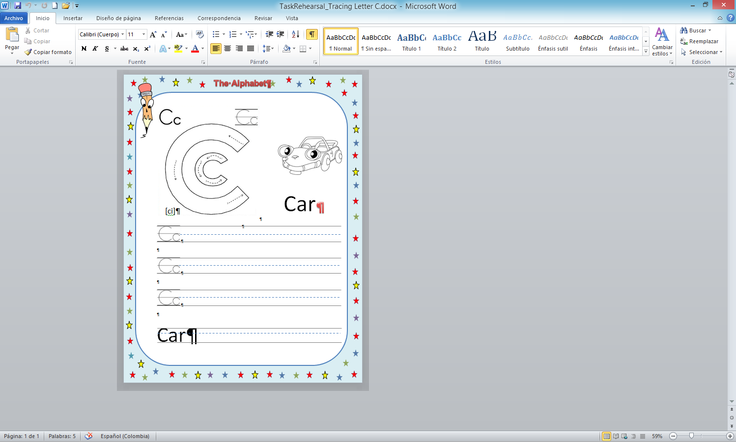

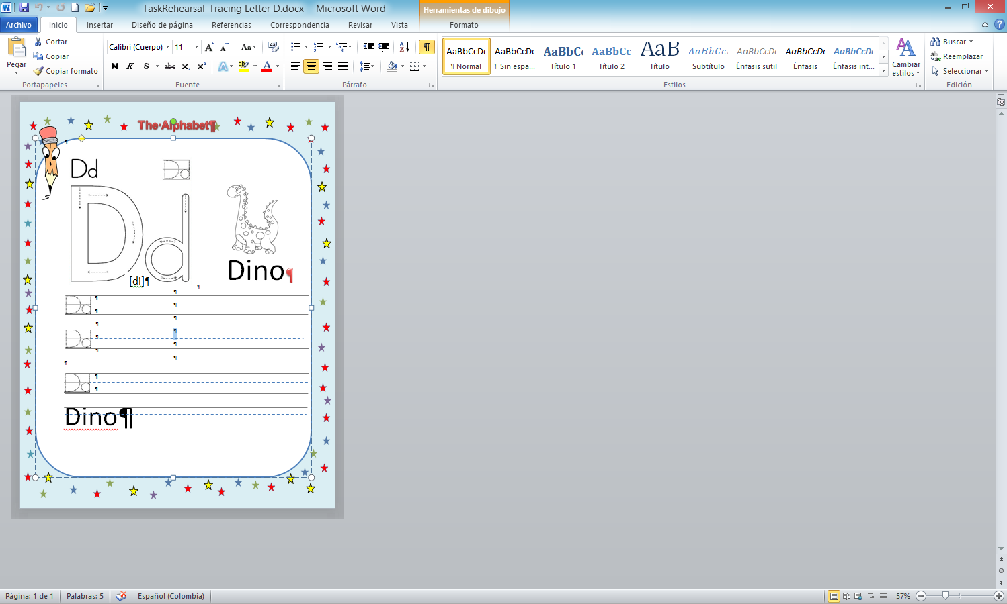

 

 



**Week 3 Worksheet for the warm-up**

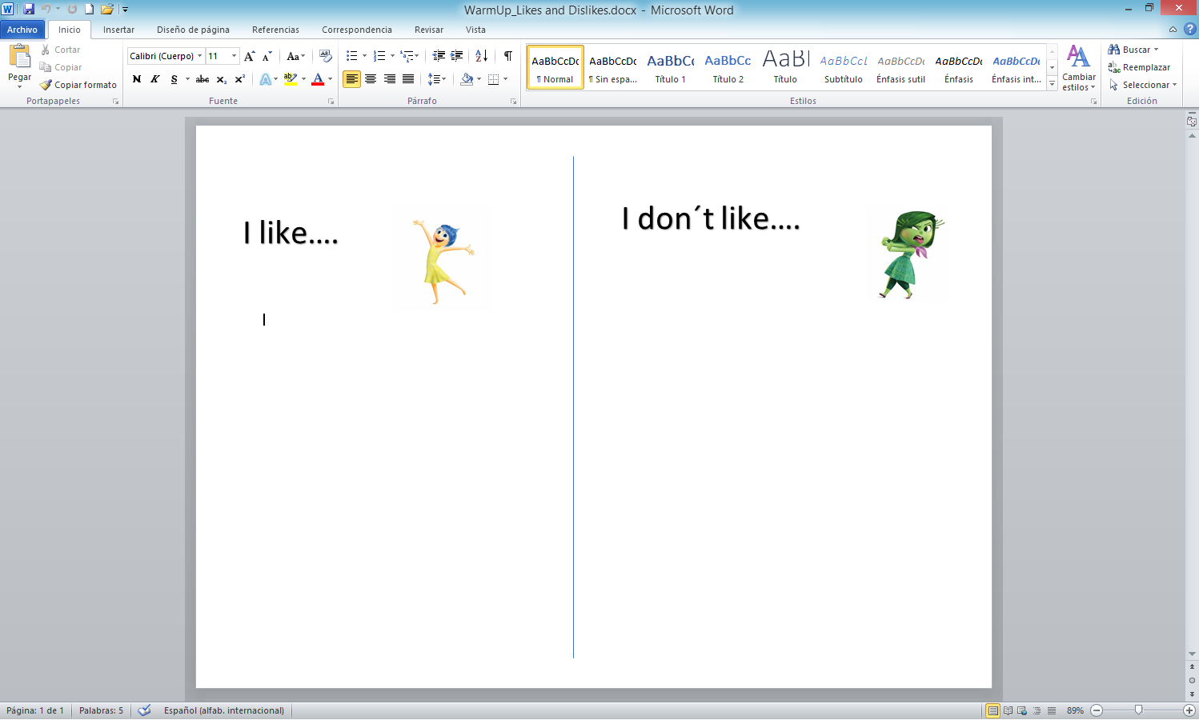

**Worksheet- task rehearsal for reading**

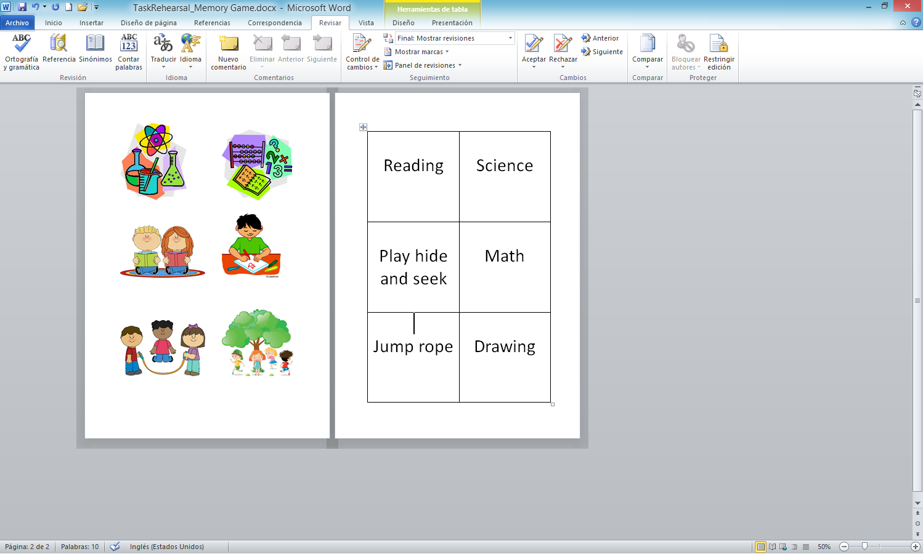

**Task completion for reading**

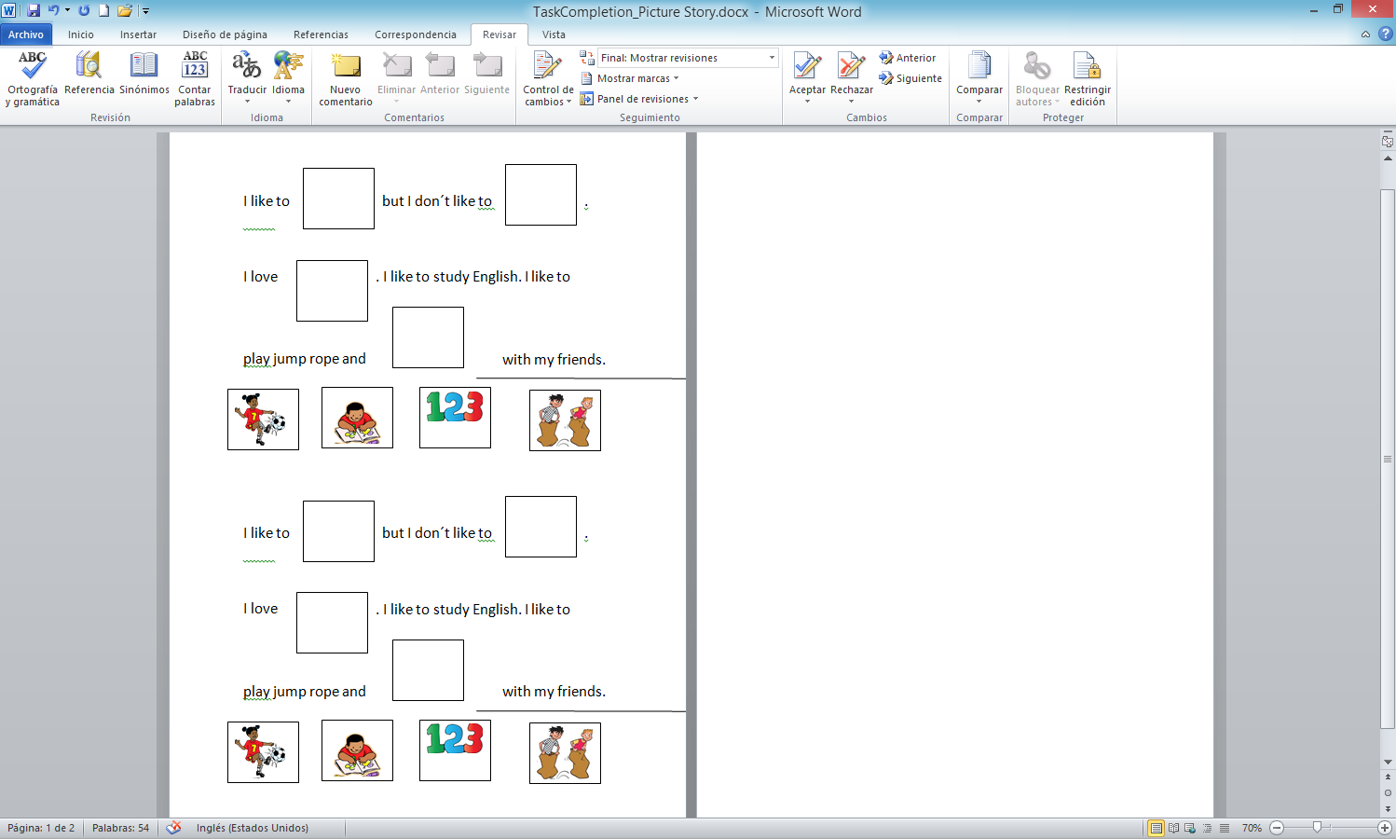

**Reading: Task assessment**

I go to Cleto Gonzalez Flores Elementary School in Heredia. It`s great! I love to go to school. I like science and math, but I don´t like reading. I love to play soccer with my friends and jump rope. I like to draw dogs and cats. I don`t like to do my homework.

I go to Cleto Gonzalez Flores Elementary School in Heredia. It`s great! I love to go to school. I like science and math, but I don´t like reading. I love to play soccer with my friends and jump rope. I like to draw dogs and cats. I don`t like to do my homework.

**Letter E worksheet**

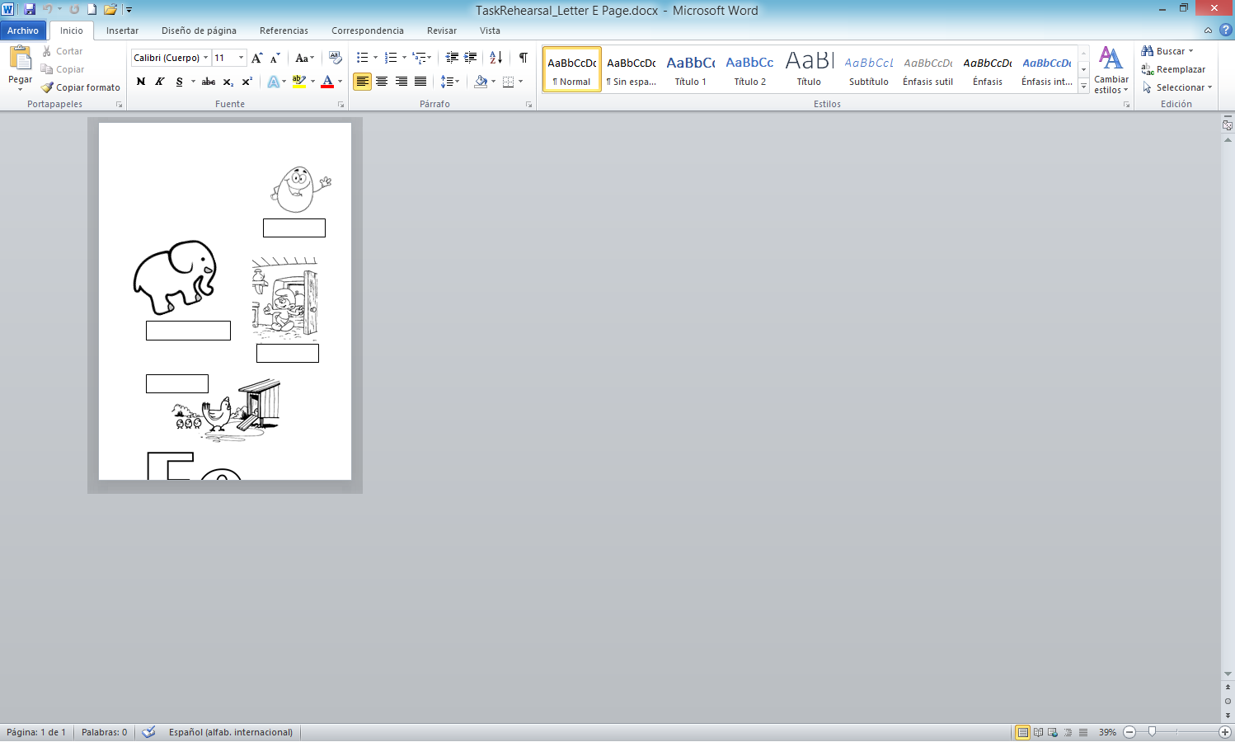

Months of the year and celebrations

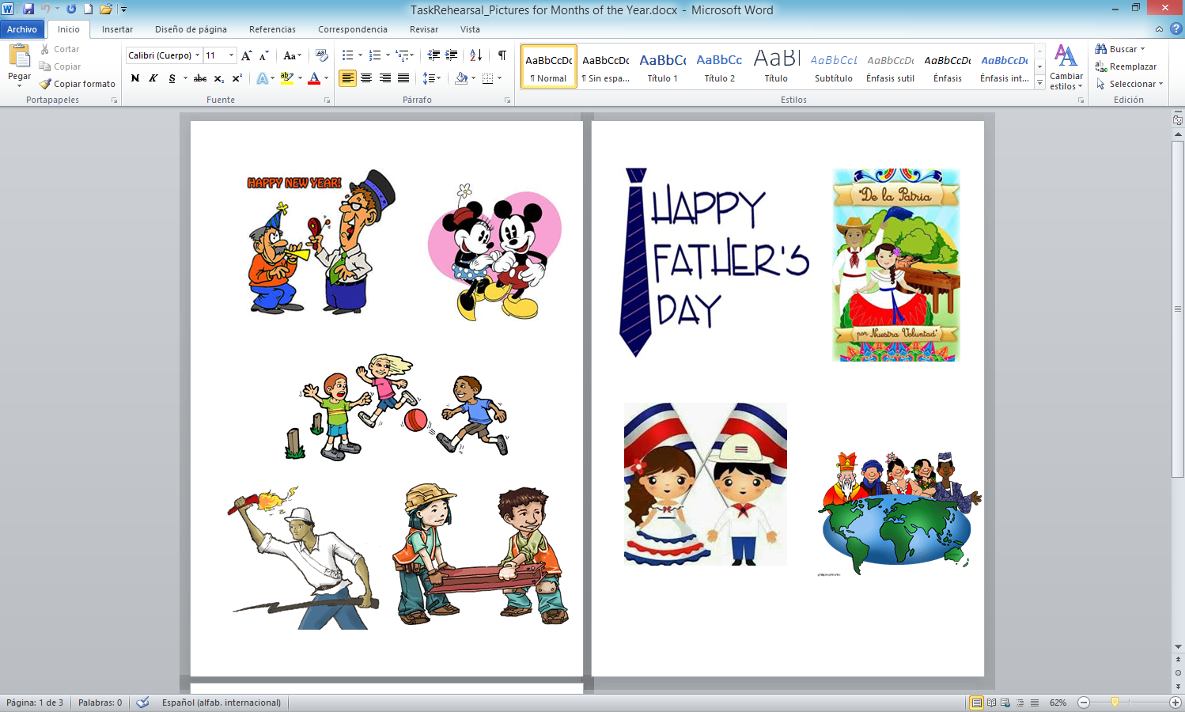 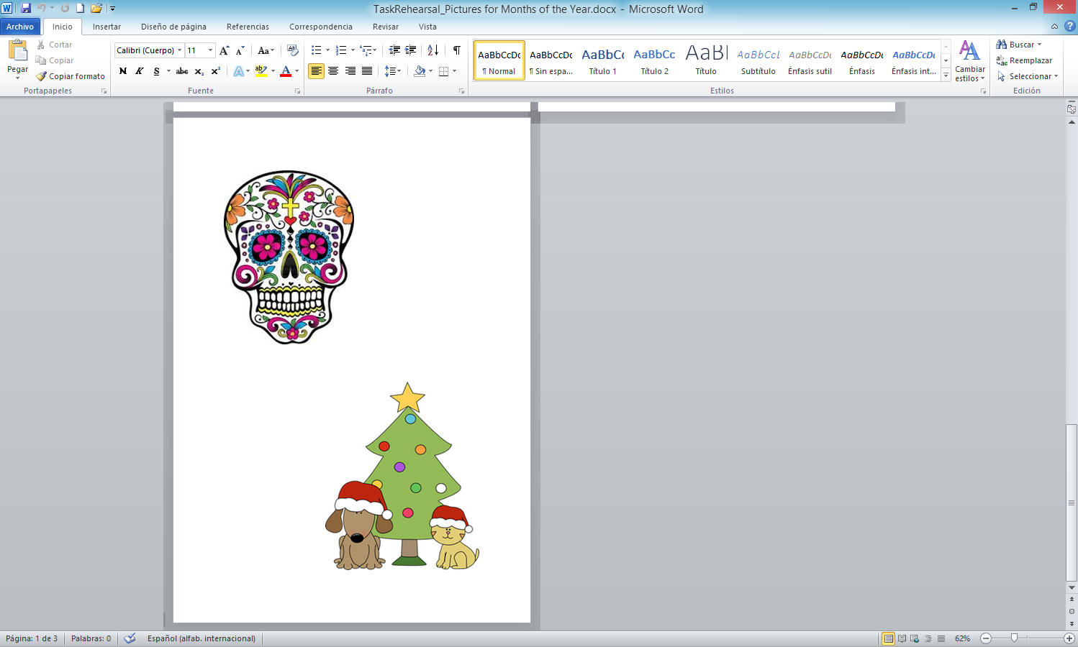

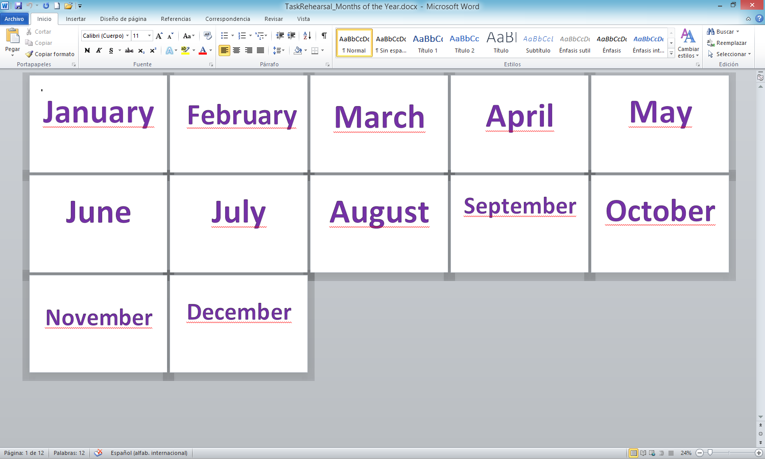

**Week 4**

**School Personnel**

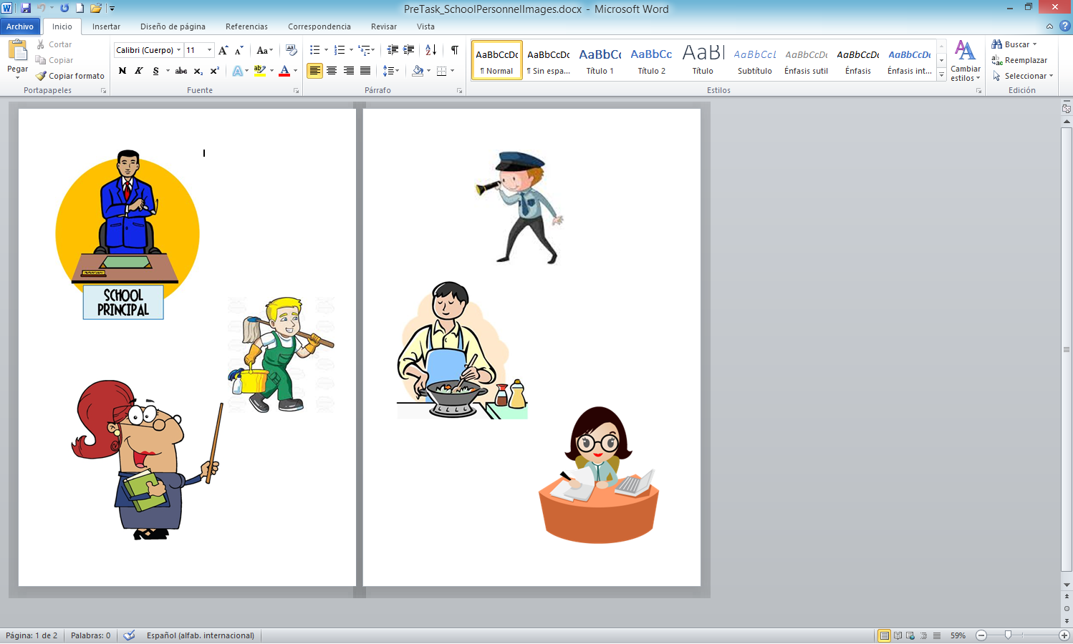

**Task rehearsal for reading**

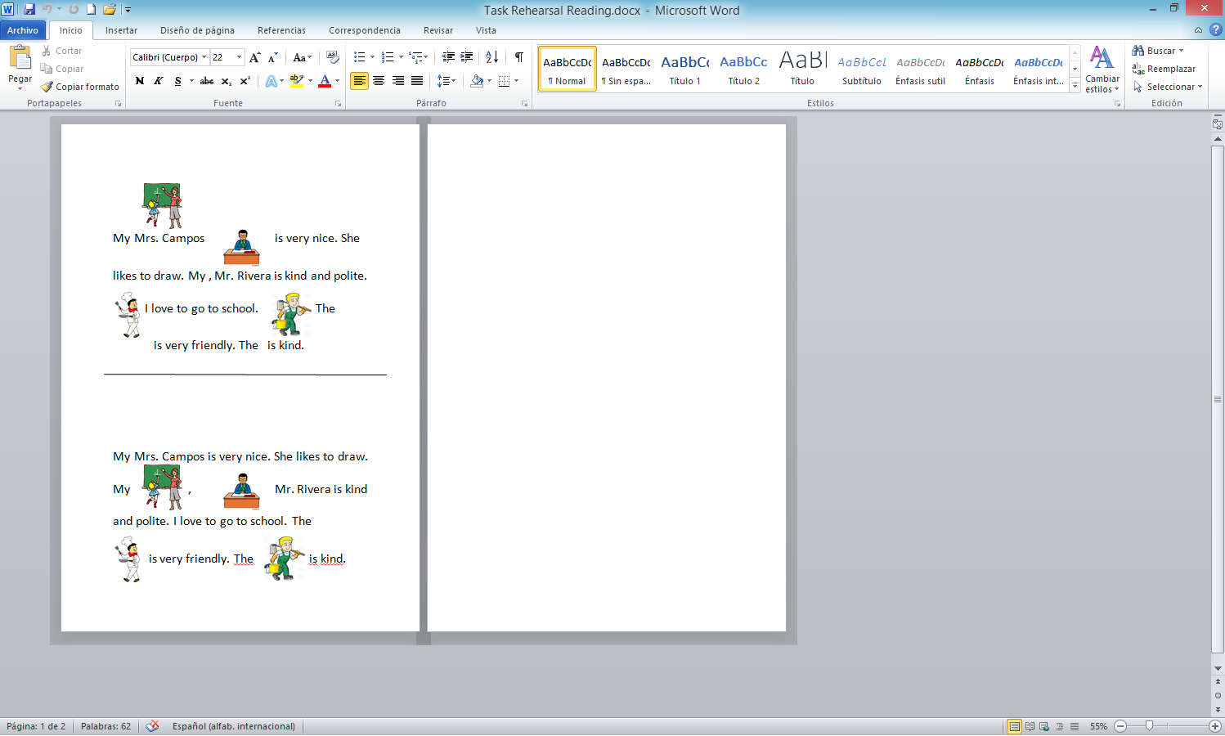

**Bingo Cards**

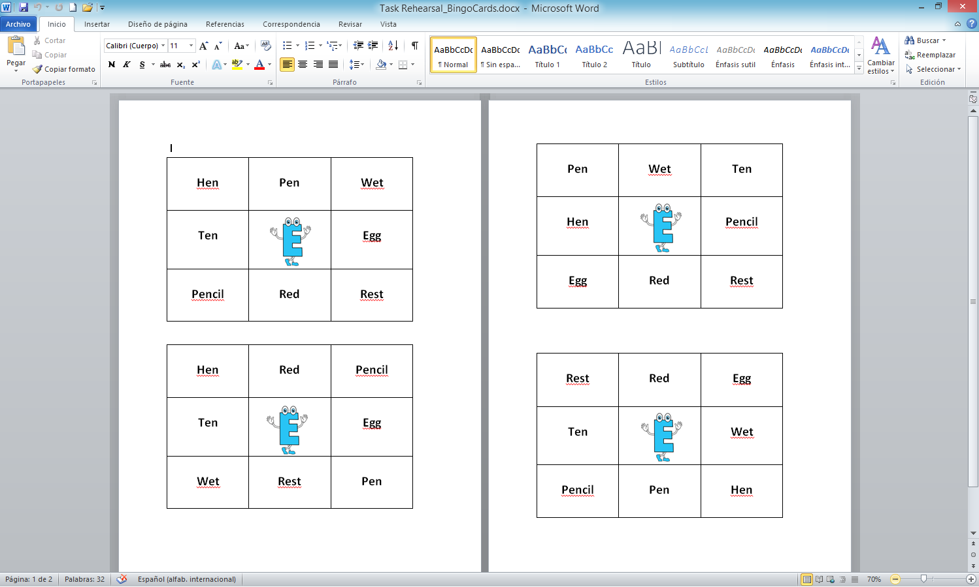

**Game cards**

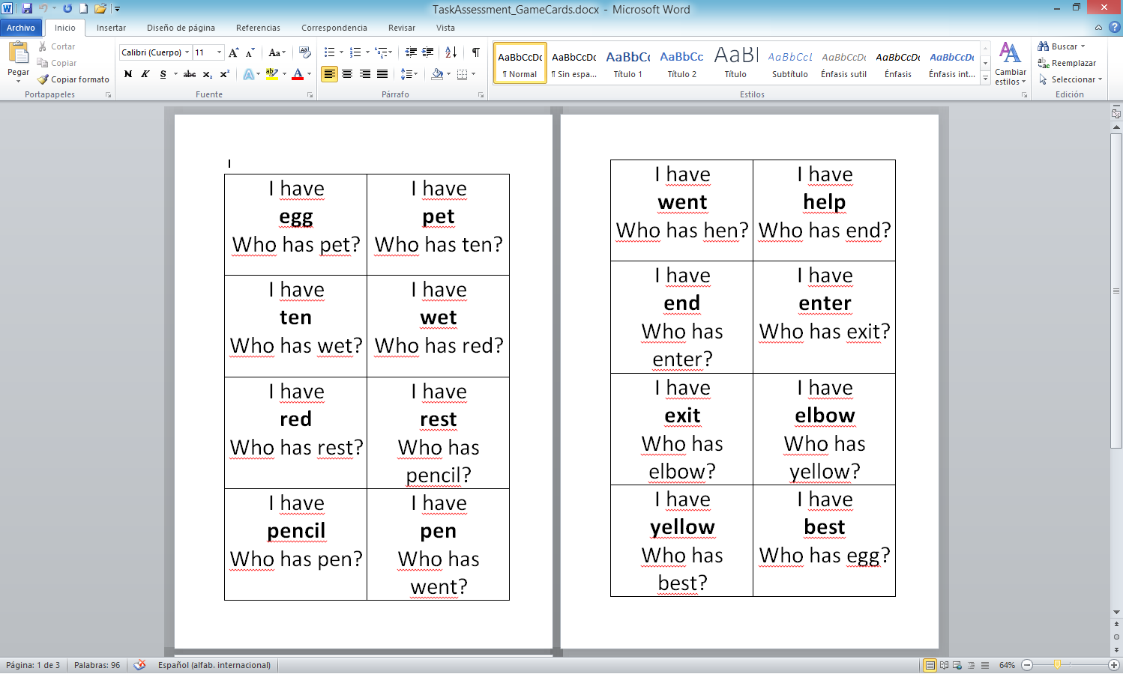

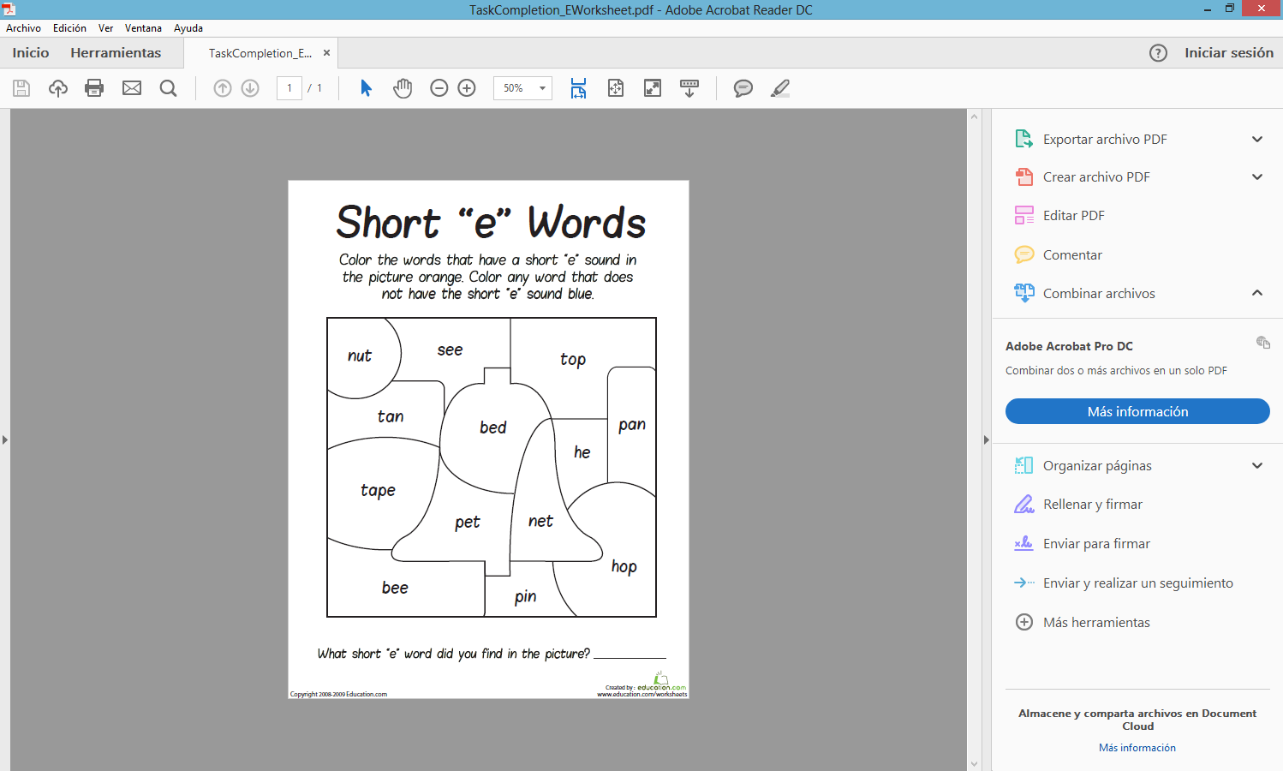

**School personnel pictures**

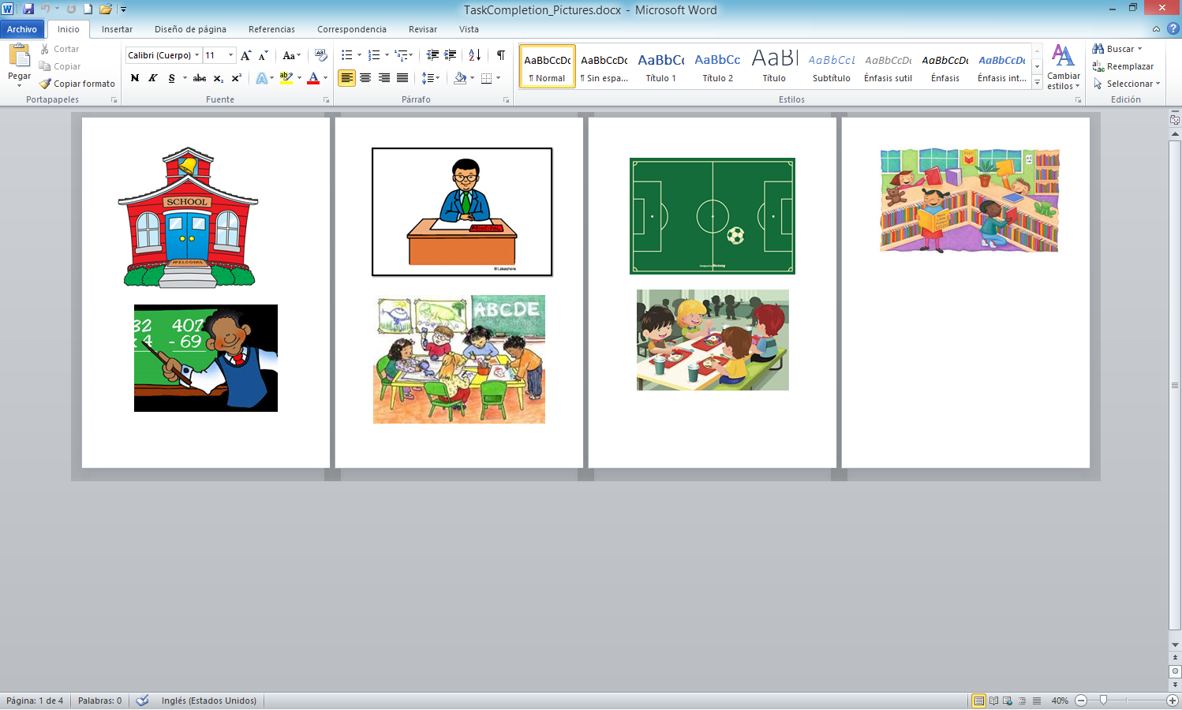

**Unit 4**

* **Question Ball Game**: Two teams are formed one in front of the other. The two teams compete for points. Points are obtained as the student with a ball, throws it to a student from the other team while asking a question about an animal sound: What noise do cows make? The student that catches the ball has to answer: the cows moo. And so on. The teams receive points for correct questions and for correct answers.
* **Question Ball**. Have the students sit in a circle.  Throw/Roll a ball to one student and ask a question.  The next step has 2 variations:   *Variation 1:* S1 throws the ball back to the T and the T throws to another S asking a different question.   
  *Variation 2:*S1 throws the ball to a different S and asks that S the same question.

Ball

**Unit 5**

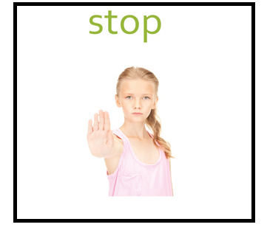[](https://www.google.com/url?sa=i&rct=j&q=&esrc=s&source=images&cd=&cad=rja&uact=8&ved=0ahUKEwjg_9Oa4ITWAhVF6iYKHWclCdoQjRwIBw&url=http://kidzguru.blogspot.com/2015/05/printableworksheets-shapesflashcards_1.html&psig=AFQjCNHjURWIc7ysxCdbRphPQnVwOe8SKg&ust=1504381569558902)

**Letter T and Letter S**

Snake

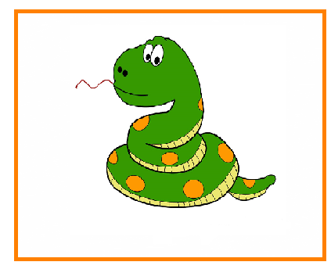

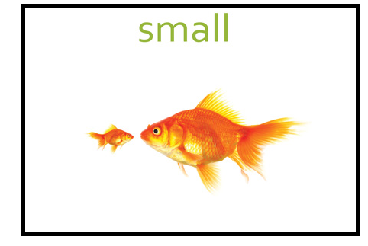

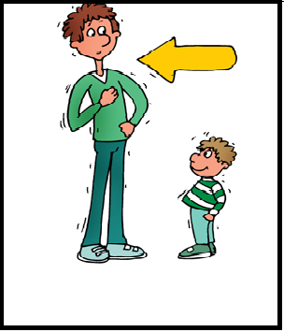

[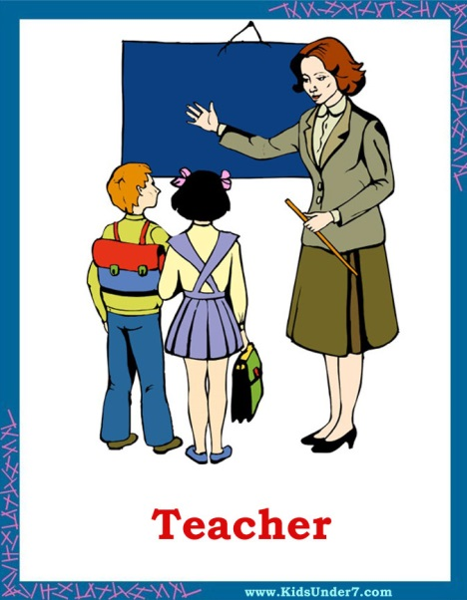](https://www.google.com/url?sa=i&rct=j&q=&esrc=s&source=images&cd=&cad=rja&uact=8&ved=0ahUKEwi_2IDj3ITWAhWGLyYKHUU1DVoQjRwIBw&url=http://www.kidsunder7.com/2011/02/occupations-and-jobs-flashcards.html&psig=AFQjCNERzyE9PuEESN1giWLngligaRr03A&ust=1504380647066915)[](https://www.google.com/url?sa=i&rct=j&q=&esrc=s&source=images&cd=&cad=rja&uact=8&ved=0ahUKEwj_36Wc3ITWAhVEMSYKHTJWDIsQjRwIBw&url=http://kidzguru.blogspot.com/2015/04/&psig=AFQjCNHKTzv5IxmweKRoVyz8jNaPL7h8Kg&ust=1504380474100586)

|  |  |
| --- | --- |
|  |  |
|  |  |
|  |  |
|  |  |

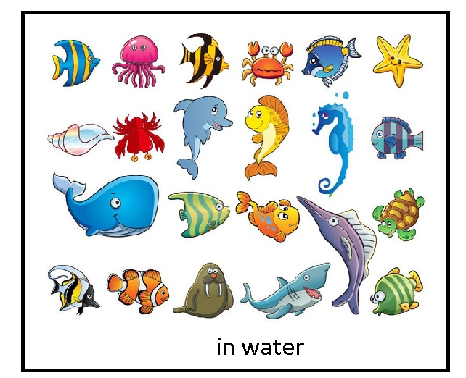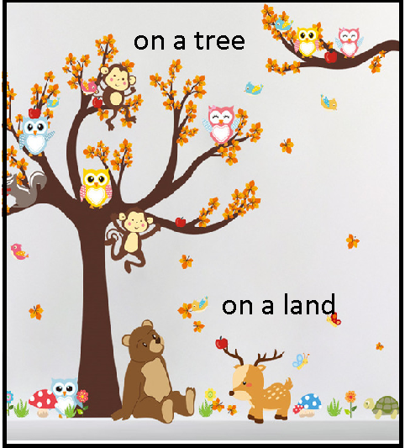

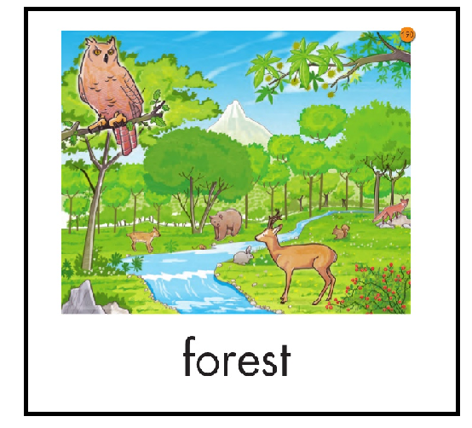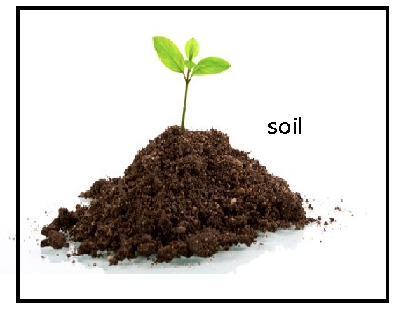

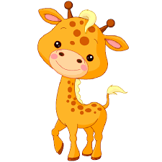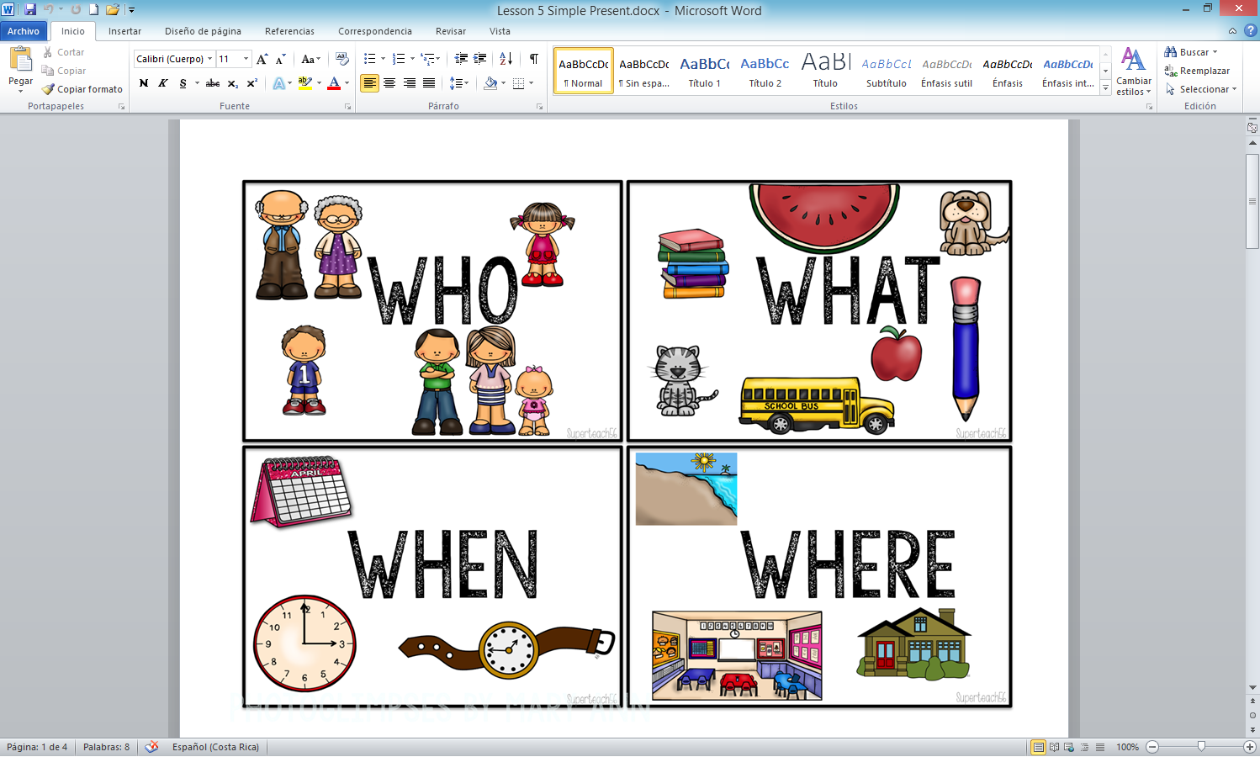

I

IT

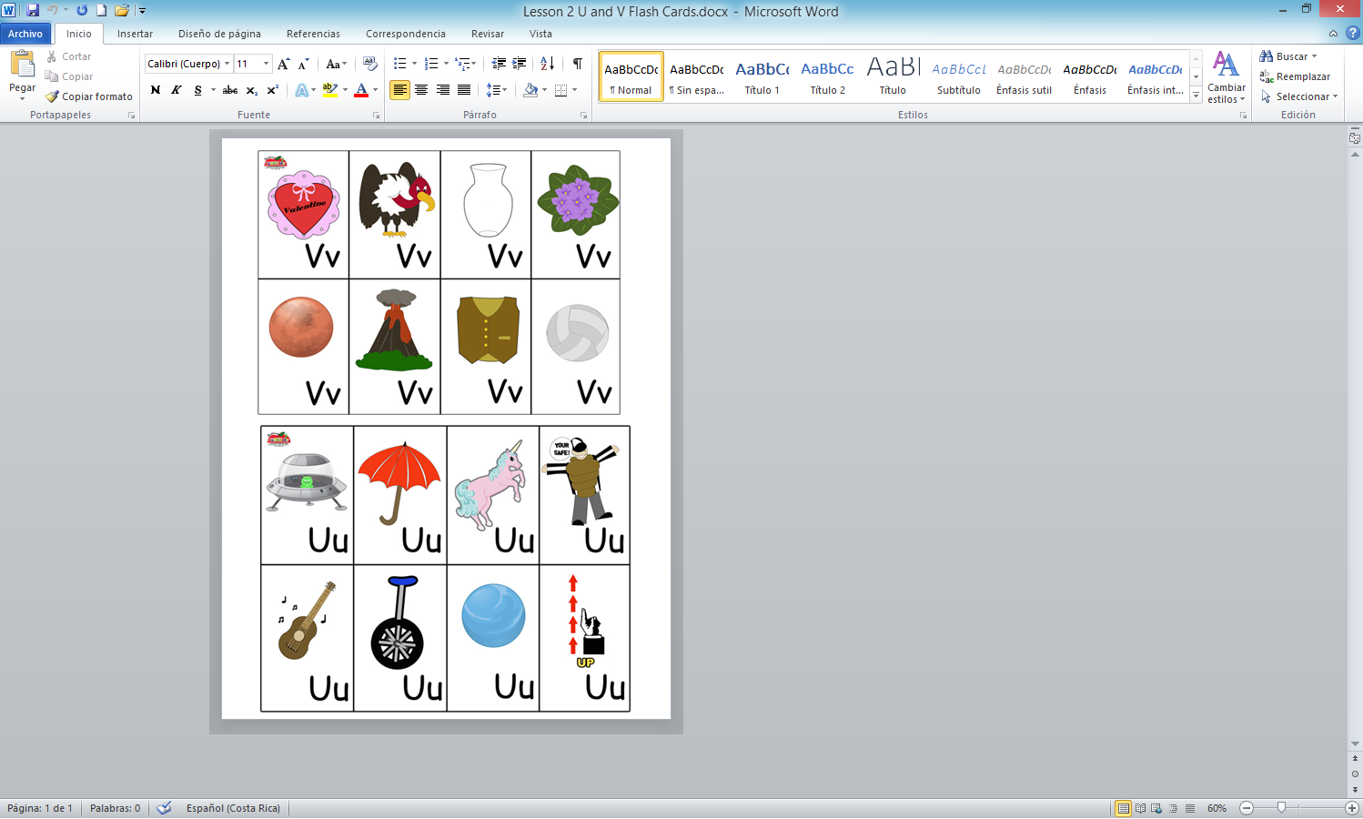

**The Story of the Caterpillar**

There once was a Caterpillar named Sofia. She was small and brown. She lived on a very tiny, green leaf in the forest. She started eating the leaf and became very big

She was tired so she started to make a cocoon. Inside the cocoon she started to grow and grow. Pretty soon, she could not fit in the cocoon. She fought and fought to escape the cocoon.

One day she broke free of the cocoon, but she wasn’t a caterpillar anymore. She was a big, orange butterfly! She now could fly around in the sky. She loved being a butterfly.

|  |  |
| --- | --- |
|  |  |
|  |  |
|  |  |
|  |  |

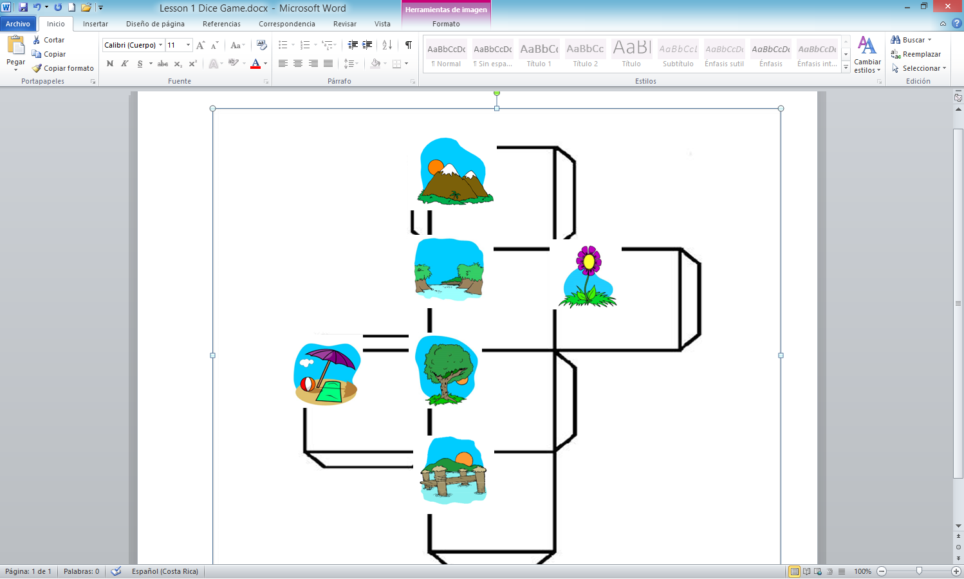

**AUTORIDADES**

Sonia Marta Mora Escalante

**Ministra de Educación Pública**

Alicia E. Vargas Porras

**Viceministra Académica**

Rosa Carranza Rojas

**Director Dirección de Desarrollo Curricular**

Anabelle Venegas Fernández

**Jefa, Departamento de Primero y Segundo Ciclos**

**Comisión Redactora**

Ana Campos Centeno, Asesora Nacional de Inglés, Departamento de Primero y Segundo Ciclo, Coordinación

Yaudy Ramírez Vázquez, Asesora Nacional de Inglés, Departamento de Primero y Segundo Ciclos

**Colaboradores**

Andres Mendoza Gutierrez, Asesor Regional de Inglés, Dirección Regional de Heredia

Grettel Chaves Hernandez, Docente de inglés

Acacia Campos Vargas, Docente de inglés

Grettel Duran Coccio, Docente de inglés

Magaly Hernandez Valenciano, Docente de inglés

Marcela Nuñez Molina, Docente de inglés

Karen Zarate Arias, Docente de inglés

Alberto Balam Navarro, Voluntario del Cuerpo de Paz

Natalie Borrego, Voluntaria del Cuerpo de Paz

Ryan Wilkens, Voluntario del Cuerpo de Paz

Chelsy Albertson, English Editor